

Name: Bhavna Thakur

ID NO. :- 21EL095

Division :- 11

Subject:- Digital System Design

Branch :- Electronics

1) **Clock Divider**

**Verilog code:-**

module clock_divider (

input wire clk, input wire reset, output reg clk_div

);

reg [3:0] counter;

always @(posedge clk or posedge reset) begin

if (reset) begin counter <= 4'b0000; clk_div <= 1'b0; end else begin if (counter == 4'b1000) begin counter <= 4'b0000; clk_div <= ~clk_div; end else begin counter <= counter + 1'b1;

end end end

endmodule

**Testbench:-**

module tb_clock_divider;

reg tb_clk; reg tb_reset; wire tb_clk_div;

clock_divider uut ( .clk(tb_clk),

.reset(tb_reset),

.clk_div(tb_clk_div)

);

always begin #5 tb_clk = ~tb_clk; end

initial begin tb_reset = 0;

#10 tb_reset = 1;

#100; $stop; end

endmodule

**RTL schematic:-**

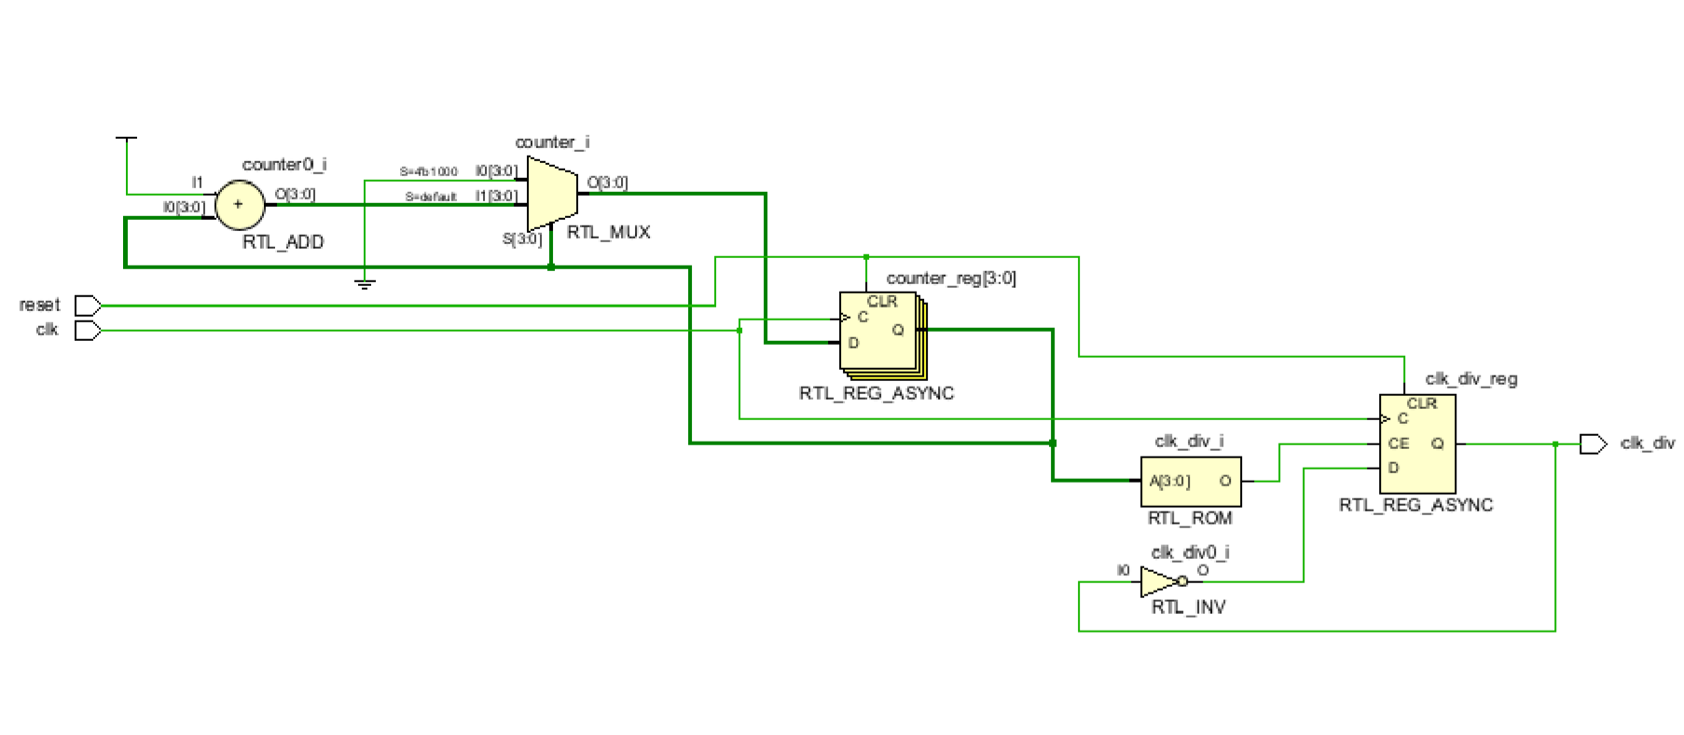

**Synthesis report:-**

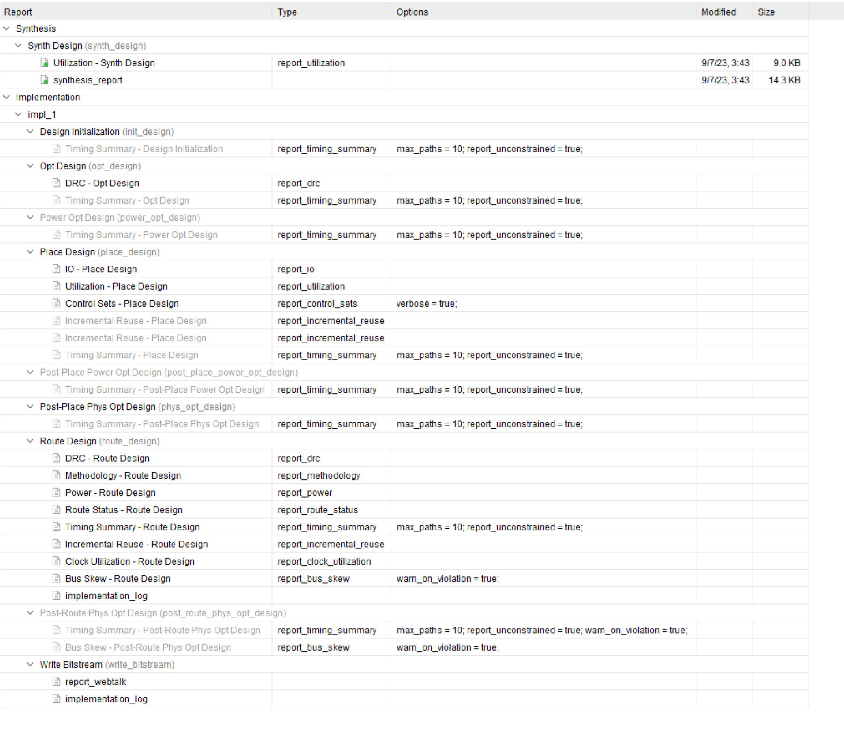

**power**

**report:**

**-**

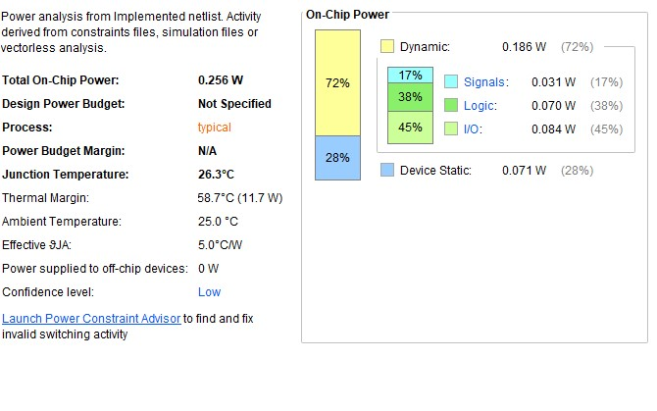

**Output:-**

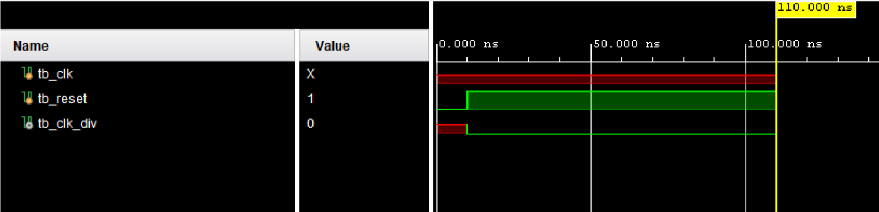

2**) Johnson Counter:-**

**Verilog code:-** module johnson_counter_structural (

input wire clk, input wire reset, output reg [3:0] counter_out

);

wire q0, q1, q2, q3;

d_flip_flop DFF0 (.D(reset), .clk(clk), .Q(q0)); d_flip_flop DFF1 (.D(q0), .clk(clk), .Q(q1)); d_flip_flop DFF2 (.D(q1), .clk(clk), .Q(q2)); d_flip_flop DFF3 (.D(q2), .clk(clk), .Q(q3));

always @* begin counter_out = {q3, q2, q1, q0}; end

endmodule

module d_flip_flop (

input wire D, input wire clk, output reg Q

);

always @(posedge clk) begin Q <= D; end

endmodule

**Testbench:-**

module tb_johnson_counter_structural;

reg tb_clk; reg tb_reset; wire [3:0] tb_counter_out;

johnson_counter_structural uut (

.clk(tb_clk),

.reset(tb_reset),

.counter_out(tb_counter_out)

);

always begin #5 tb_clk = ~tb_clk; end

initial begin tb_reset = 0;

#10 tb_reset = 1;

#30;

$display("Counter Output: %b", tb_counter_out);

$stop;

end

endmodule

**RTL schematic:-**

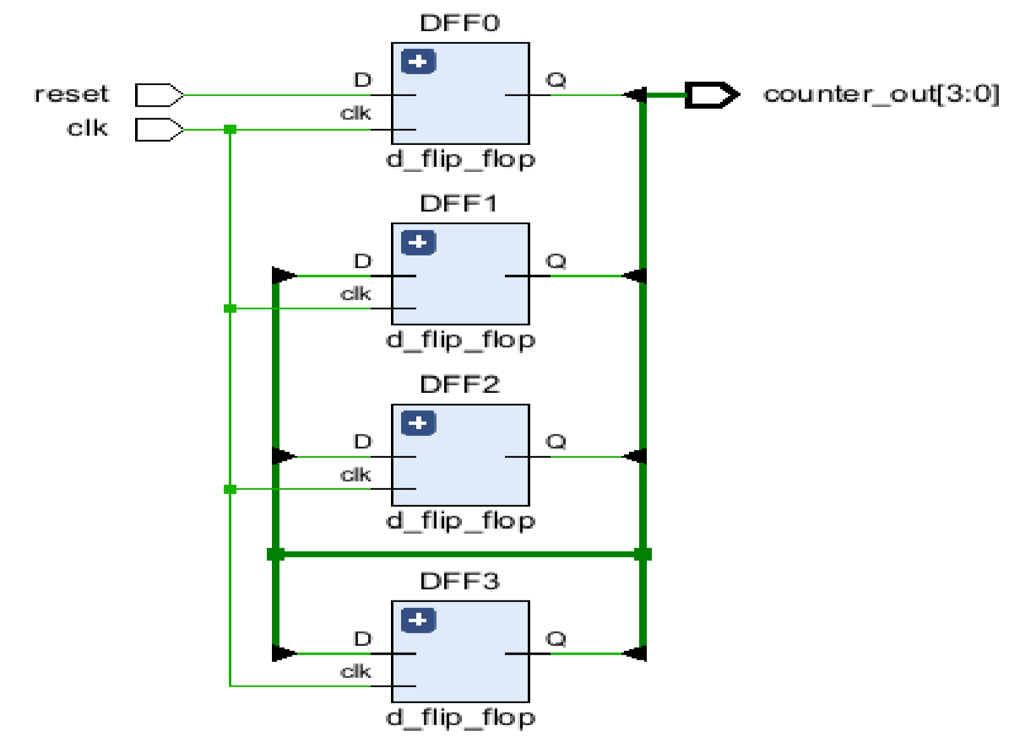

**Synthesis report:-**

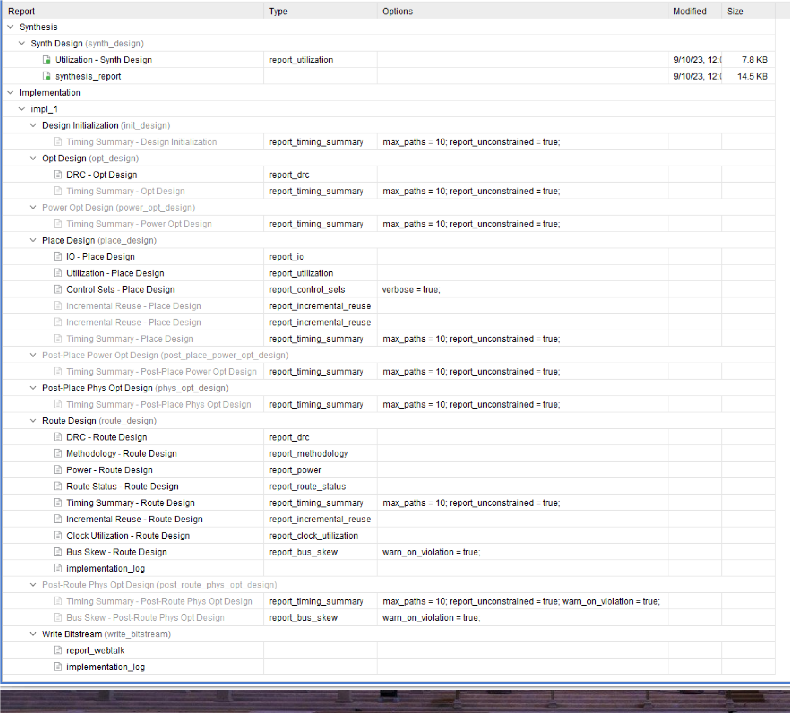

**power report:-**

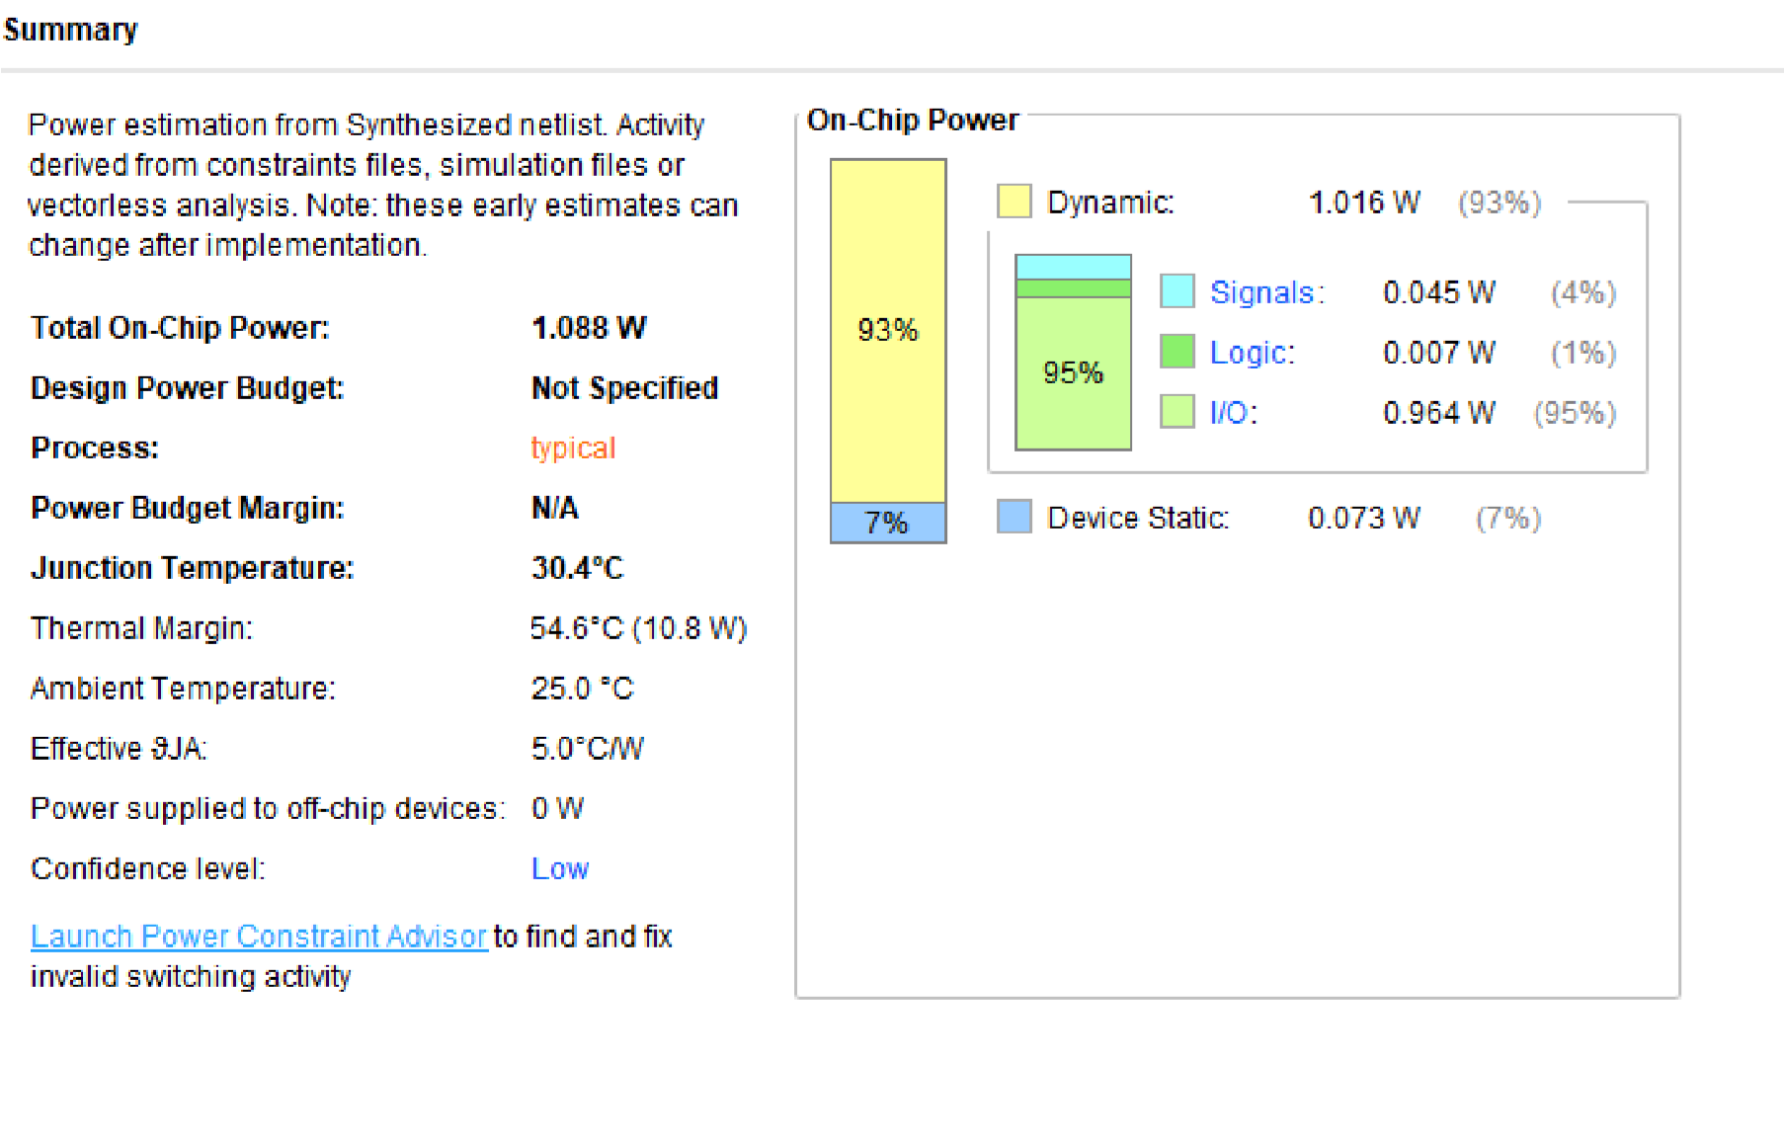

**Output:-**

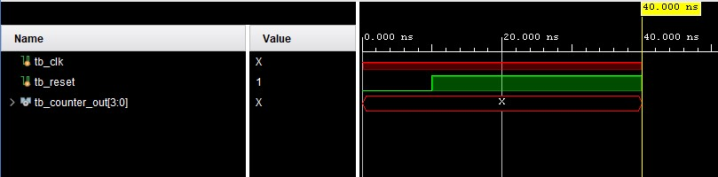

**3) 5 Input Majority Circuit**

**Verilog code:-** module majority_circuit_5input (

input wire a, b, c, d, e, output reg y

);

always @* begin

if ((a & b & c) | (a & b & d) | (a & b & e) | (a & c & d) | (a & c & e) | (a & d & e) |

(b & c & d) | (b & c & e) | (b & d & e) | (c & d & e))

y = 1'b1; else y = 1'b0;

end

endmodule

**Testbench:-**

module tb_majority_circuit_5input; reg tb_a, tb_b, tb_c, tb_d, tb_e; wire tb_y; majority_circuit_5input uut (

.a(tb_a),

.b(tb_b),

.c(tb_c),

.d(tb_d),

.e(tb_e),

.y(tb_y)

);

initial begin tb_a = 1; tb_b = 1; tb_c = 1; tb_d = 1; tb_e = 1;

#10;

$display("Input: %b %b %b %b %b, Output: %b", tb_a, tb_b, tb_c, tb_d, tb_e, tb_y); tb_a = 0; tb_b = 0; tb_c = 0; tb_d = 0; tb_e = 0;

#10;

$display("Input: %b %b %b %b %b, Output: %b", tb_a, tb_b, tb_c, tb_d, tb_e, tb_y);

tb_a = 1; tb_b = 1; tb_c = 1; tb_d = 0; tb_e = 0;

#10;

$display("Input: %b %b %b %b %b, Output: %b", tb_a, tb_b, tb_c, tb_d, tb_e, tb_y); tb_a = 1; tb_b = 1; tb_c = 0; tb_d = 0; tb_e = 0;

#10;

$display("Input: %b %b %b %b %b, Output: %b", tb_a, tb_b, tb_c, tb_d, tb_e, tb_y);

$stop; end

endmodule

**RTL schematic:-**

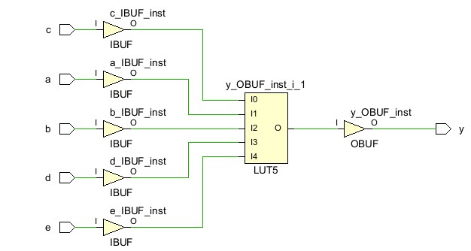

**Synthesis report:-**

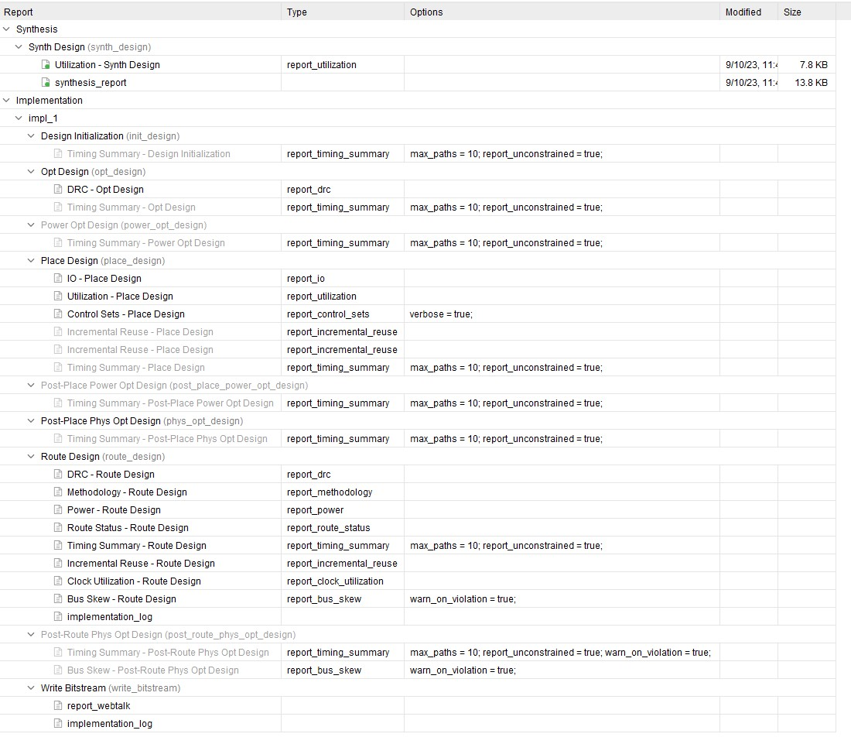

**power report:-**

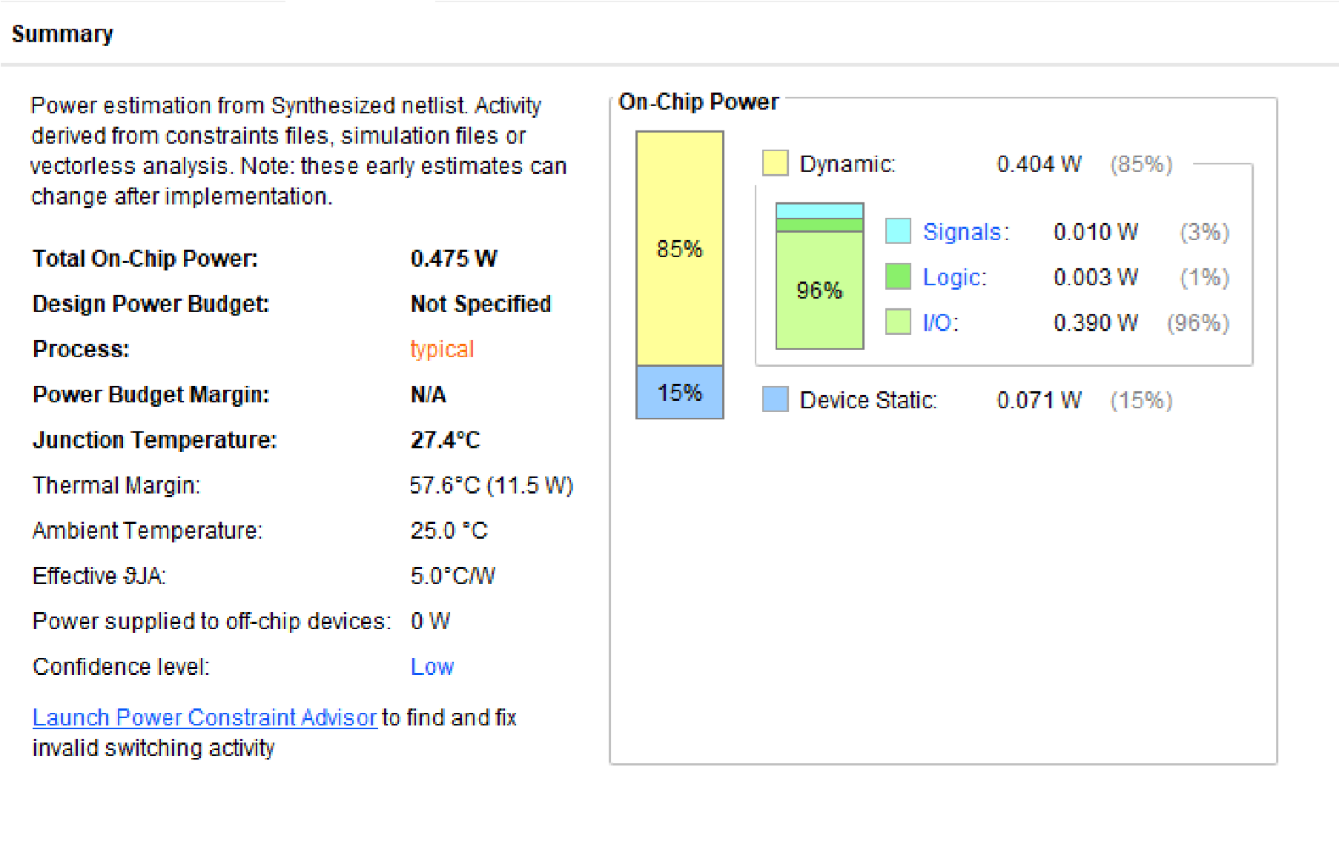

**Output:-**

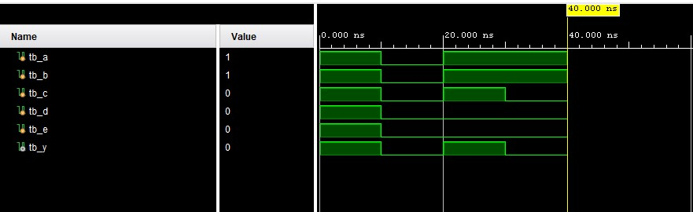

**4) Parity Generator:-**

**Verilog code:-** module odd_parity_generator (

input [7:0] data, output reg parity

);

always @* begin

parity = ^data; end

endmodule

**Testbench:-**

module tb_odd_parity_generator;

reg tb_data [7:0]; wire tb_parity;

odd_parity_generator uut (

.data(tb_data),

.parity(tb_parity)

);

initial begin

tb_data = 8'b10101010;

#10;

$display("Input Data: %b, Parity: %b", tb_data, tb_parity); tb_data = 8'b11110000;

#10;

$display("Input Data: %b, Parity: %b", tb_data, tb_parity); $stop; end

endmodule

**RTL schematic:-**

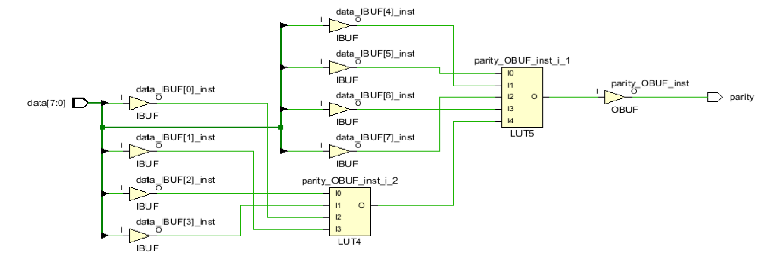

**Synthesis report:-**

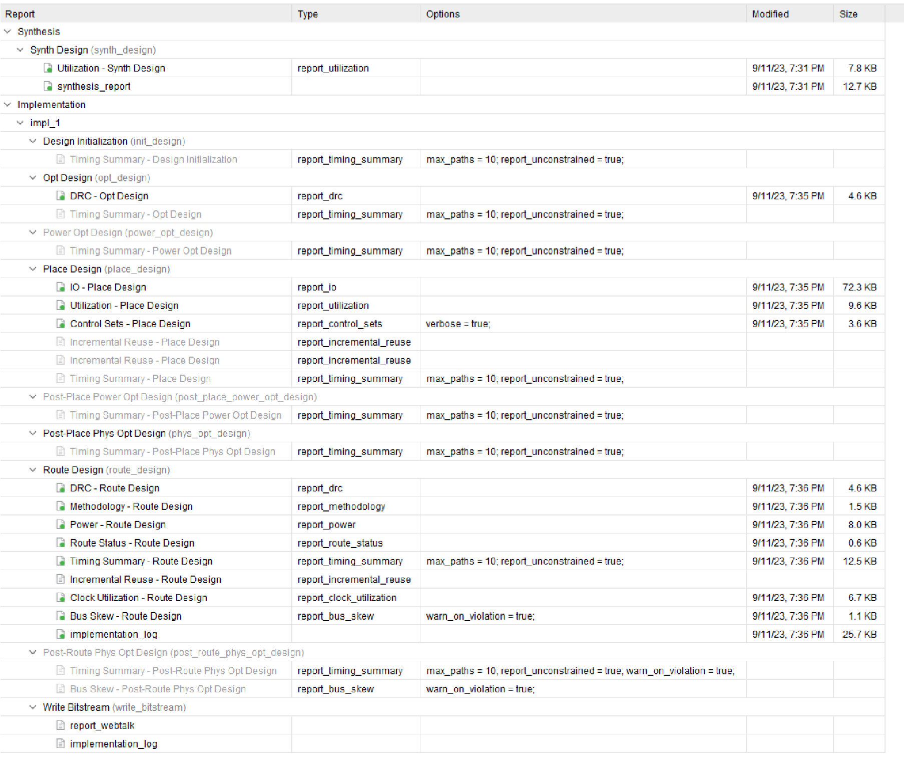

**power report:-**

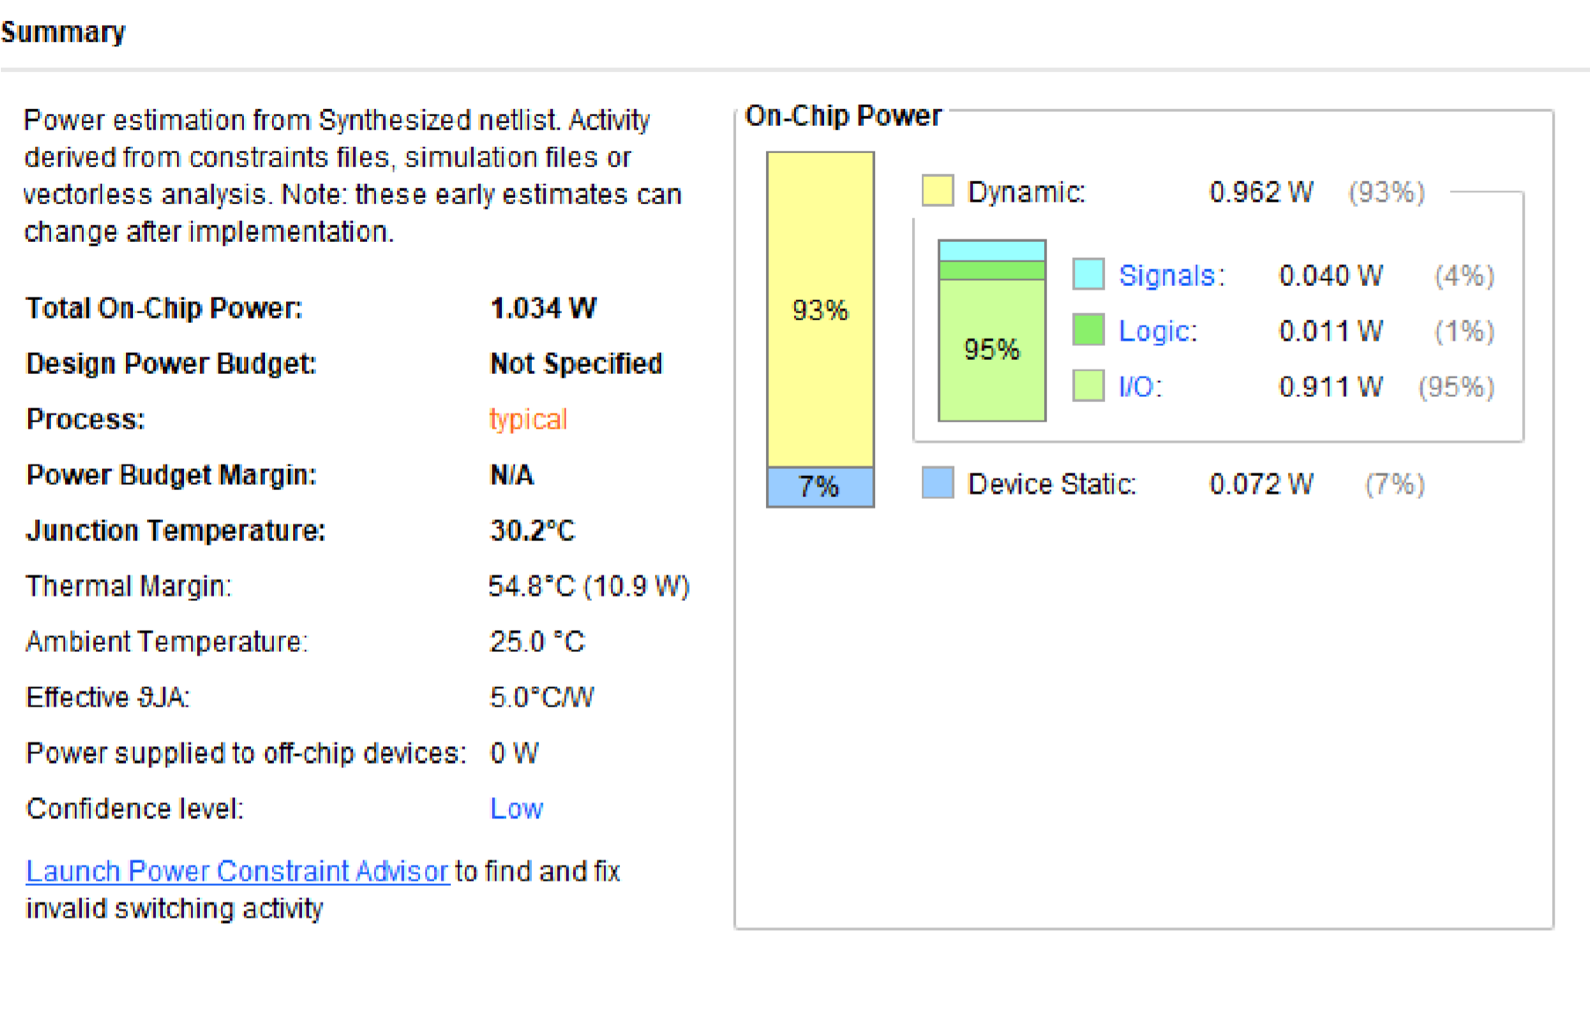

**Output:-**

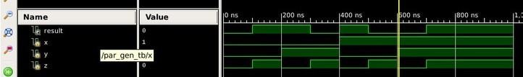

**5) Binary to One Hot Encoder:-**

**Verilog code:-** module binary_to_one_hot_encoder (

input [3:0] binary_input, output reg [15:0] one_hot_output

);

always @* begin case (binary_input)

4'b0001: one_hot_output = 16'b0000000000000001;

4'b0010: one_hot_output = 16'b0000000000000010;

4'b0100: one_hot_output = 16'b0000000000000100; 4'b1000: one_hot_output = 16'b0000000000001000; default: one_hot_output = 16'b0000000000000000;

endcase end

endmodule

**Testbench:-**

module tb_binary_to_one_hot_encoder;

reg [3:0] tb_binary_input; wire [15:0] tb_one_hot_output; binary_to_one_hot_encoder uut ( .binary_input(tb_binary_input),

.one_hot_output(tb_one_hot_output)

);

initial begin

tb_binary_input = 4'b0001;

#10;

$display("Binary Input: %b, One-Hot Output: %b", tb_binary_input, tb_one_hot_output); tb_binary_input = 4'b0100;

#10;

$display("Binary Input: %b, One-Hot Output: %b", tb_binary_input, tb_one_hot_output); tb_binary_input = 4'b1010;

#10;

$display("Binary Input: %b, One-Hot Output: %b", tb_binary_input, tb_one_hot_output);

$stop; end

endmodule

**RTL schematic:-**

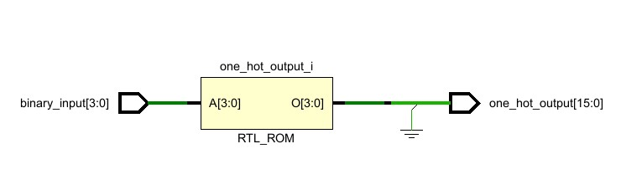

**Synthesis report:-** 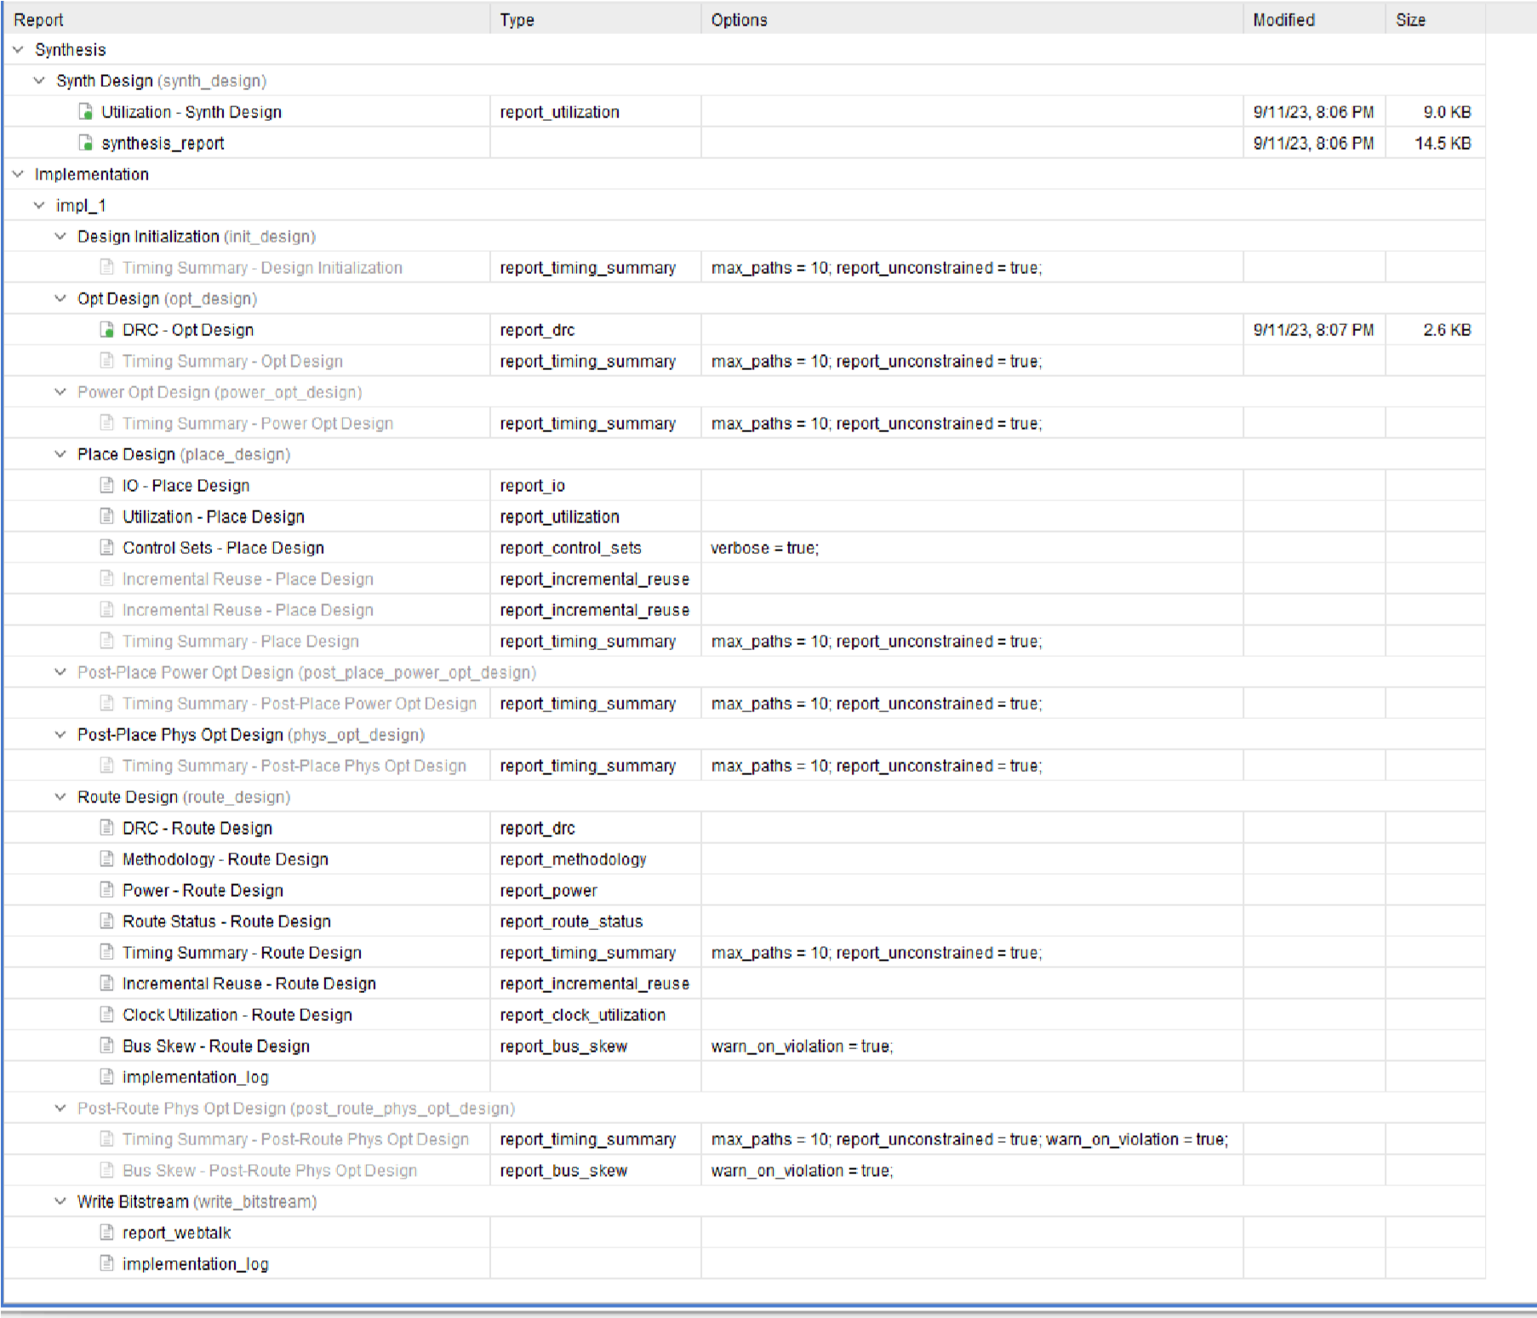

**power report:-**

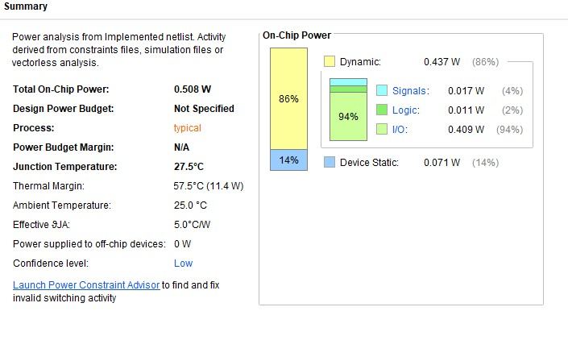

**Output:**

**-**

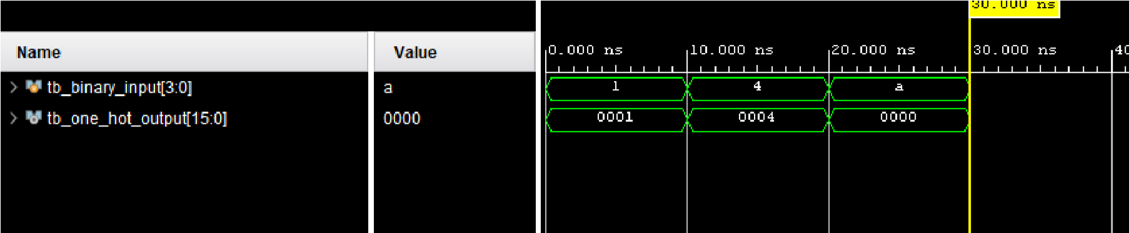

**6) N-bit Comparator:-**

**Verilog code:-** module n_bit_comparator (

input [7:0] A, input [7:0] B, output equal, output greater, output less

);

assign equal = (A == B); assign greater = (A > B); assign less = (A < B);

endmodule **Testbench:-**

module tb_n_bit_comparator;

reg [7:0] tb_A;

reg [7:0] tb_B; wire tb_equal; wire tb_greater; wire tb_less;

n_bit_comparator uut (

.A(tb_A),

.B(tb_B),

.equal(tb_equal),

.greater(tb_greater),

.less(tb_less)

);

initial begin

tb_A = 8'b01010101; tb_B = 8'b01010101;

#10;

$display("Input A: %b, Input B: %b, Equal: %b, Greater: %b, Less: %b", tb_A, tb_B, tb_equal, tb_greater, tb_less);

tb_A = 8'b10101010; tb_B = 8'b01010101;

#10;

$display("Input A: %b, Input B: %b, Equal: %b, Greater: %b, Less: %b", tb_A, tb_B, tb_equal, tb_greater, tb_less);

tb_A = 8'b01010101; tb_B = 8'b10101010;

#10;

$display("Input A: %b, Input B: %b, Equal: %b, Greater: %b, Less: %b", tb_A, tb_B, tb_equal, tb_greater, tb_less);

$stop;

end

endmodule

**RTL schematic:-**

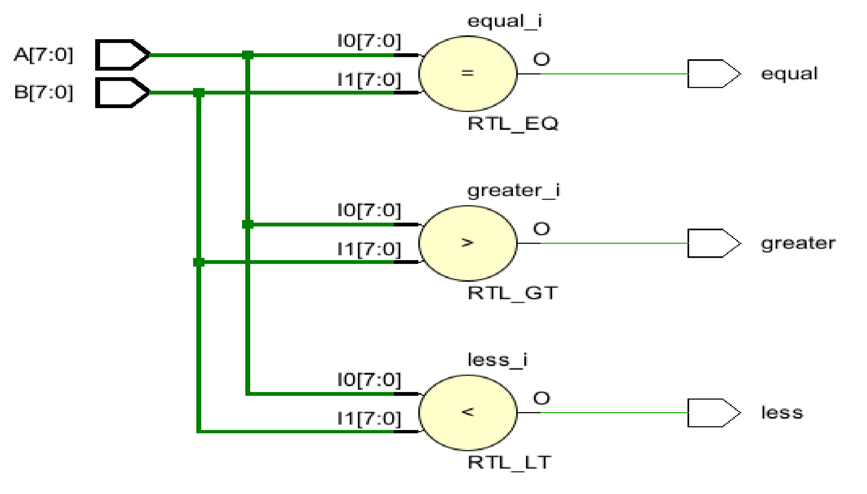

**Synthesis report:**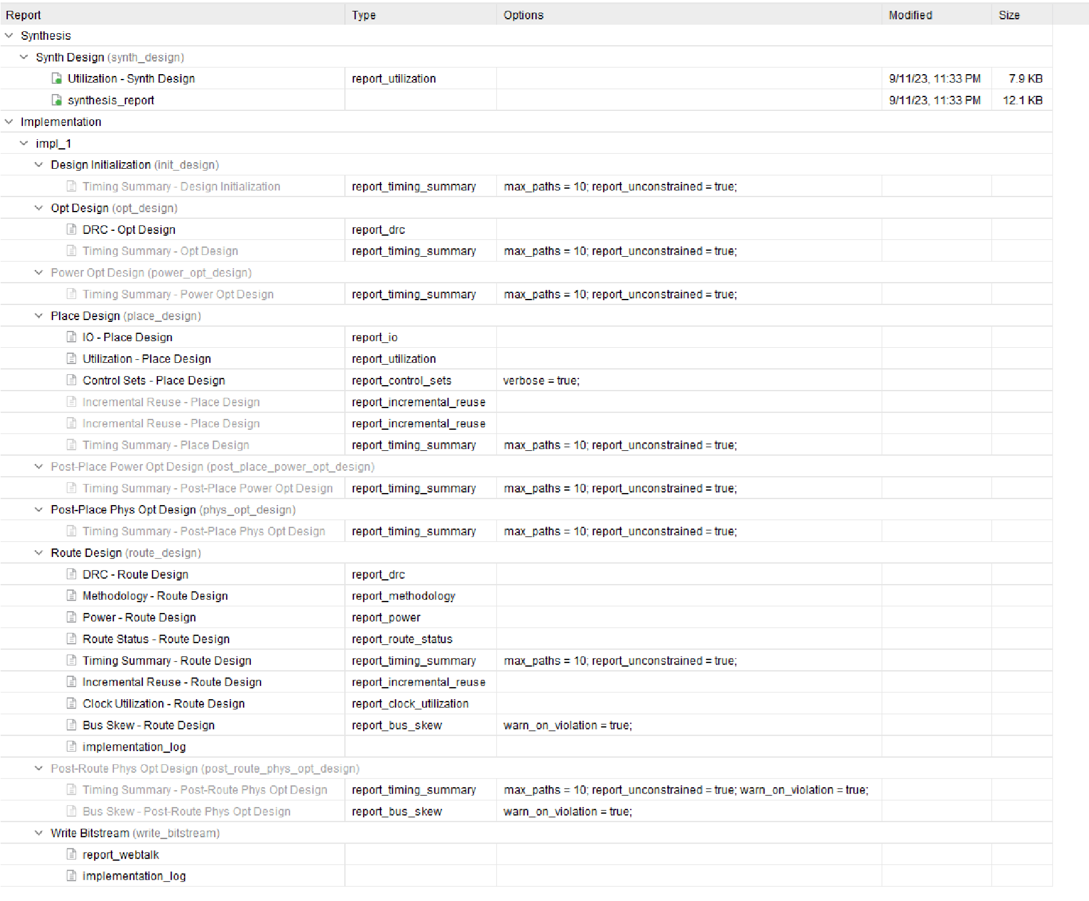

**power report:-**

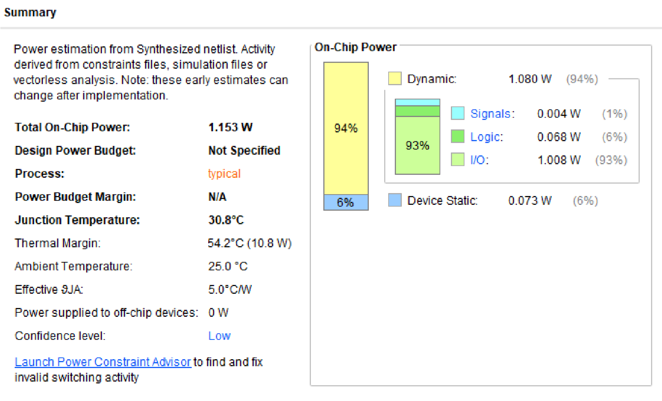

**Output:-**

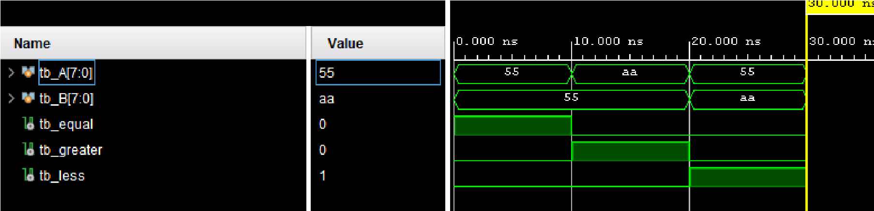

**7) Fixed Point Restoring Division**

**Verilog code:-** module fixed_point_restoring_division ( input signed [7:0] dividend, input signed [7:0] divisor, output reg signed [7:0] quotient

);

reg signed [7:0] remainder; reg [3:0] count; reg sign;

always @* begin

count = 4'd0; remainder = dividend; sign = (dividend < 0) ^ (divisor < 0);

while (count < 4'd64) begin if (remainder[7] == 1) begin remainder = remainder + (divisor >> count);

end else begin remainder = remainder - (divisor >> count);

end count = count + 1; end if (sign) begin quotient = -remainder; end else begin quotient = remainder; end end

endmodule **Testbench:-**

module tb_fixed_point_restoring_division;

reg signed [7:0] tb_dividend; reg signed [7:0] tb_divisor; wire signed [7:0] tb_quotient; fixed_point_restoring_division uut (

.dividend(tb_dividend),

.divisor(tb_divisor),

.quotient(tb_quotient)

);

initial begin

tb_dividend = 8'b00000110; tb_divisor = 8'b00000010;

#10;

$display("Dividend: %b, Divisor: %b, Quotient: %b", tb_dividend, tb_divisor, tb_quotient);

$stop; end

endmodule

**RTL schematic:-**

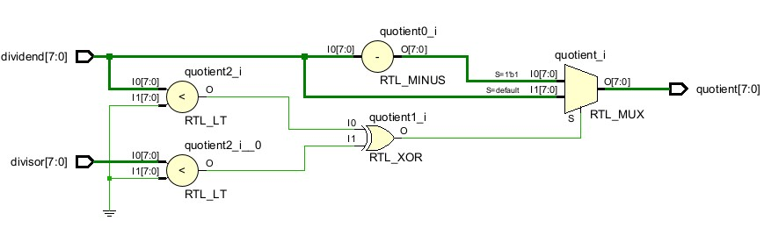

**Synthesis report:-**

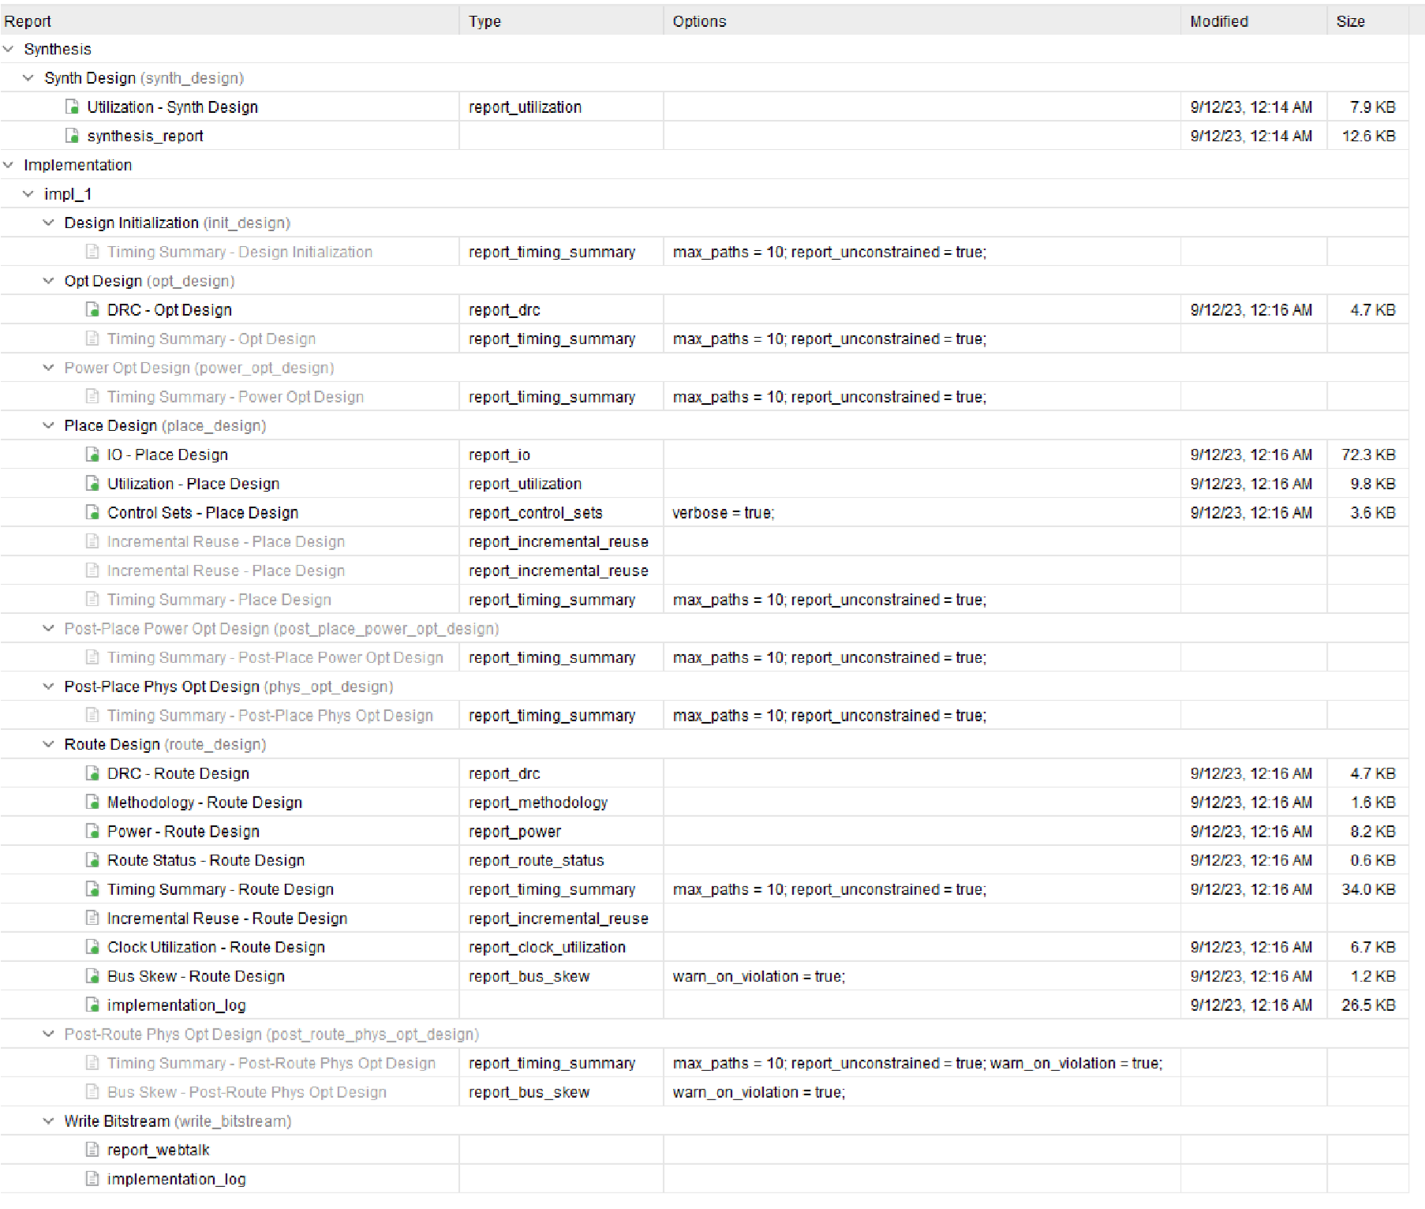

**power report:-**

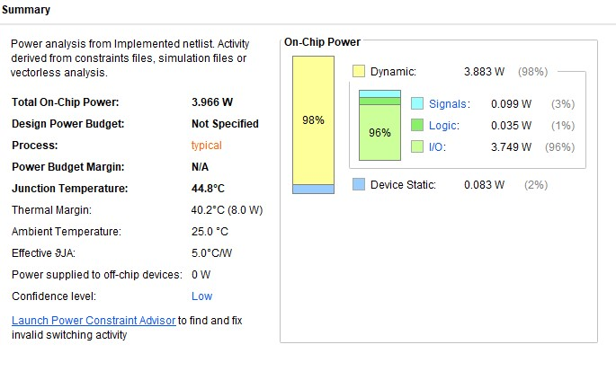

**Output:-**

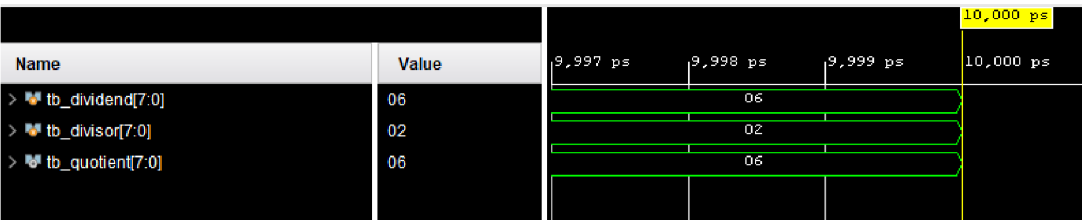

**8)DAY TO BCD**

**Verilog code:-** module bcd_to_7seg_decoder (

input [3:0] bcd_input, output reg [6:0] seg_output

);

always @* begin case(bcd_input)

4'b0000: seg_output = 7'b0111111;

4'b0001: seg_output = 7'b0000110;

4'b0010: seg_output = 7'b1011011;

4'b0011: seg_output = 7'b1001111;

4'b0100: seg_output = 7'b1100110;

4'b0101: seg_output = 7'b1101101;

4'b0110: seg_output = 7'b1111101;

4'b0111: seg_output = 7'b0000111;

4'b1000: seg_output = 7'b1111111; 4'b1001: seg_output = 7'b1101111; default: seg_output = 7'b0111111; endcase end

endmodule

**Testbench:-**

module tb_bcd_to_7seg_decoder;

reg [3:0] tb_bcd_input; wire [6:0] tb_seg_output;

bcd_to_7seg_decoder uut ( .bcd_input(tb_bcd_input),

.seg_output(tb_seg_output)

);

initial begin

tb_bcd_input = 4'b0010;

#10;

$display("BCD Input: %b, 7-Segment Output: %b", tb_bcd_input, tb_seg_output);

tb_bcd_input = 4'b1001;

#10;

$display("BCD Input: %b, 7-Segment Output: %b", tb_bcd_input, tb_seg_output);

$stop;

end

endmodule

**RTL schematic:-**

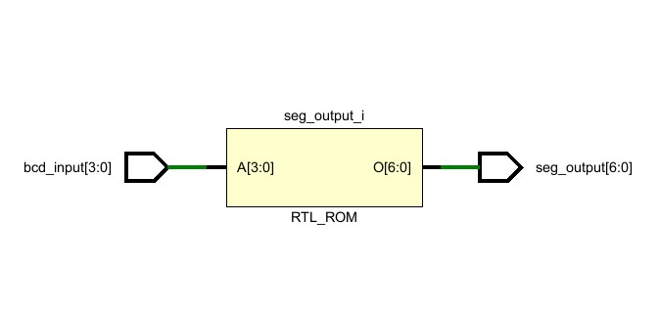

**Synthesis report:-**

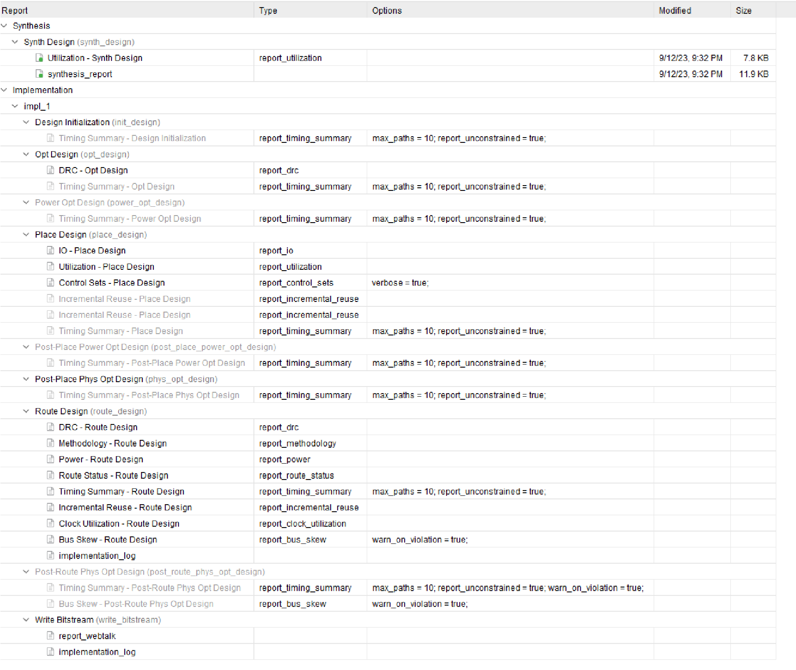

**power report:-** 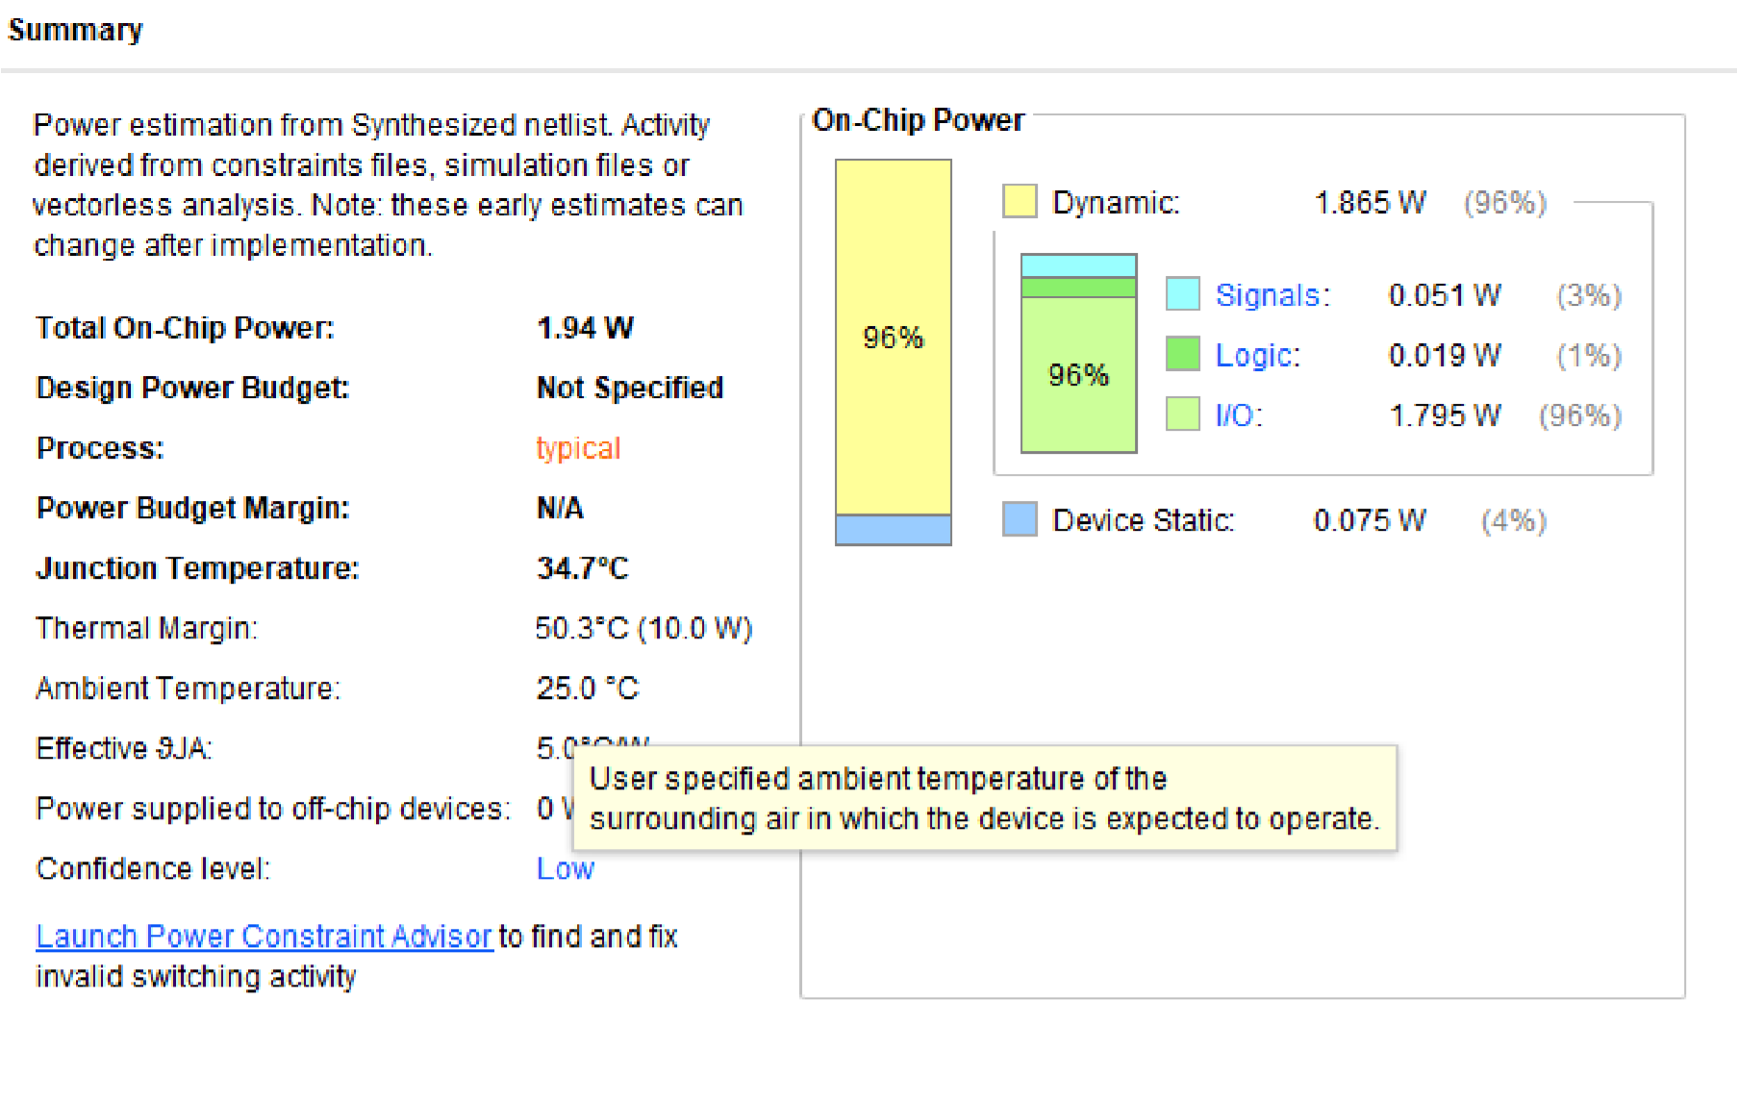

**Output:**

**-**

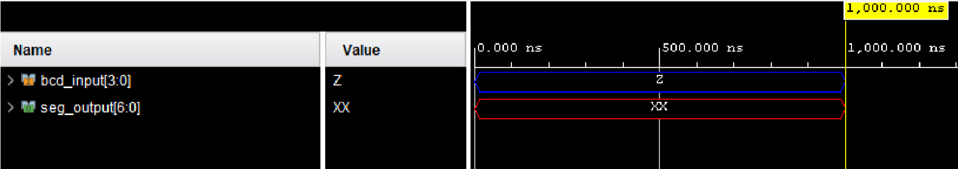

**9)Positive Edge Detector:-**

**Verilog code:-** module and_gate (input a, input b, output y);

assign y = a & b;

endmodule

module or_gate (input a, input b, output y);

assign y = a | b;

endmodule

module not_gate (input a, output y);

assign y = ~a;

endmodule

module positive_edge_detector (input clk, output reg pos_edge_detected);

wire clk_n; wire pos_edge;

not_gate u1 (.a(clk), .y(clk_n));

and_gate u2 (.a(clk), .b(clk_n), .y(pos_edge));

always @(posedge clk) begin pos_edge_detected <= pos_edge;

end

endmodule

**Testbench:-**

module tb_positive_edge_detector;

reg tb_clk;

wire tb_pos_edge_detected;

positive_edge_detector uut (

.clk(tb_clk),

.pos_edge_detected(tb_pos_edge_detected)

);

always begin #5 tb_clk = ~tb_clk; end initial begin tb_clk = 0; #10;

#5 tb_clk = 1;

#10;

$display("Positive Edge Detected: %b", tb_pos_edge_detected);

#5 tb_clk = 0;

#10;

$display("Positive Edge Detected: %b", tb_pos_edge_detected);

$stop; end

endmodule

**RTL schematic:-**

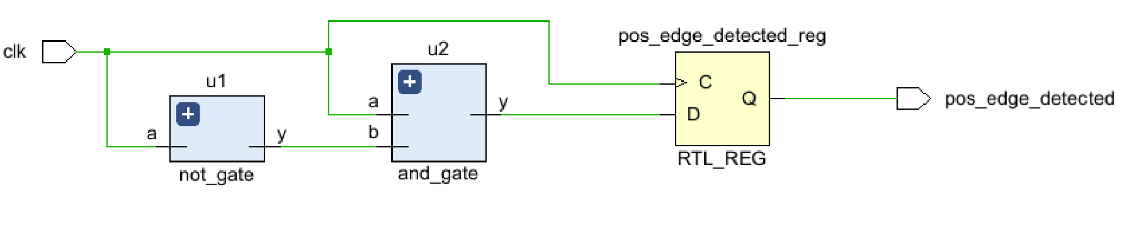

**Synthesis report:-**

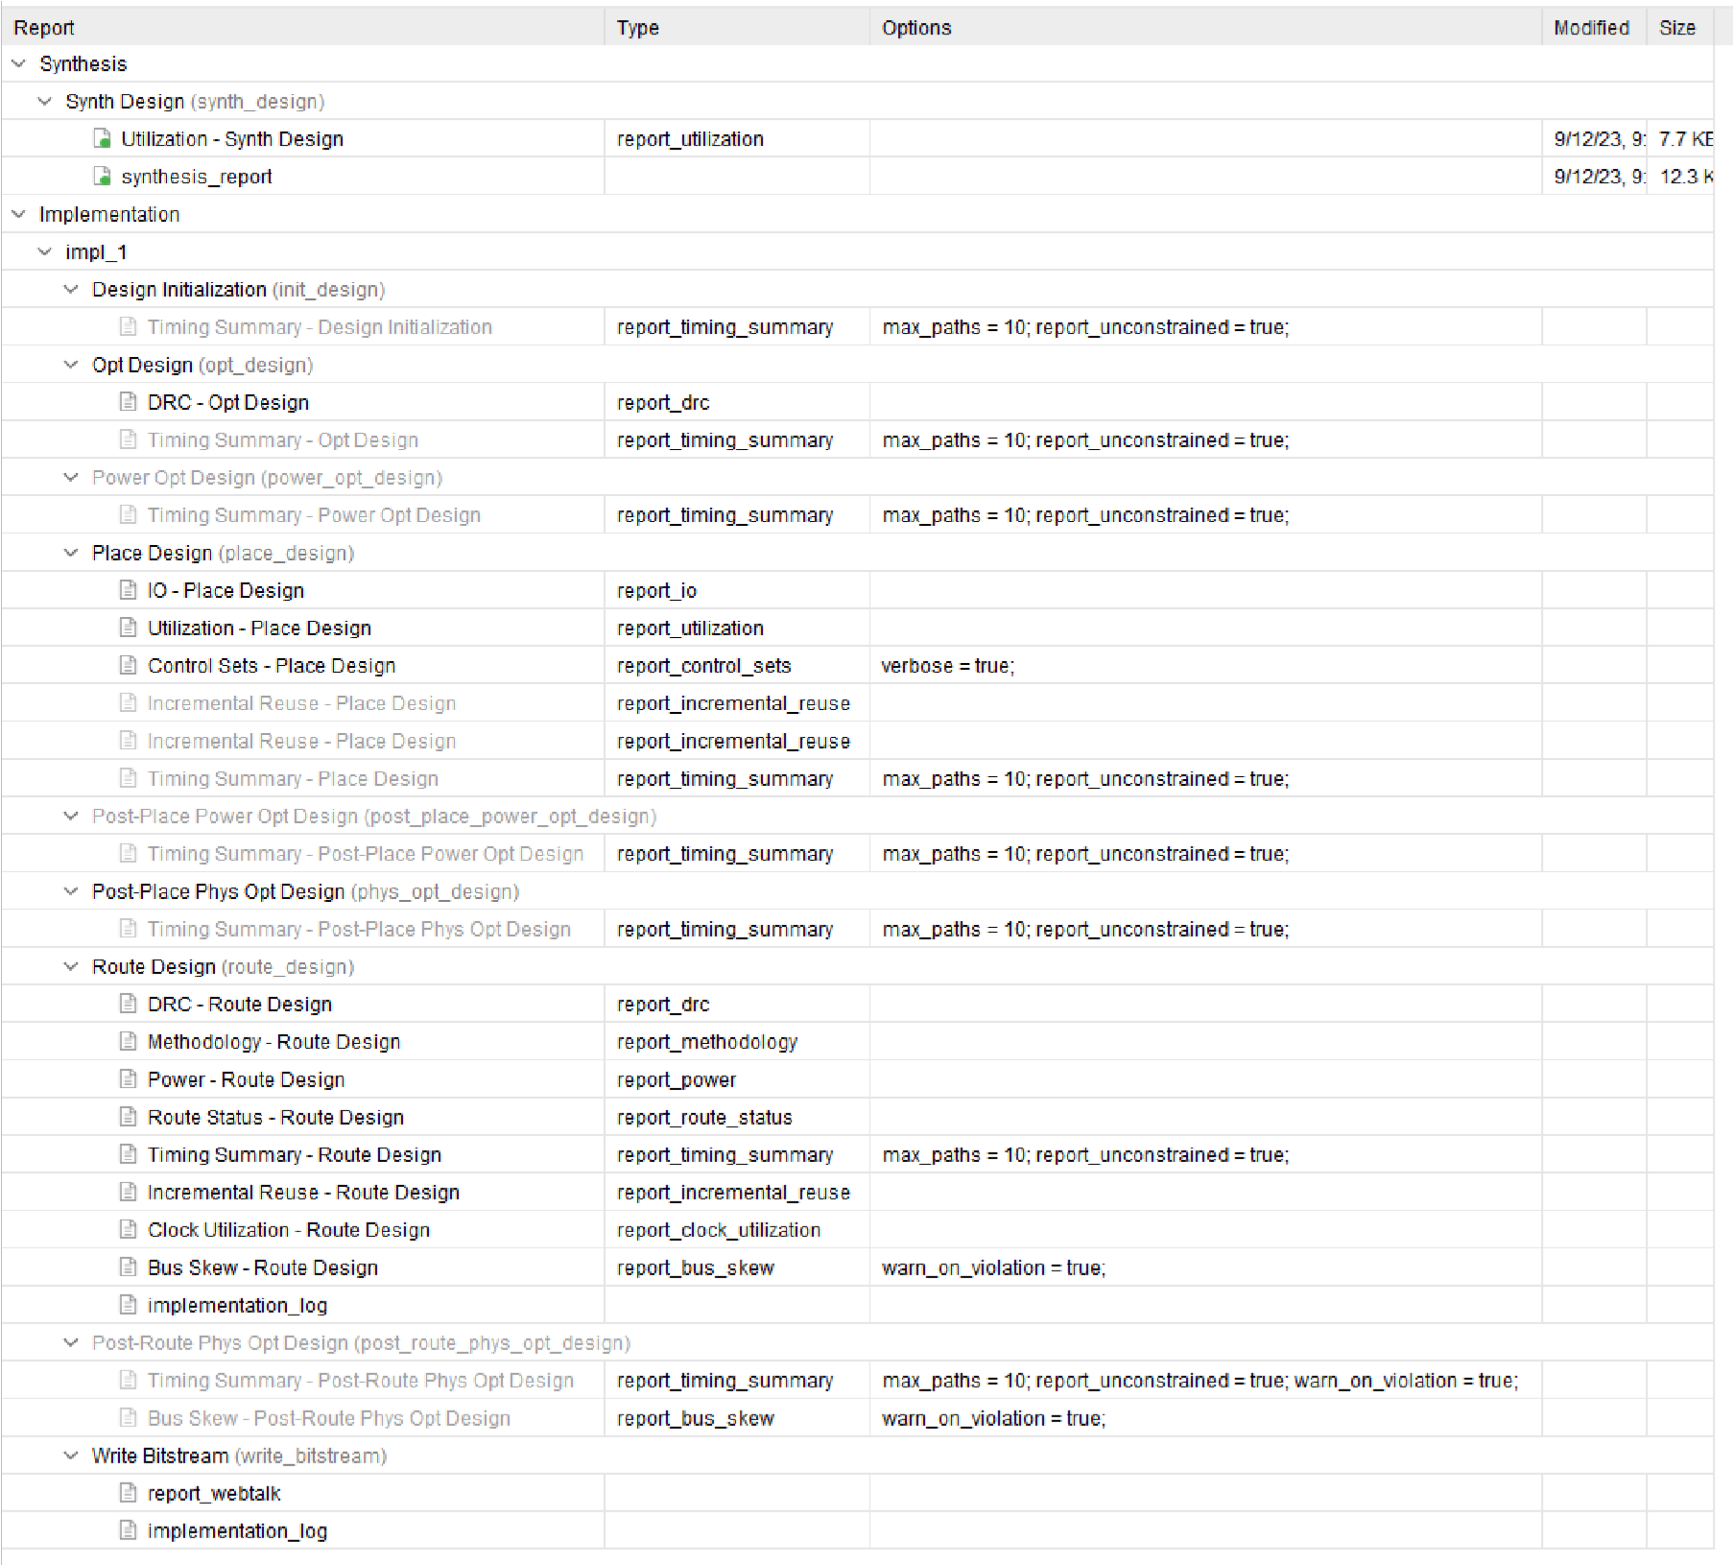

**power report:-**

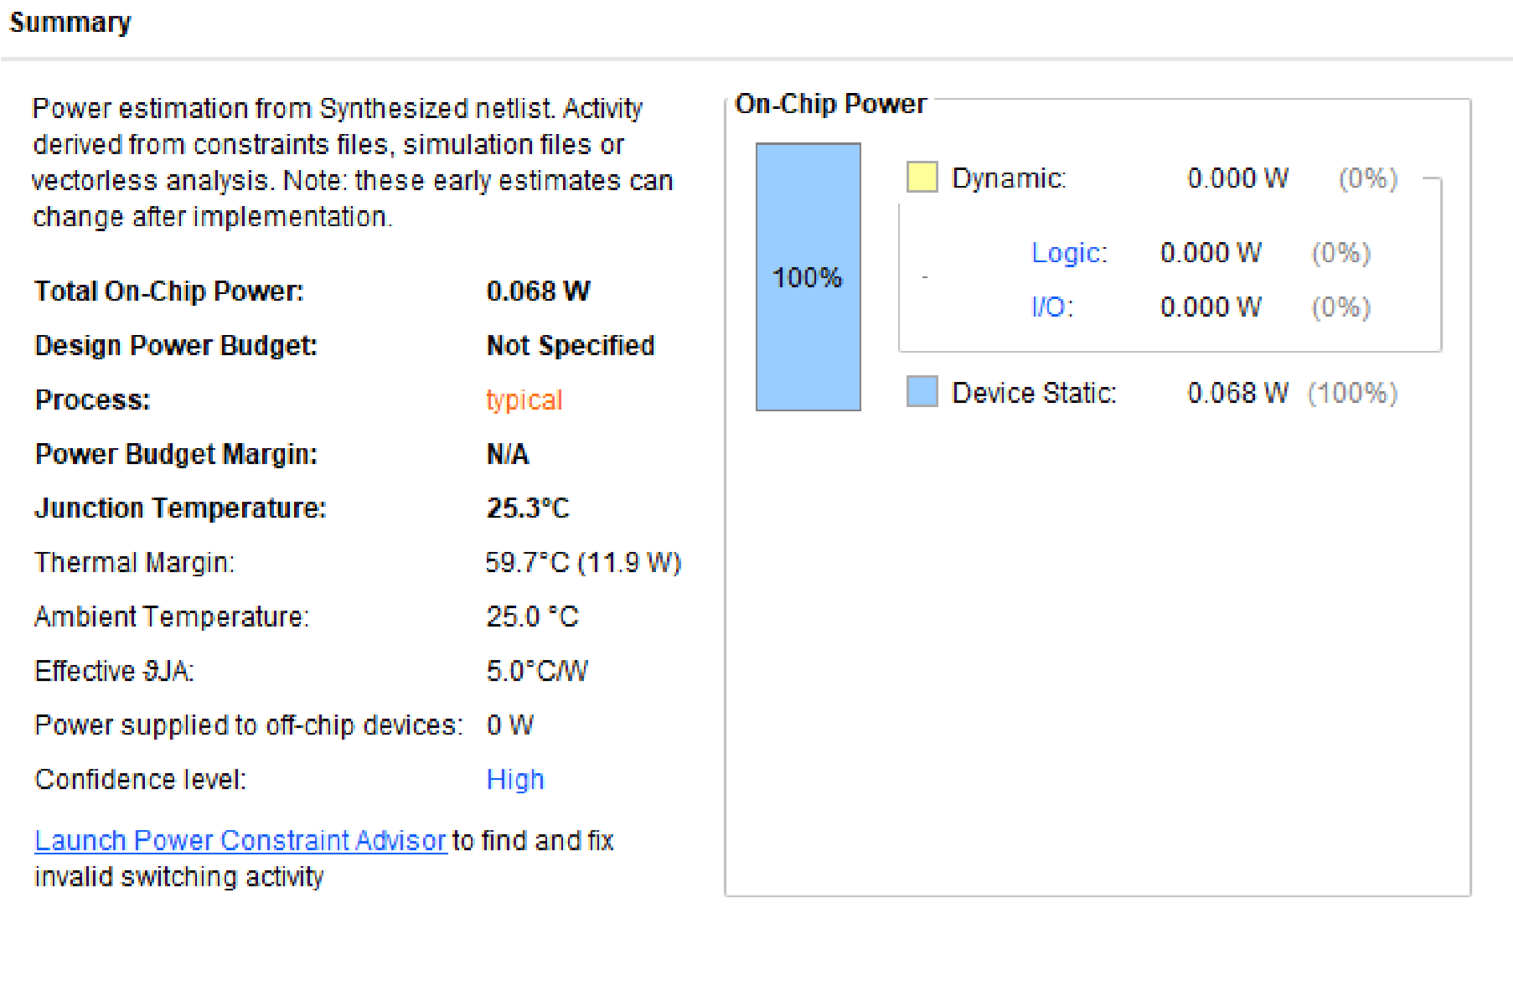

**Output:-**

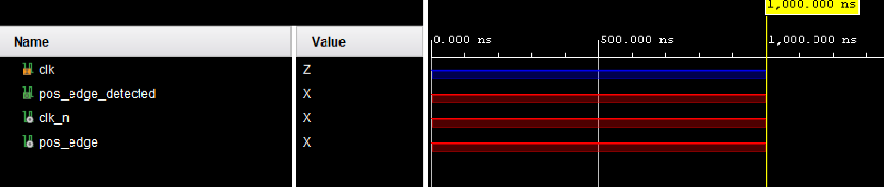

**10)4-Bit Carry Select Adder**

**Verilog code:-** module carry_select_adder (

input [3:0] A, input [3:0] B, input Cin, output [3:0] S, output Cout1, output Cout2

);

wire [3:0] S1, S2;

wire Cout_intermediate;

full_adder u1 (.A(A[0]), .B(B[0]), .Cin(Cin), .S(S1[0]), .Cout(Cout_intermediate));

full_adder u2 (.A(A[1]), .B(B[1]), .Cin(Cout_intermediate), .S(S1[1]),

.Cout(Cout_intermediate));

full_adder u3 (.A(A[2]), .B(B[2]), .Cin(Cout_intermediate), .S(S1[2]),

.Cout(Cout_intermediate)); full_adder u4 (.A(A[3]), .B(B[3]), .Cin(Cout_intermediate), .S(S1[3]), .Cout(Cout1));

full_adder u5 (.A(A[0]), .B(B[0]), .Cin(Cout1), .S(S2[0]), .Cout(Cout_intermediate));

full_adder u6 (.A(A[1]), .B(B[1]), .Cin(Cout_intermediate), .S(S2[1]),

.Cout(Cout_intermediate));

full_adder u7 (.A(A[2]), .B(B[2]), .Cin(Cout_intermediate), .S(S2[2]),

.Cout(Cout_intermediate)); full_adder u8 (.A(A[3]), .B(B[3]), .Cin(Cout_intermediate), .S(S2[3]), .Cout(Cout2));

assign S = {S2, S1};

endmodule

module full_adder (

input A, B, Cin, output S, Cout -

);

xor_gate u1 (.a(A), .b(B), .y(S)); xor_gate u2 (.a(S), .b(Cin), .y(S));

and_gate u3 (.a(A), .b(B), .y(C1)); and_gate u4 (.a(S), .b(Cin), .y(C2)); and_gate u5 (.a(A), .b(Cin), .y(C3));

or_gate u6 (.a(C1), .b(C2), .y(C4)); or_gate u7 (.a(C3), .b(C4), .y(Cout));

endmodule

module xor_gate (input a, input b, output y);

assign y = a ^ b;

endmodule

module and_gate (input a, input b, output y);

assign y = a & b;

endmodule

module or_gate (input a, input b, output y);

assign y = a | b;

endmodule **Testbench:-**

module tb_carry_select_adder;

reg [3:0] tb_A; reg [3:0] tb_B; reg tb_Cin; wire [3:0] tb_S; wire tb_Cout1; wire tb_Cout2;

carry_select_adder uut (

.A(tb_A),

.B(tb_B),

.Cin(tb_Cin),

.S(tb_S),

.Cout1(tb_Cout1),

.Cout2(tb_Cout2)

);

initial begin

tb_A = 4'b0101; tb_B = 4'b0011; tb_Cin = 1'b0;

#10;

$display("A: %b, B: %b, Cin: %b, S: %b, Cout1: %b, Cout2: %b", tb_A, tb_B, tb_Cin, tb_S, tb_Cout1, tb_Cout2);

$stop; end

endmodule

**RTL schematic:-**

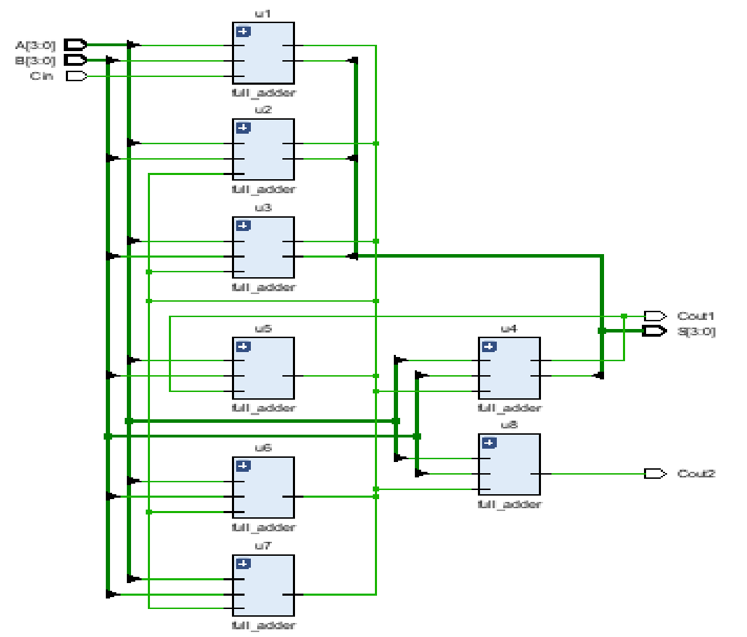

**Synthesis report:-**

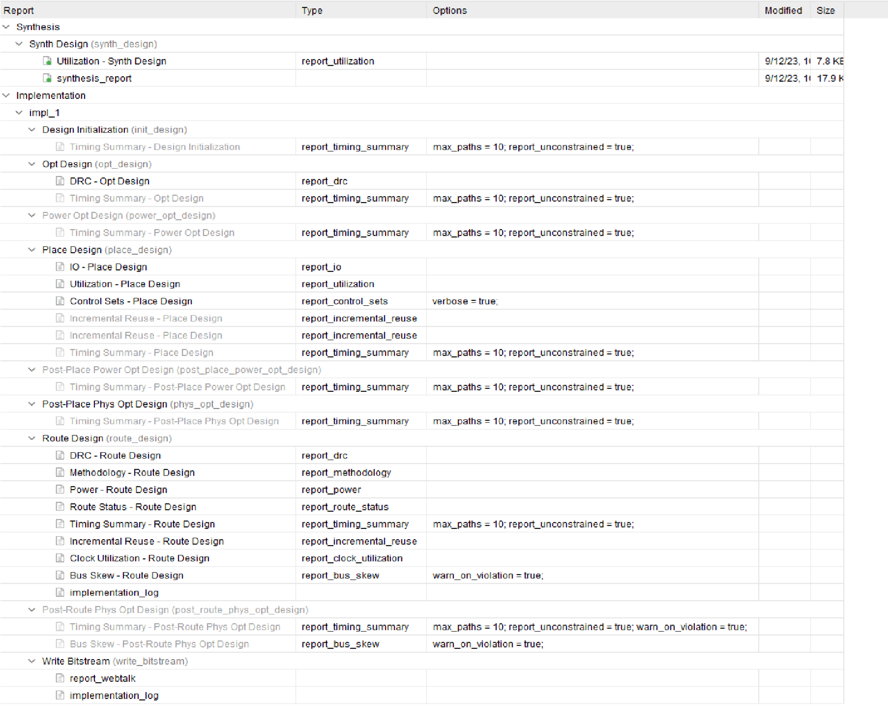

**power report:-**

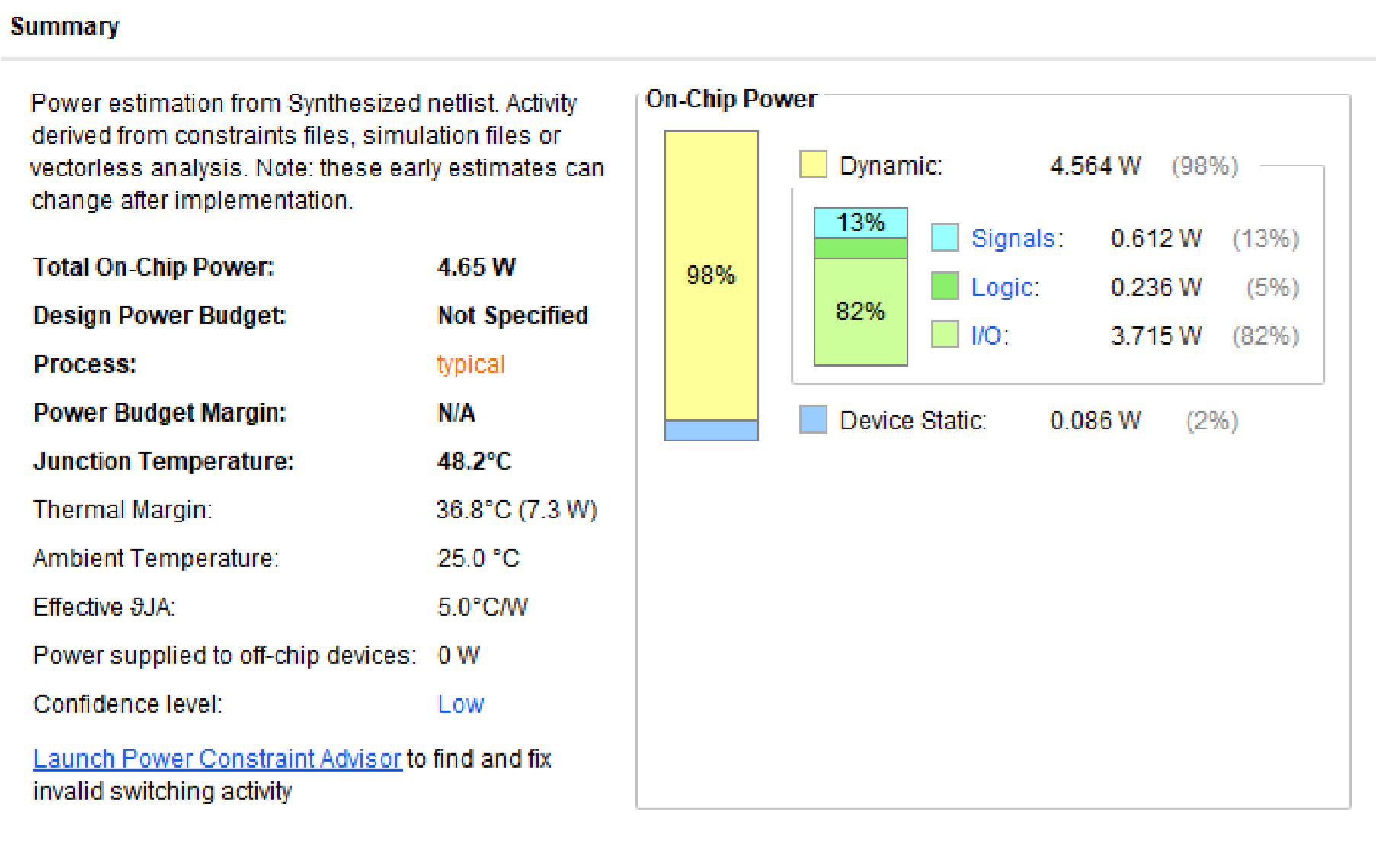

**Output:-**

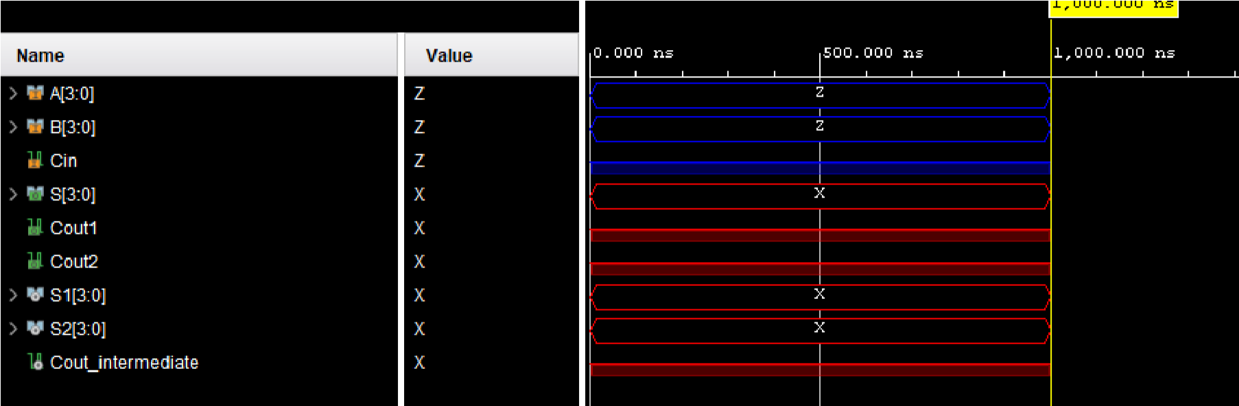

**11) Moore FSM which detects 1010 Sequence**

**Verilog code:-**

module fsm_1010_detector (

input wire clk, input wire rst,

input wire in_data, output reg detect

);

parameter S0 = 2'b00; parameter S1 = 2'b01; parameter S2 = 2'b10; parameter S3 = 2'b11;

reg [1:0] state, next_state;

always @(posedge clk or posedge rst) begin

if (rst) begin state <= S0; end else begin state <= next_state; end end always @* begin

case(state)

S0: next_state = (in_data == 1'b1) ? S1 : S0;

S1: next_state = (in_data == 1'b0) ? S2 : S0;

S2: next_state = (in_data == 1'b1) ? S3 : S0; S3: next_state = (in_data == 1'b0) ? S0 : S0; default: next_state = S0; endcase end

always @* begin

detect = (state == S3); end

endmodule **Testbench:-**

module tb_fsm_1010_detector;

parameter CLK_PERIOD = 10; parameter SIM_TIME = 100;

reg clk, rst, in_data; wire detect;

fsm_1010_detector uut (

.clk(clk),

.rst(rst),

.in_data(in_data),

.detect(detect)

);

always #((CLK_PERIOD / 2)) clk = ~clk;

initial begin

clk = 0; rst = 1;

in_data = 0;

#10 rst = 0;

#10 in_data = 1; // State S1

#10 in_data = 0; // State S2

#10 in_data = 1; // State S0

#10 in_data = 0; // State S0

#10 in_data = 1; // State S0

#10 in_data = 1; // State S1

#10 in_data = 0; // State S2

#10 in_data = 1; // State S3

#10 in_data = 0; // State S0

#10 in_data = 1; // State S1

#10 in_data = 0; // State S2

#10 in_data = 1; // State S0

#10 in_data = 0; // State S0

#10 in_data = 1; // State S0 #10 $finish; end

endmodule

**RTL schematic:-**

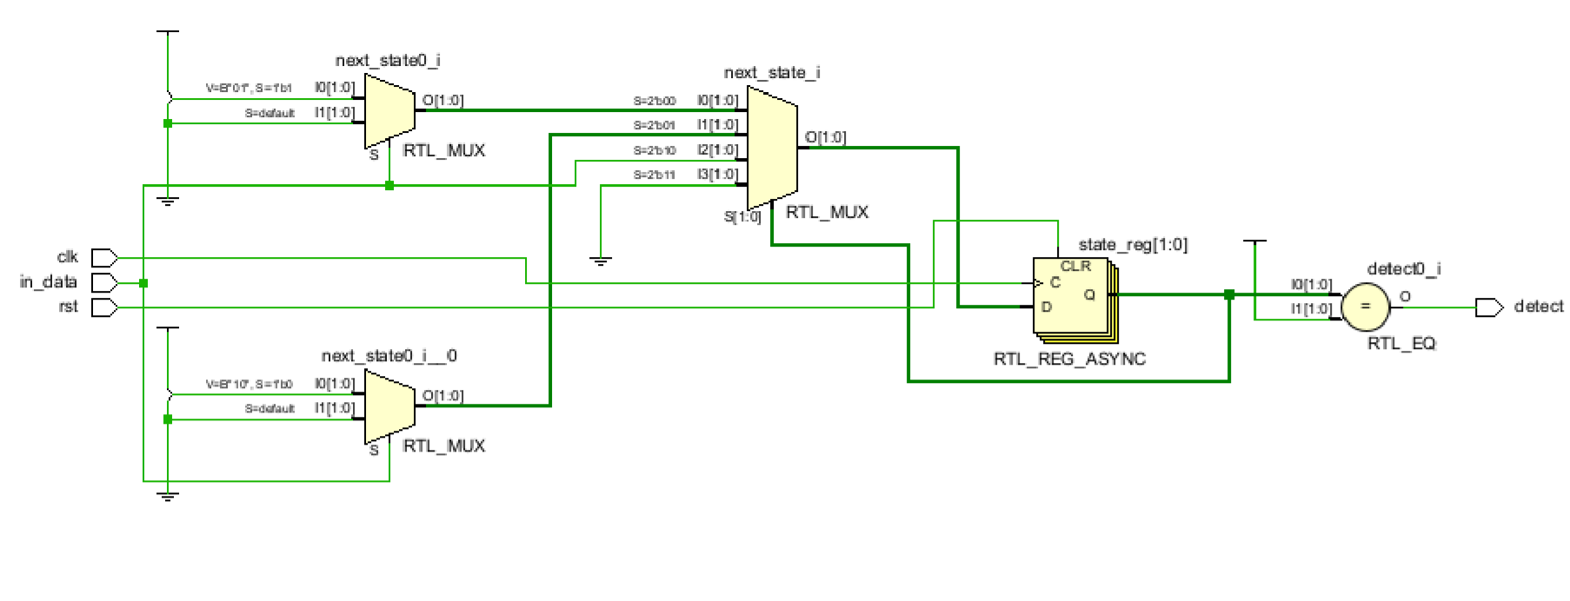

**Synthesis report:-**

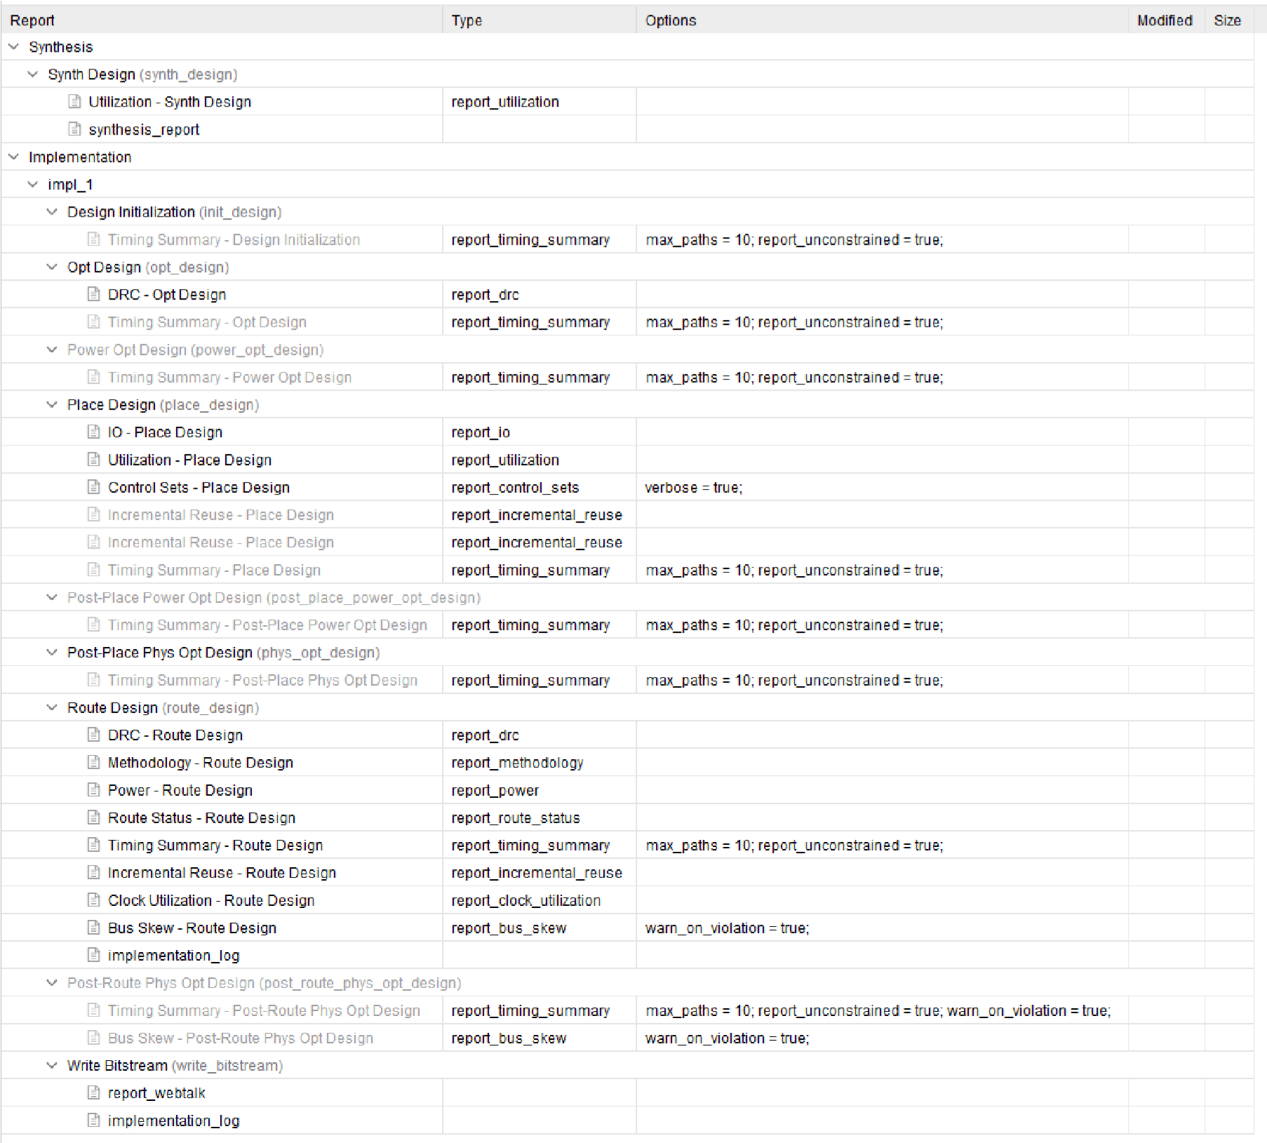

**power report:-**

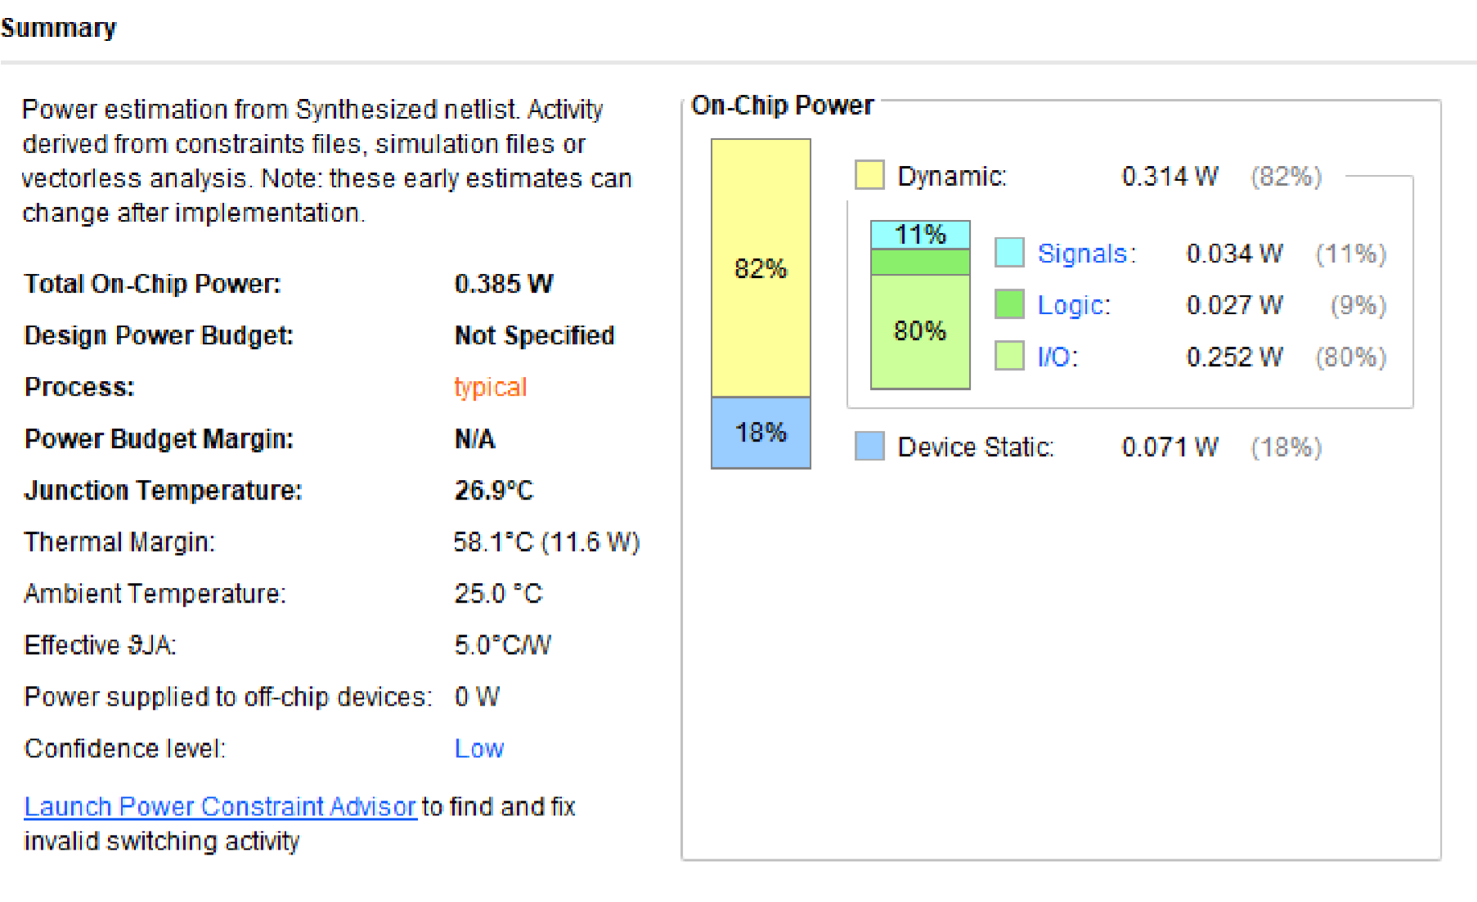

**Output:-**

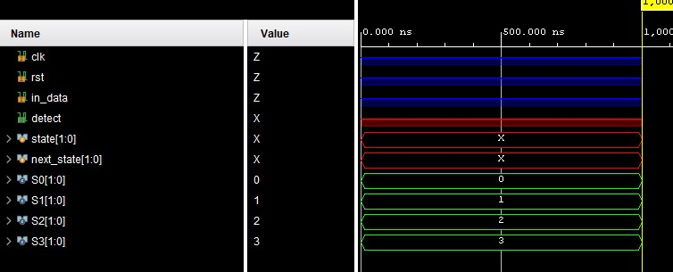

**12)N:1 Multiplexer**

**Verilog code:-** module mux_4to1 (

input wire [3:0] data_in, input wire [1:0] sel, output reg out

);

always @* begin

case(sel)

2'b00: out = data_in[0];

2'b01: out = data_in[1];

2'b10: out = data_in[2]; 2'b11: out = data_in[3]; default: out = 1'b0; endcase end

endmodule **Testbench:-**

module tb_mux_4to1;

parameter CLK_PERIOD = 10; parameter SIM_TIME = 100;

reg [3:0] data_in; reg [1:0] sel; wire out; mux_4to1 uut (

.data_in(data_in),

.sel(sel),

.out(out)

);

initial begin

data_in = 4'b0000; sel = 2'b00;

#10 sel = 2'b00;

#10 data_in = 4'b1010;

#10 sel = 2'b10;

#10 data_in = 4'b0110;

#10 sel = 2'b01;

#10 data_in = 4'b1100;

#10 sel = 2'b11;

#10 data_in = 4'b0011;

#10 $finish; end

Endmodule

**RTL schematic:-**

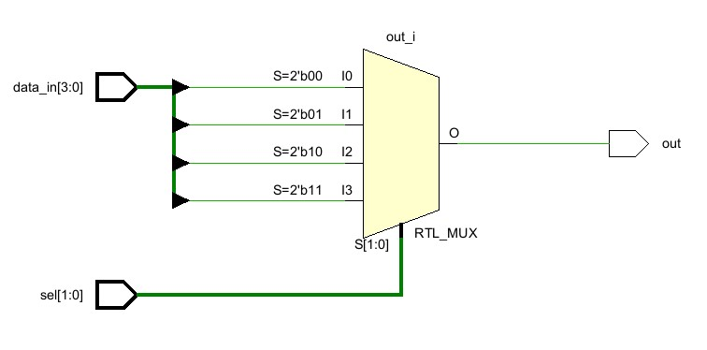

**Synthesis report:-**

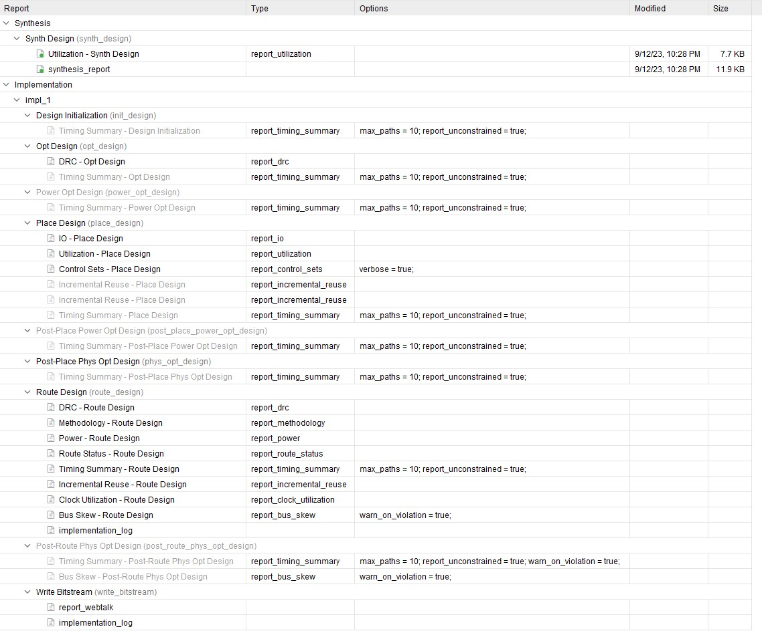

**power report:-**

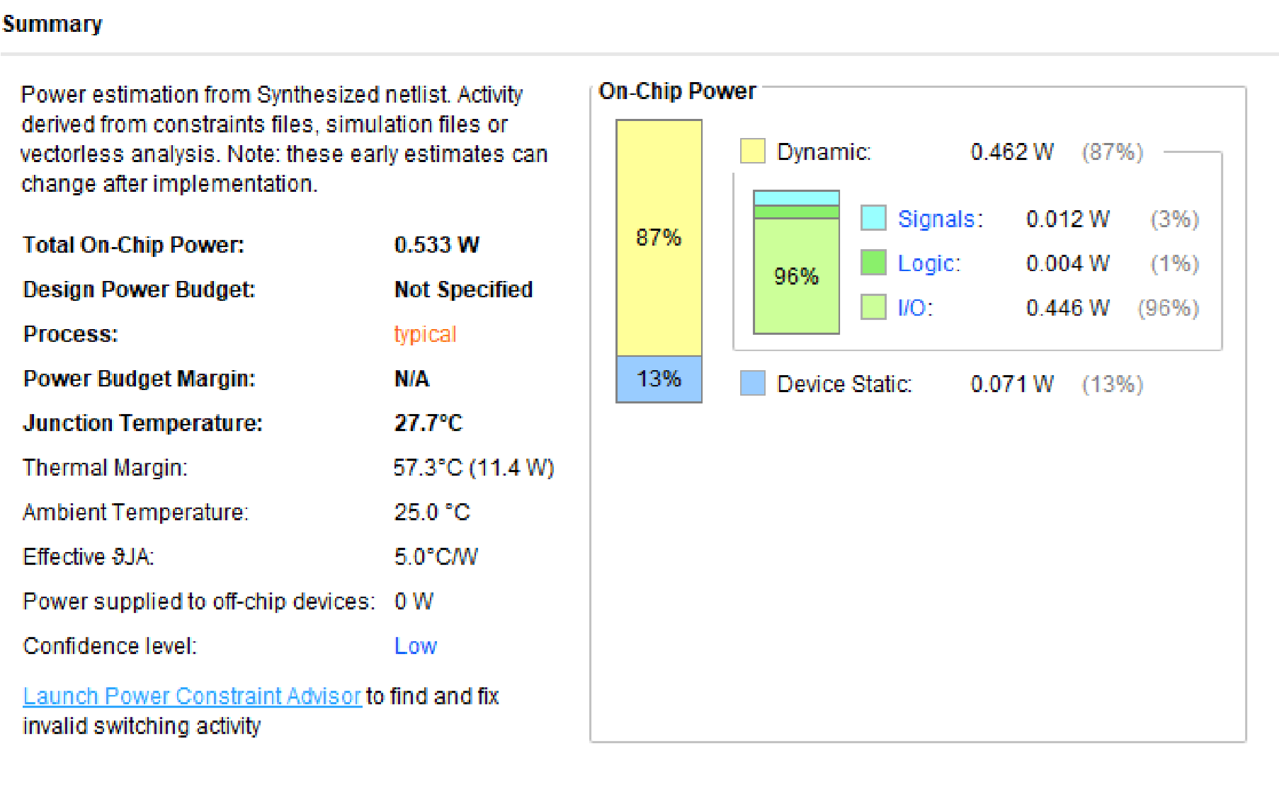

**Output:-**

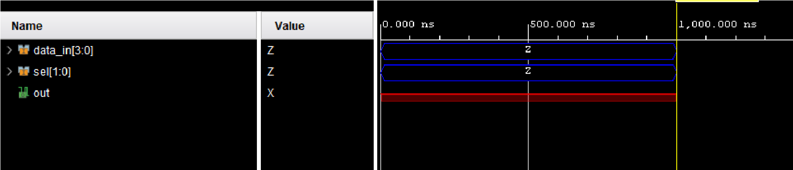

**13) Write RTL code for a BCD counter**

**Verilog code:-** module bcd_counter_24hr (

input wire clk, input wire rst, output reg [3:0] hr, output reg [3:0] min, output reg [3:0] sec

);

reg [3:0] count_hr, count_min, count_sec;

always @(posedge clk or posedge rst) begin

if (rst) begin

count_hr <= 4'b0000; count_min <= 4'b0000; count_sec <= 4'b0000; end else begin if (count_sec == 4'b1001) begin count_sec <= 4'b0000; if (count_min == 4'b1001) begin count_min <= 4'b0000; if (count_hr == 4'b0011) begin count_hr <= 4'b0000; end else begin count_hr <= count_hr + 4'b0001;

end

end else begin

count_min <= count_min + 4'b0001;

end

end else begin count_sec <= count_sec + 4'b0001;

end end end

always @* begin

hr = count_hr; min = count_min; sec = count_sec; end

endmodule **Testbench:-**

module tb_bcd_counter_24hr;

parameter CLK_PERIOD = 10; parameter SIM_TIME = 1000;

reg clk, rst; wire [3:0] hr, min, sec;

bcd_counter_24hr uut (

.clk(clk),

.rst(rst),

.hr(hr),

.min(min),

.sec(sec)

);

always #((CLK_PERIOD / 2)) clk = ~clk;

initial begin

clk = 0; rst = 1;

#10 rst = 0;

#SIM_TIME;

#10 $finish; end

endmodule

**RTL schematic:-**

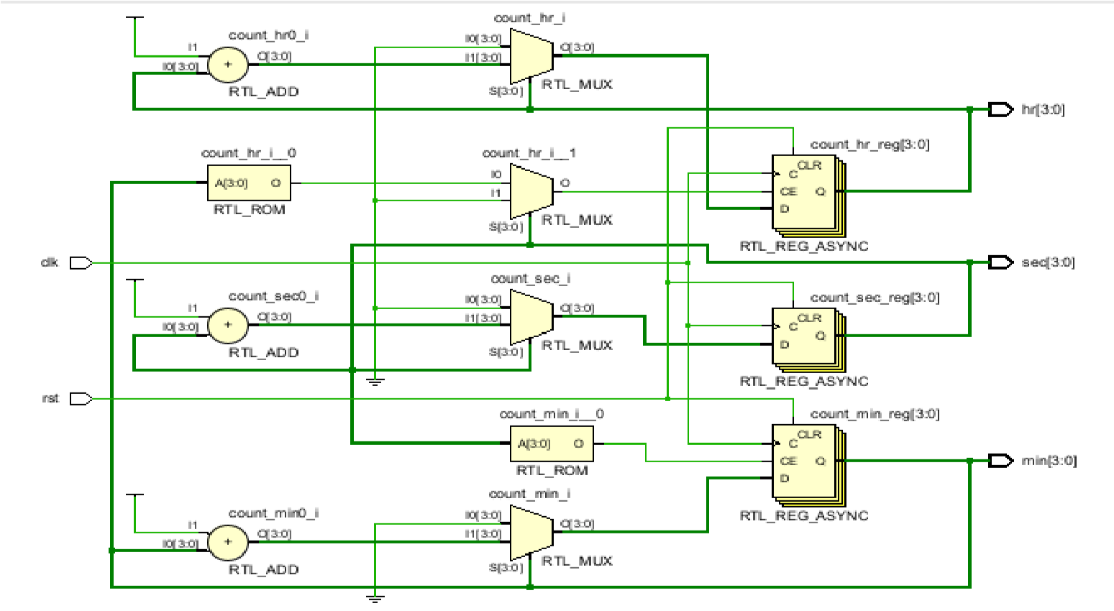

**Synthesis report:-**

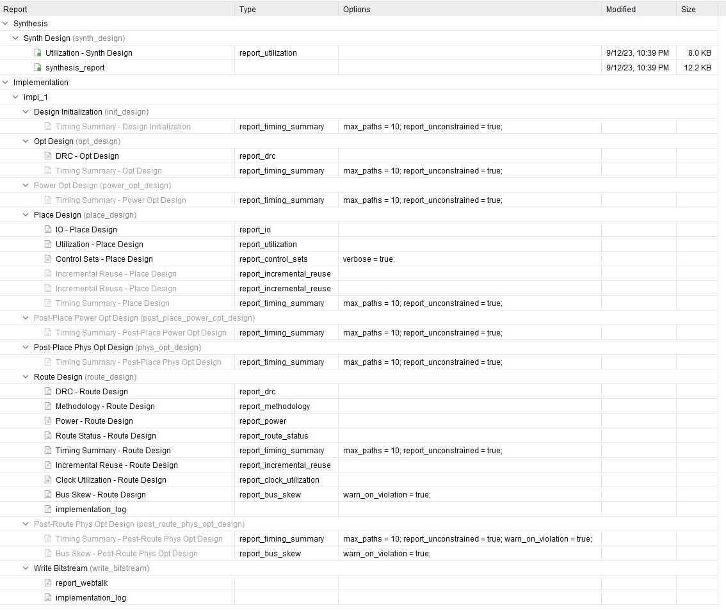

**power report:-**

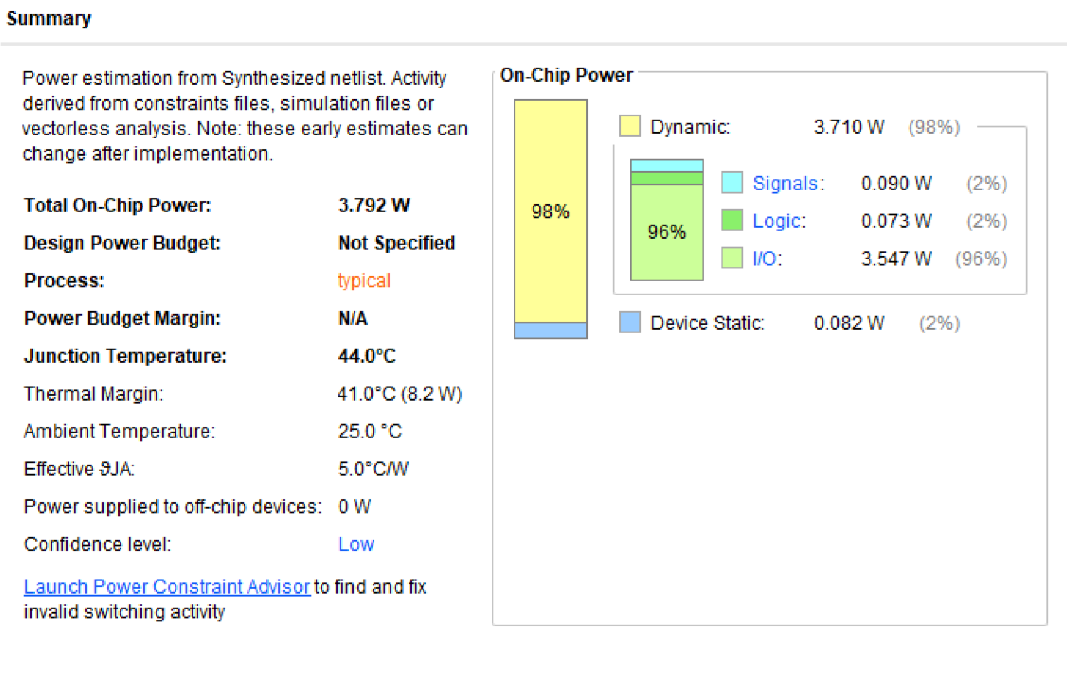

**Output:-**

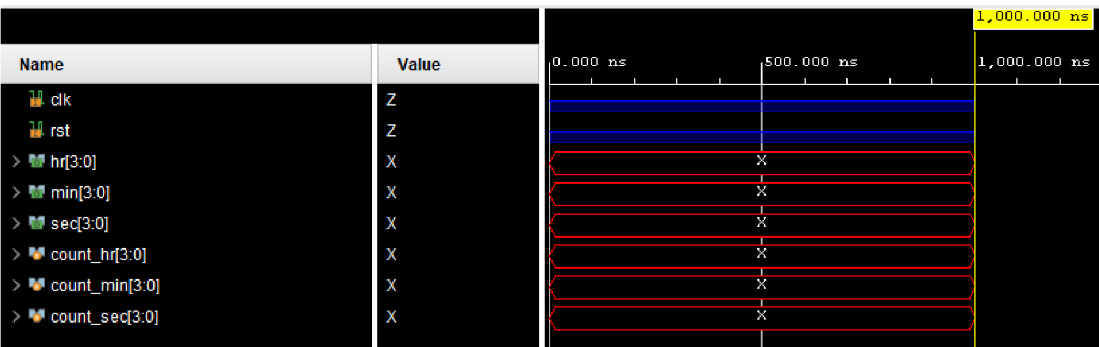

**14)3-to-1 1-bit MUX with a 1-bit latch**

**Verilog code:-** module mux_3to1_with_latch (

input wire a, input wire b, input wire c, input wire sel, input wire en, output reg out

);

always @(a, b, c, sel) begin

case (sel)

2'b00: out = a;

2'b01: out = b; 2'b10: out = c; default: out = 1'b0;) endcase end

always @(posedge en) begin

if (en) begin case (sel)

2'b00: out <= a;

2'b01: out <= b; 2'b10: out <= c; default: out <= 1'b0; endcase end

endmodule

**Testbench:-**

module tb_mux_3to1_with_latch;

parameter CLK_PERIOD = 10;

reg a, b, c, sel, en; wire out;

mux_3to1_with_latch uut (

.a(a),

.b(b),

.c(c),

.sel(sel),

.en(en),

.out(out)

);

initial begin a = 0; b = 1; c = 0; sel = 2'b00; en = 1;

#10 sel = 2'b00;

#10 a = 1;

#10 sel = 2'b01;

#10 b = 0;

#10 sel = 2'b10;

#10 c = 1;

#10 en = 0;

#10 c = 0;

#10 a = 1;

#10 b = 1;

#10 en = 1;

#10 b = 0;

#10 $finish; end

endmodule

**RTL schematic:-**

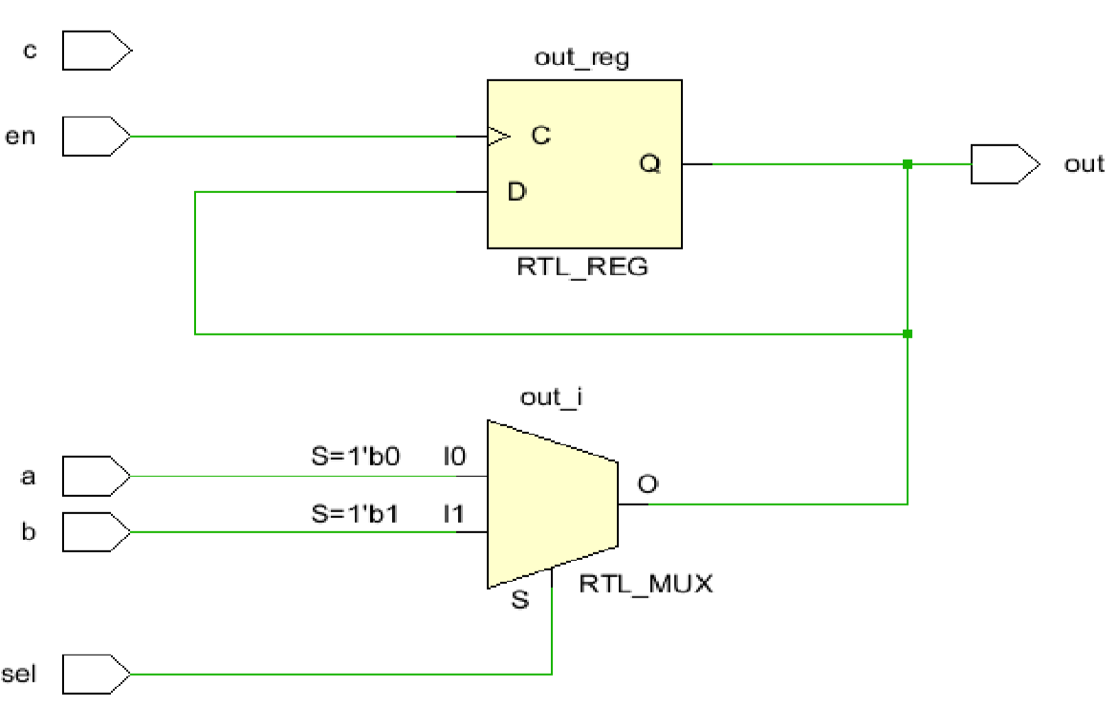

**Synthesis report:-**

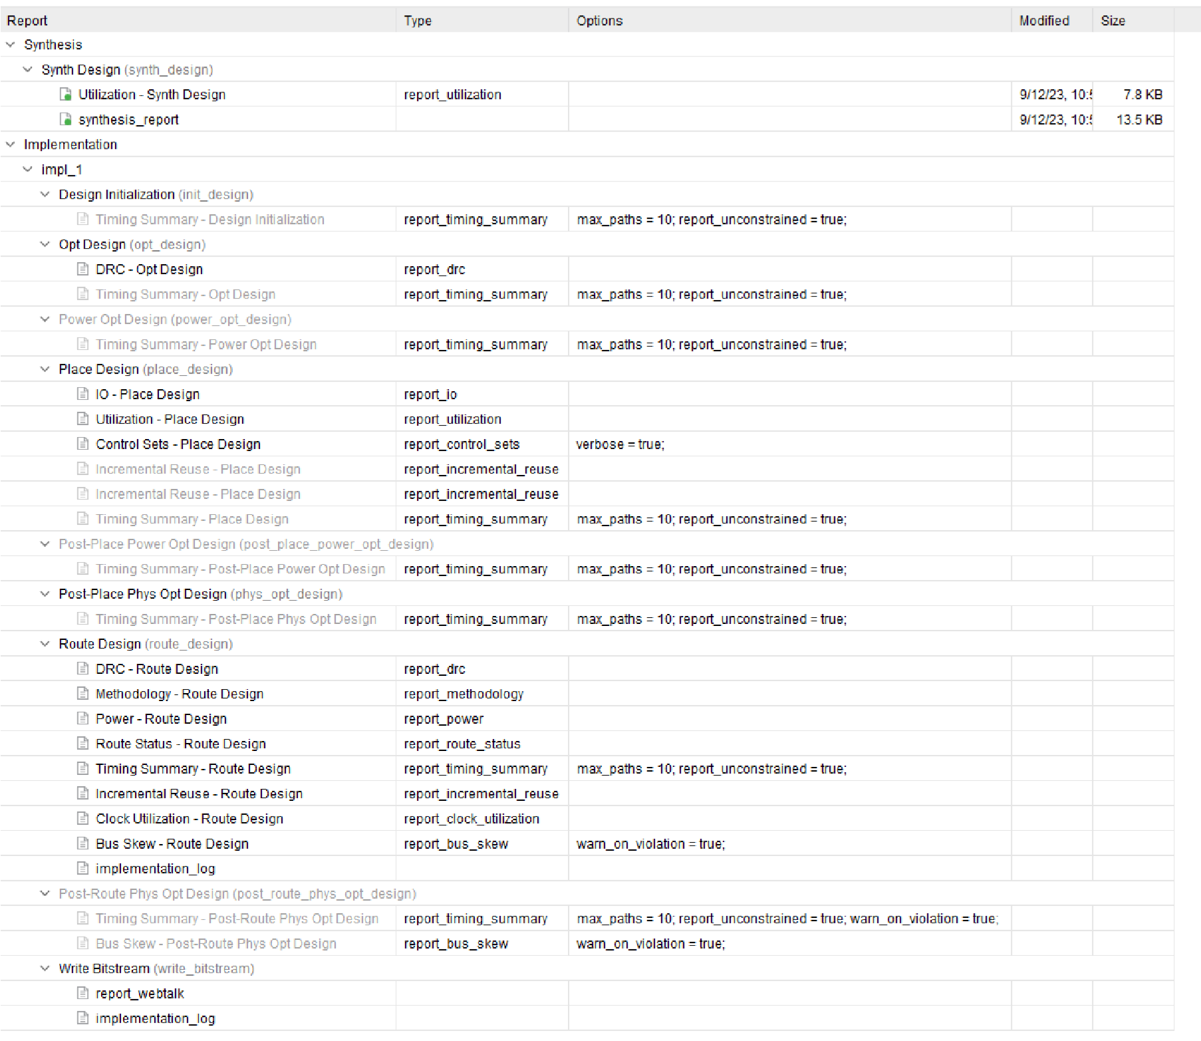

**power report:-**

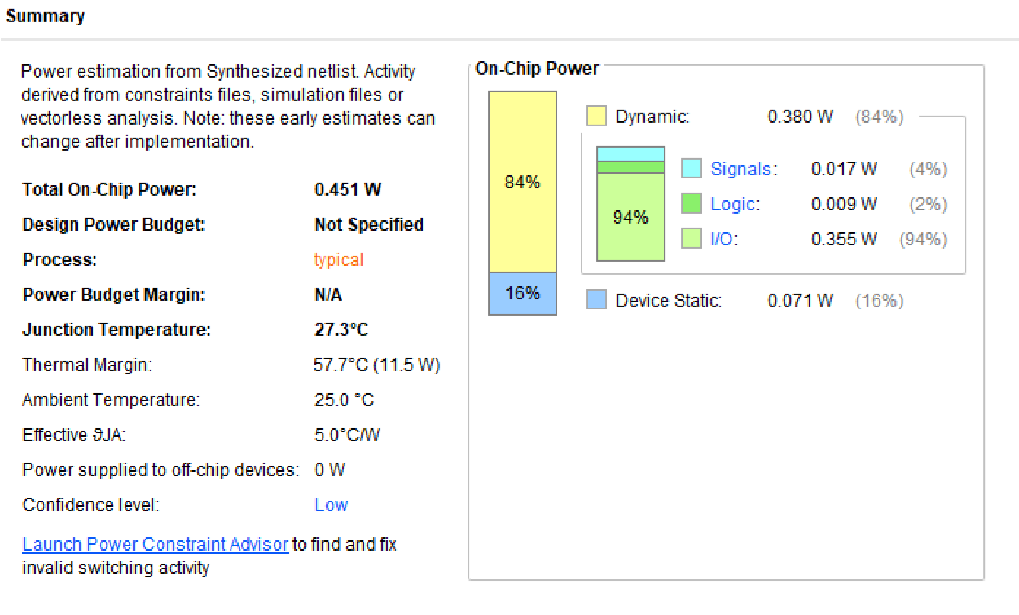

**Output:-**

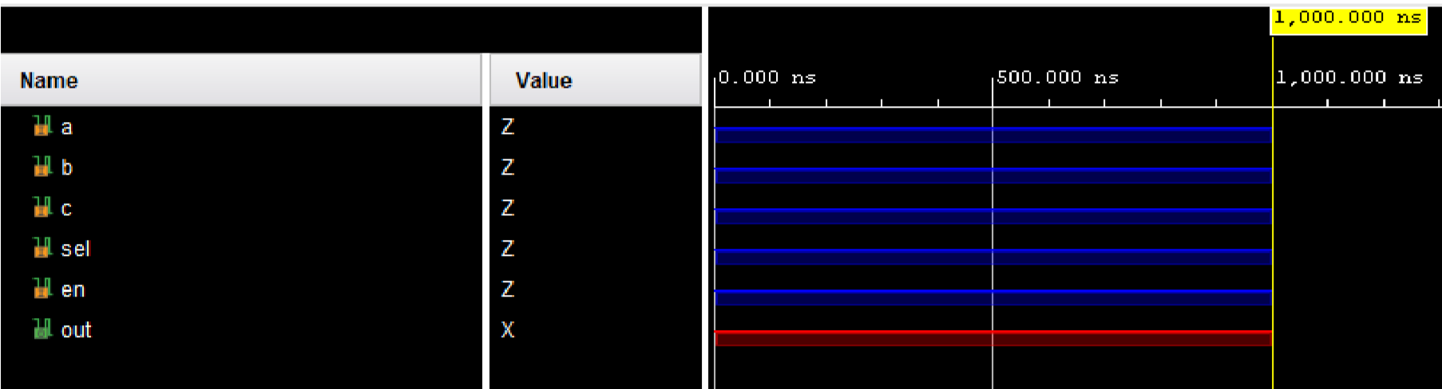

**15) BCD to Seven Segment Display**

**Verilog code:-** module bcd_to_7seg_decoder (

input [3:0] bcd, output reg [6:0] seg

);

always @* begin

case(bcd)

4'b0000: seg = 7'b1000000;

4'b0001: seg = 7'b1111001;

4'b0010: seg = 7'b0100100;

4'b0011: seg = 7'b0110000;

4'b0100: seg = 7'b0011001;

4'b0101: seg = 7'b0010010;

4'b0110: seg = 7'b0000010;

4'b0111: seg = 7'b1111000;

4'b1000: seg = 7'b0000000; 4'b1001: seg = 7'b0011000; default: seg = 7'b1111111; endcase end

endmodule **Testbench:-**

module tb_bcd_to_7seg_decoder; parameter CLK_PERIOD = 10;

reg [3:0] bcd;

wire [6:0] seg;

bcd_to_7seg_decoder uut (

.bcd(bcd),

.seg(seg)

);

initial begin

bcd = 4'b0000;

#10 bcd = 4'b0000;

#10 bcd = 4'b0001;

#10 bcd = 4'b0010;

#10 bcd = 4'b0101;

#10 bcd = 4'b1001;

#10 bcd = 4'b1010; #10 $finish; end

endmodule

**RTL schematic:-**

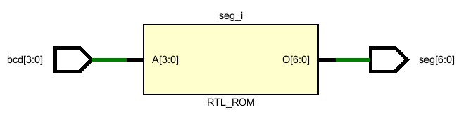

**Synthesis report:-**

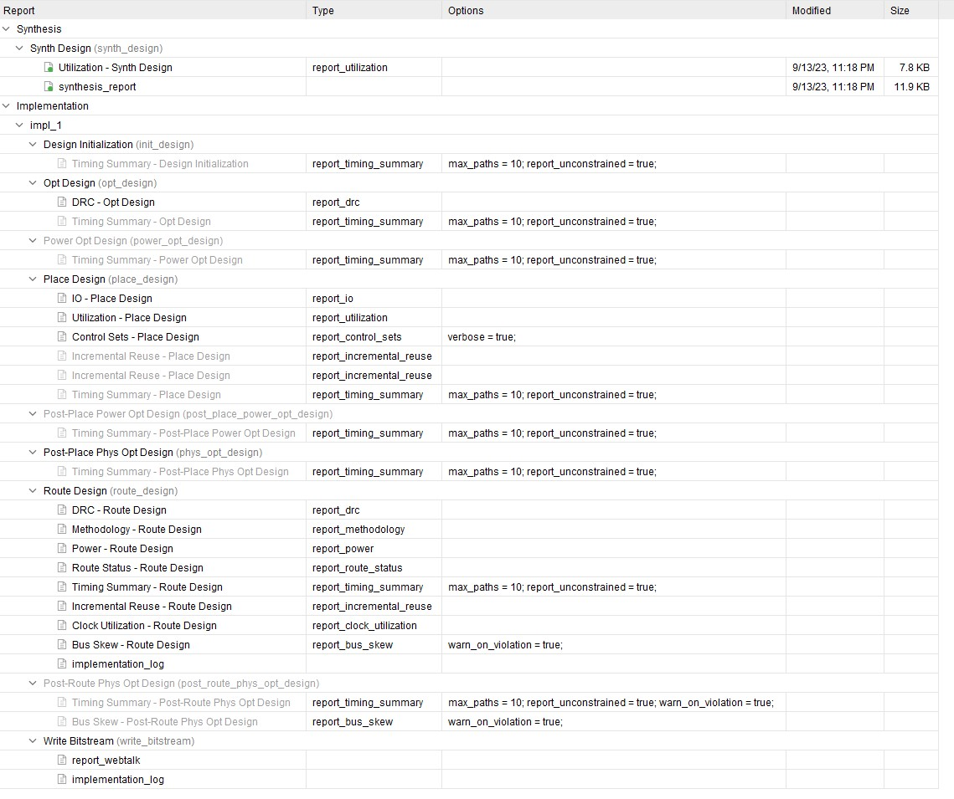

**power report:-**

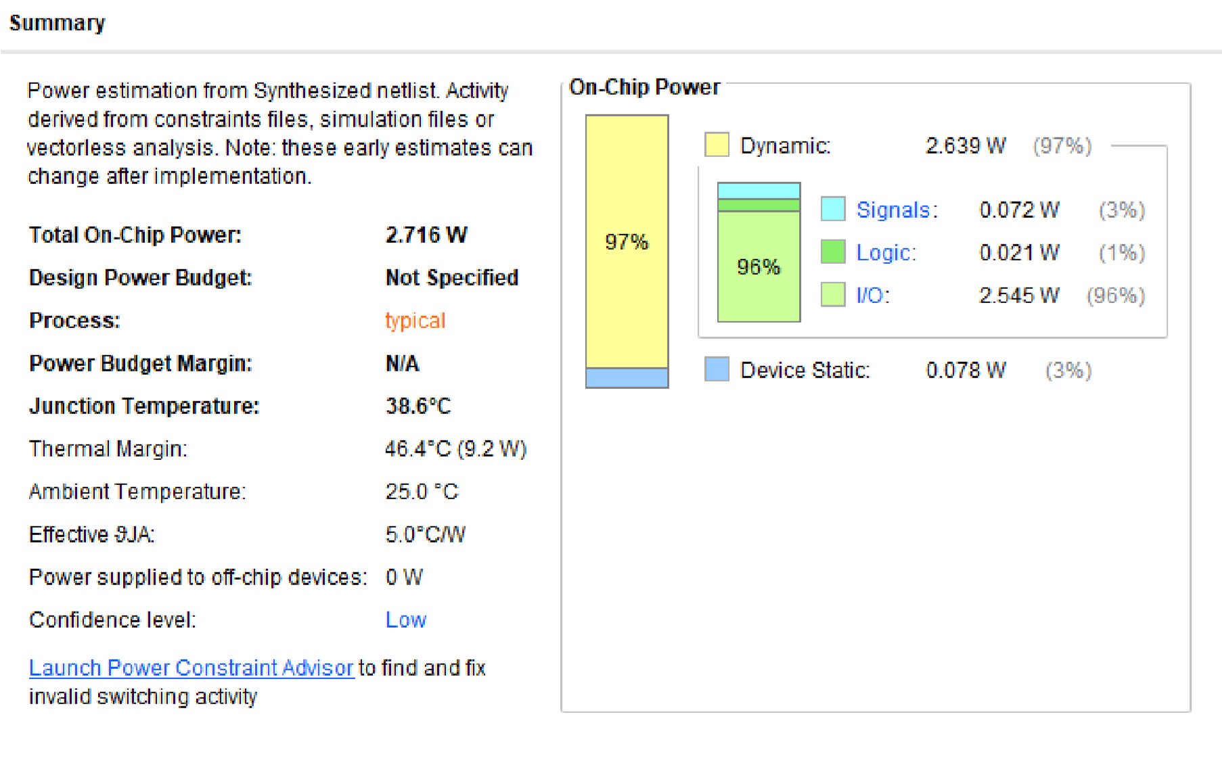

**Output:-**

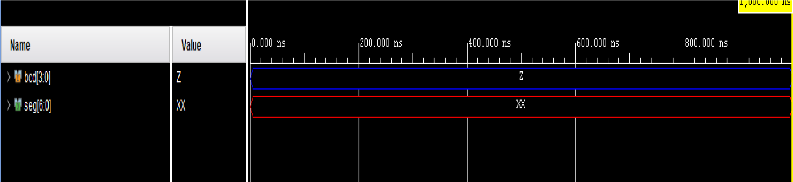

**16) D Latch using 2:1 Mux**

**Verilog code:-** module d_latch_using_mux_behavioral (

input wire d, input wire en, input wire clk, output reg q, output reg nq

);

always @* begin

if (en) begin

q = d; nq = ~d; end end

endmodule **Testbench:-**

module tb_d_latch_using_mux_behavioral; parameter CLK_PERIOD = 10;

reg d, en, clk; wire q, nq;

d_latch_using_mux_behavioral uut (

.d(d),

.en(en),

.clk(clk),

.q(q),

.nq(nq)

);

always #((CLK_PERIOD / 2)) clk = ~clk; initial begin

d = 0; en = 0; clk = 0;

#10 d = 1;

#10 en = 0;

#10 en = 1;

#10 d = 0;

#10 en = 0;

#10 $finish; end

endmodule

**RTL schematic:-**

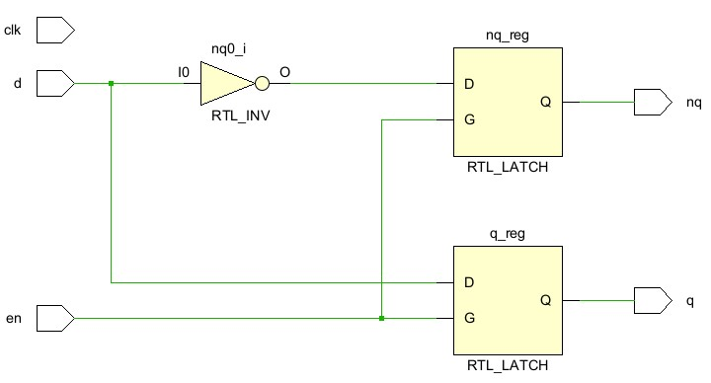

**Synthesis report:-**

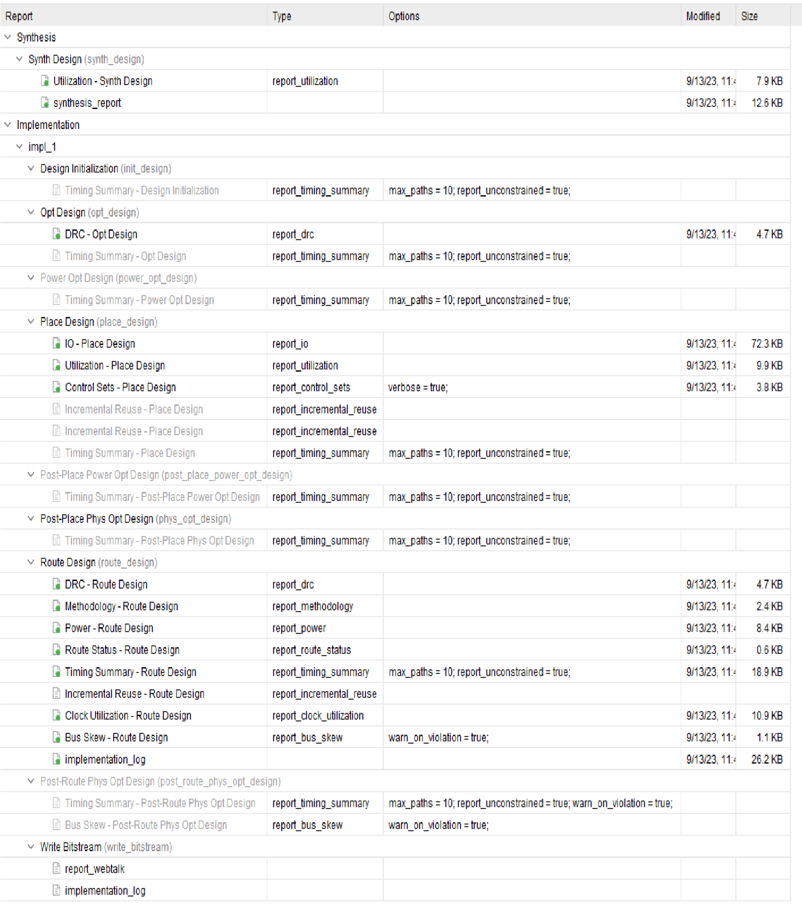

**power report:-**

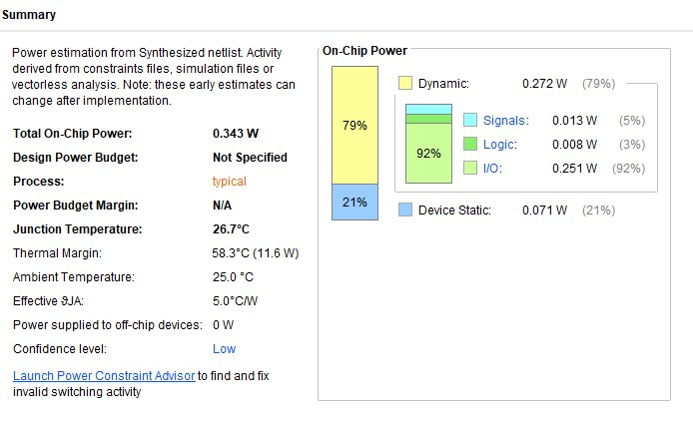

**Output:-**

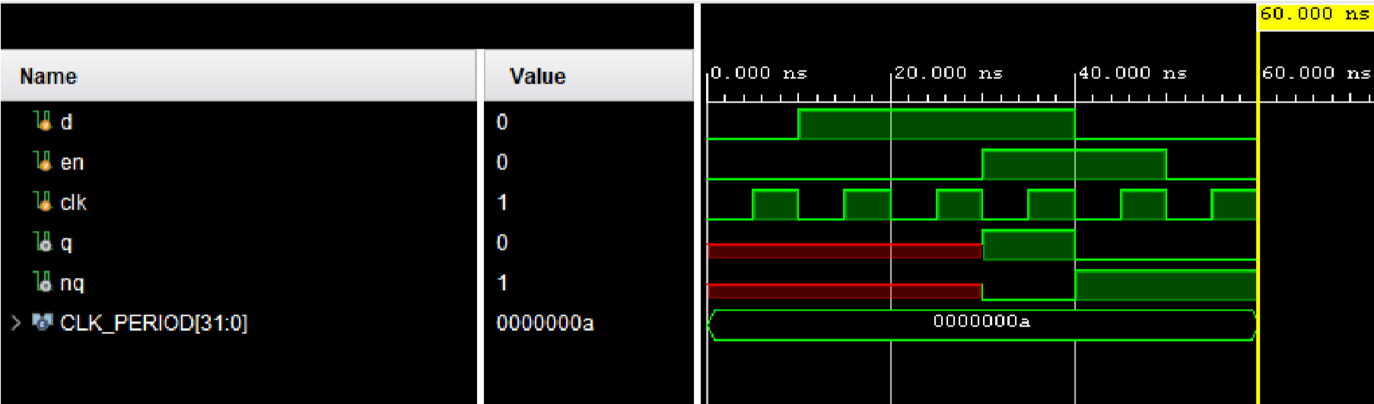

**17) 8-Bit Barrel Shifter**

**Verilog code:-** module barrel_shifter_8bit ( input wire [7:0] data_in, input wire [2:0] shift_amt, input wire direction, output reg [7:0] data_out

);

wire [7:0] shifted_data;

assign shifted_data = (direction) ? (data_in >> shift_amt) : (data_in << shift_amt);

always @* begin data_out = shifted_data; end

endmodule

**Testbench:-**

module tb_barrel_shifter_8bit; parameter CLK_PERIOD = 10;

reg [7:0] data_in; reg [2:0] shift_amt; reg direction; wire [7:0] data_out; barrel_shifter_8bit uut ( .data_in(data_in), .shift_amt(shift_amt),

.direction(direction),

.data_out(data_out)

);

initial begin data_in = 8'b11001100; shift_amt = 3'b001; direction = 1;

#10 shift_amt = 3'b001;

#10 direction = 0;

#10 shift_amt = 3'b010;

#10 shift_amt = 3'b000;

#10 $finish; end

endmodule

**RTL schematic:-**

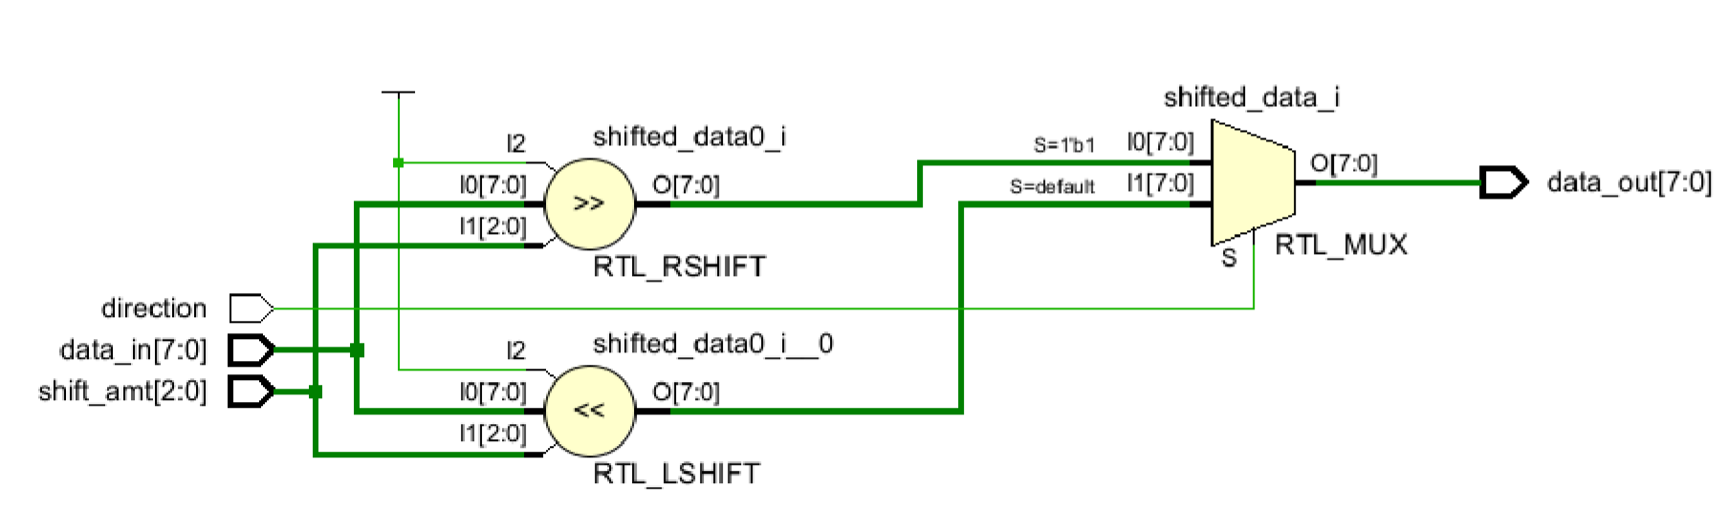

**Synthesis report:-**

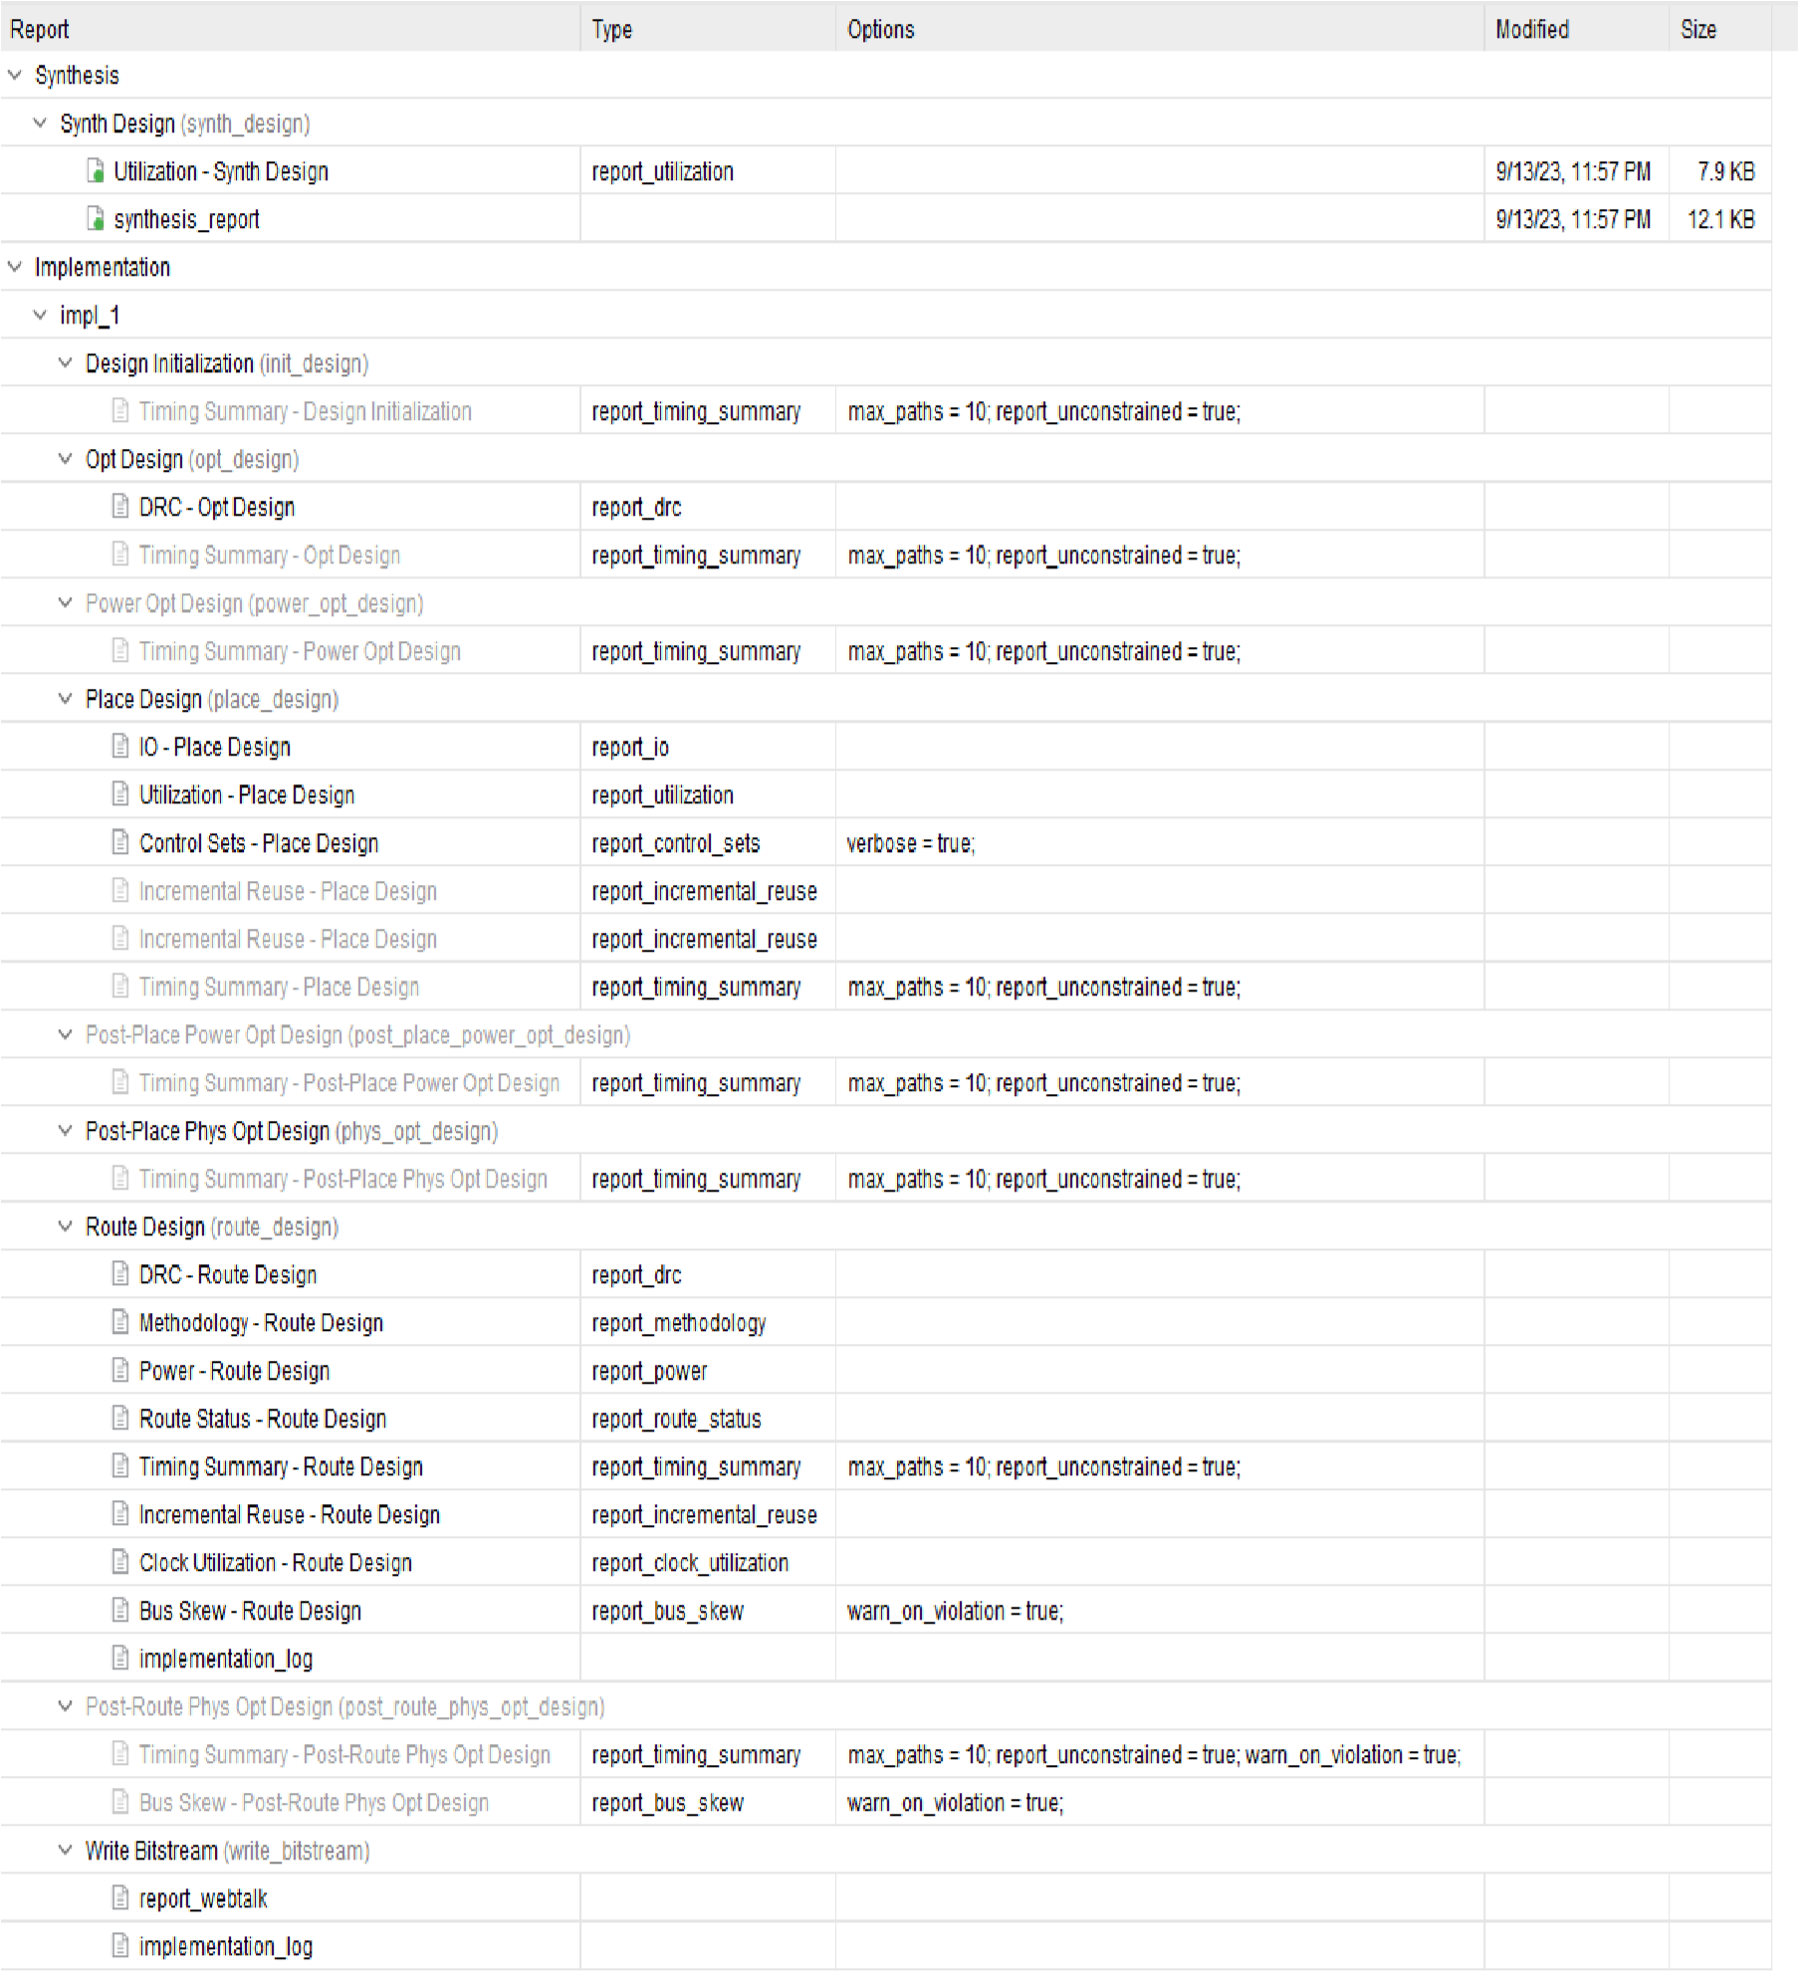

**power report:-**

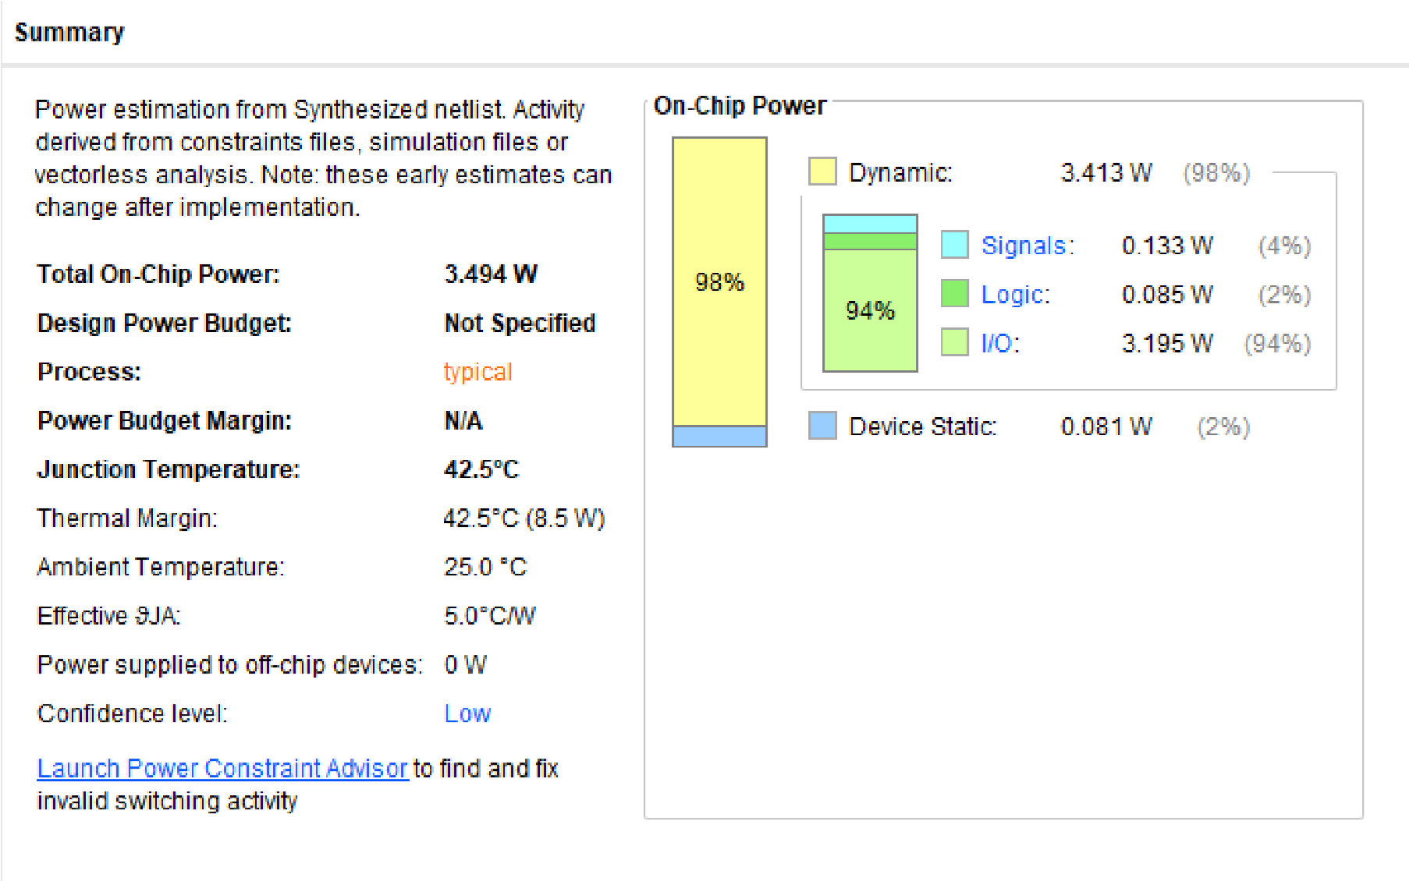

**Output:-**

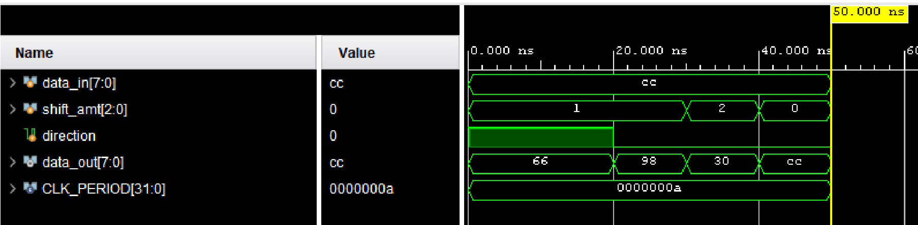

**18) 1-Bit Comparator using 4X1 Mux**

**Verilog code:-** module comparator_1bit_with_mux_behavioral (

input wire a, input wire b, output reg gt, output reg eq, output reg lt

);

always @* begin

if (a > b) begin

gt = 1; eq = 0; lt = 0;

end else if (a == b) begin

gt = 0; eq = 1; lt = 0;

end else begin

gt = 0; eq = 0; lt = 1;

end end

endmodule

**Testbench:-**

module tb_comparator_1bit_with_mux_behavioral;

parameter CLK_PERIOD = 10;

reg a, b; wire gt, eq, lt;

comparator_1bit_with_mux_behavioral uut (

.a(a),

.b(b),

.gt(gt),

.eq(eq),

.lt(lt)

);

initial begin

a = 0; b = 0;

#10 a = 1;

#10 b = 0;

#10 a = 1;

#10 b = 1;

#10 a = 0;

#10 b = 1;

#10 $finish; end

endmodule

**RTL schematic:-**

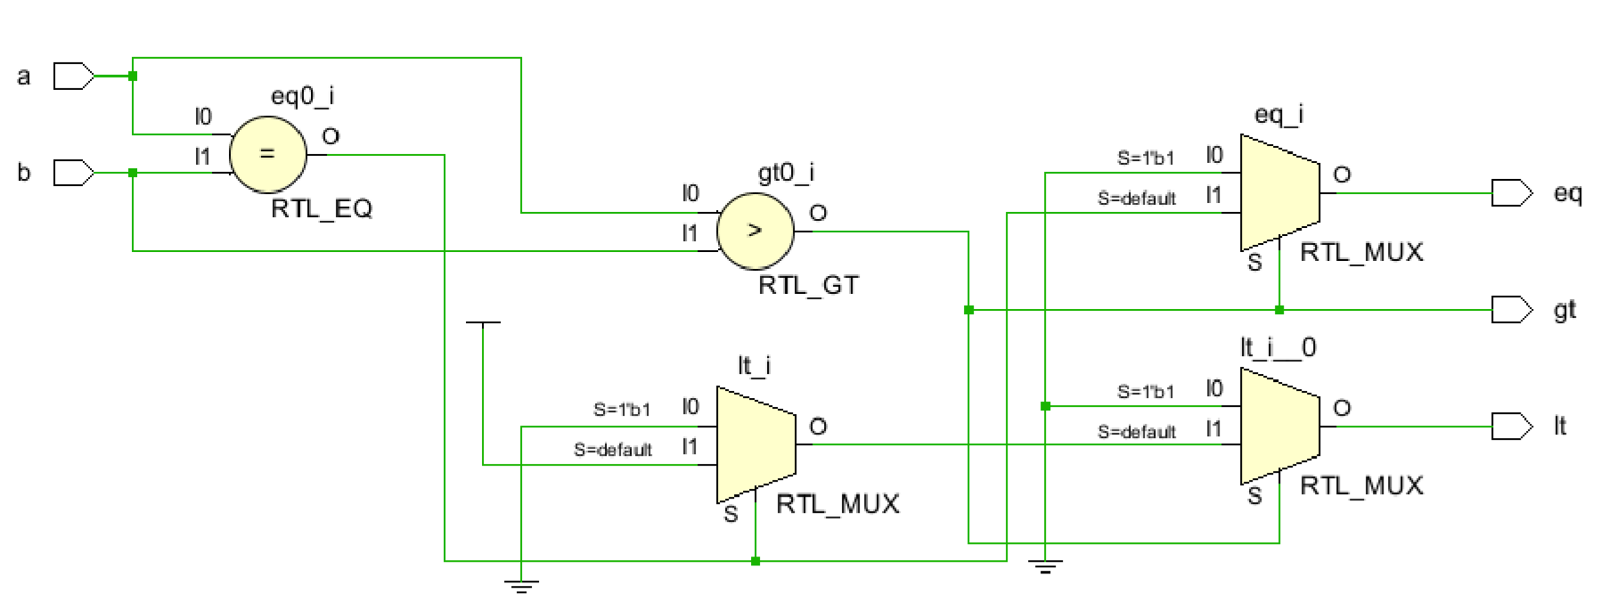

**Synthesis report:-**

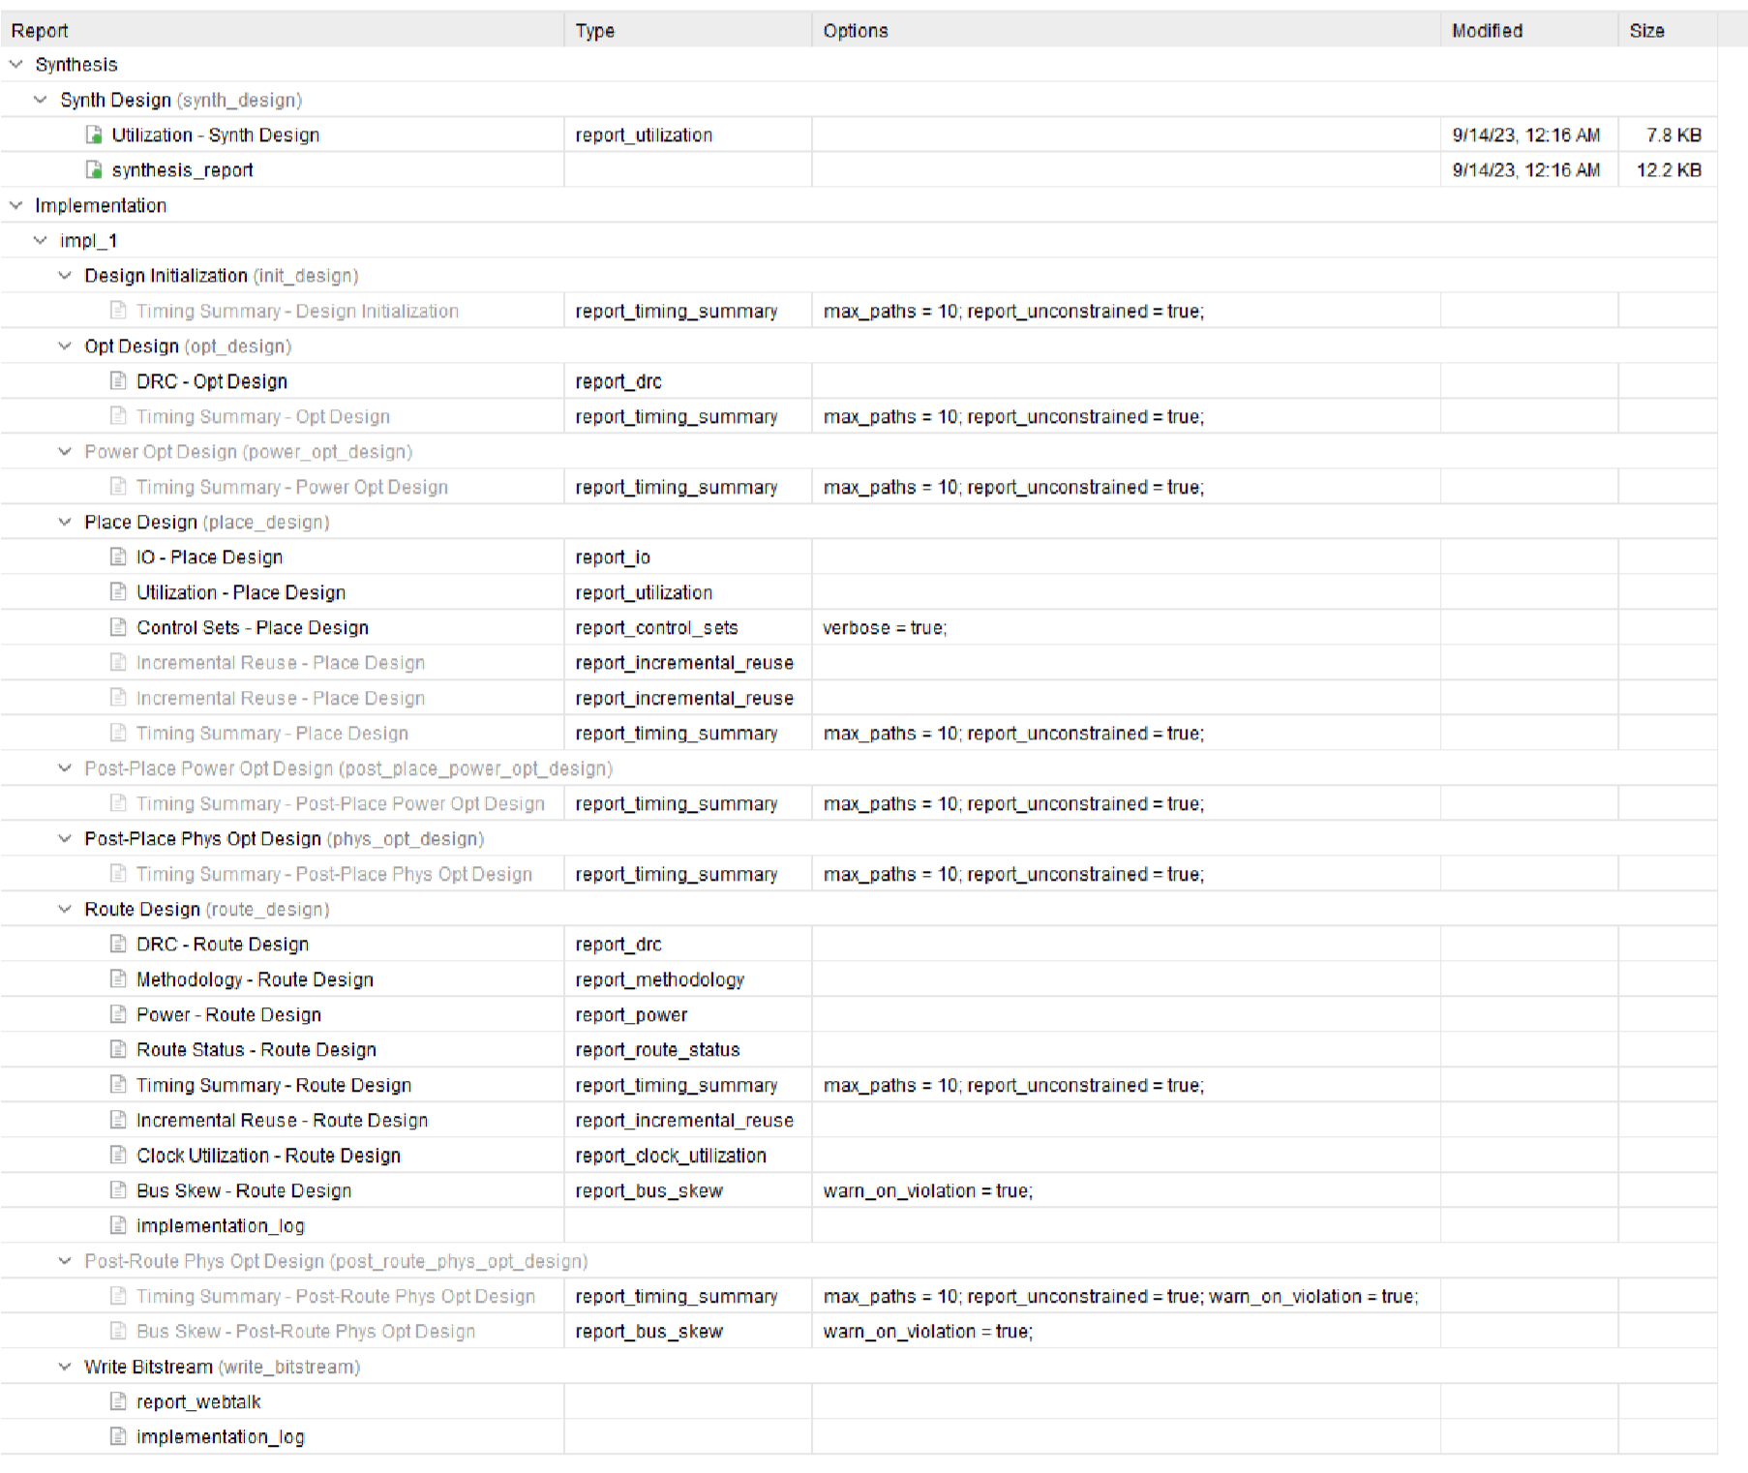

**power report:-**

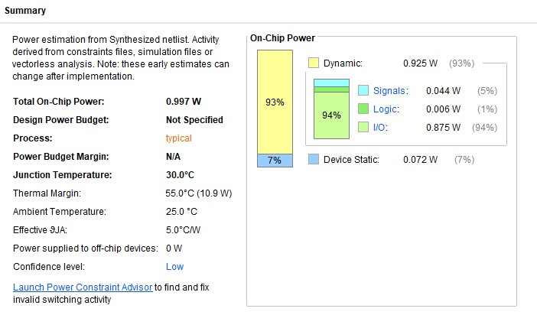

**Output:-**

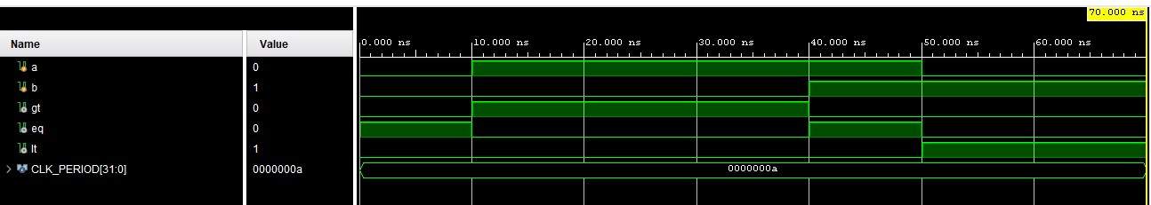

**19) Logical, Algebraic, and Rotate Shift Operations**

**Verilog code:-** module logical_shift ( input [7:0] data_in, input [2:0] shift_amt, input direction, output [7:0] data_out

);

assign data_out = (direction) ? (data_in << shift_amt) : (data_in >> shift_amt);

endmodule

module algebraic_shift ( input [7:0] data_in, input [2:0] shift_amt, input direction, output [7:0] data_out

);

assign data_out = (direction) ? (data_in << shift_amt) : (data_in >>> shift_amt);

endmodule

module rotate_shift ( input [7:0] data_in, input [2:0] shift_amt, input direction, output [7:0] data_out

);

assign data_out = (direction) ? (data_in << shift_amt) | (data_in >> (8 - shift_amt)) : (data_in >> shift_amt) | (data_in << (8 - shift_amt));

endmodule

**Testbench:-**

module tb_shift_operations;

parameter CLK_PERIOD = 10;

reg [7:0] data_in; reg [2:0] shift_amt; reg direction; wire [7:0] data_out;

logical_shift u_logical_shift (

.data_in(data_in),

.shift_amt(shift_amt),

.direction(direction),

.data_out(data_out)

);

algebraic_shift u_algebraic_shift (

.data_in(data_in),

.shift_amt(shift_amt),

.direction(direction),

.data_out(data_out)

);

rotate_shift u_rotate_shift ( .data_in(data_in),

.shift_amt(shift_amt),

.direction(direction),

.data_out(data_out)

);

initial begin

data_in = 8'b11001100; shift_amt = 3'b001; direction = 1;

#10 $display("Logical Left Shift:");

#10 shift_amt = 3'b010;

#10 $display("Logical Right Shift:");

#10 direction = 0;

#10 shift_amt = 3'b010;

#10 $display("Algebraic Left Shift:");

#10 shift_amt = 3'b010;

#10 $display("Algebraic Right Shift:");

#10 direction = 0;

#10 shift_amt = 3'b010;

#10 $display("Rotate Left:");

#10 direction = 1;

#10 shift_amt = 3'b010;

#10 $display("Rotate Right:");

#10 direction = 0;

#10 shift_amt = 3'b010;

#10 $finish; end

endmodule

**RTL schematic:-**

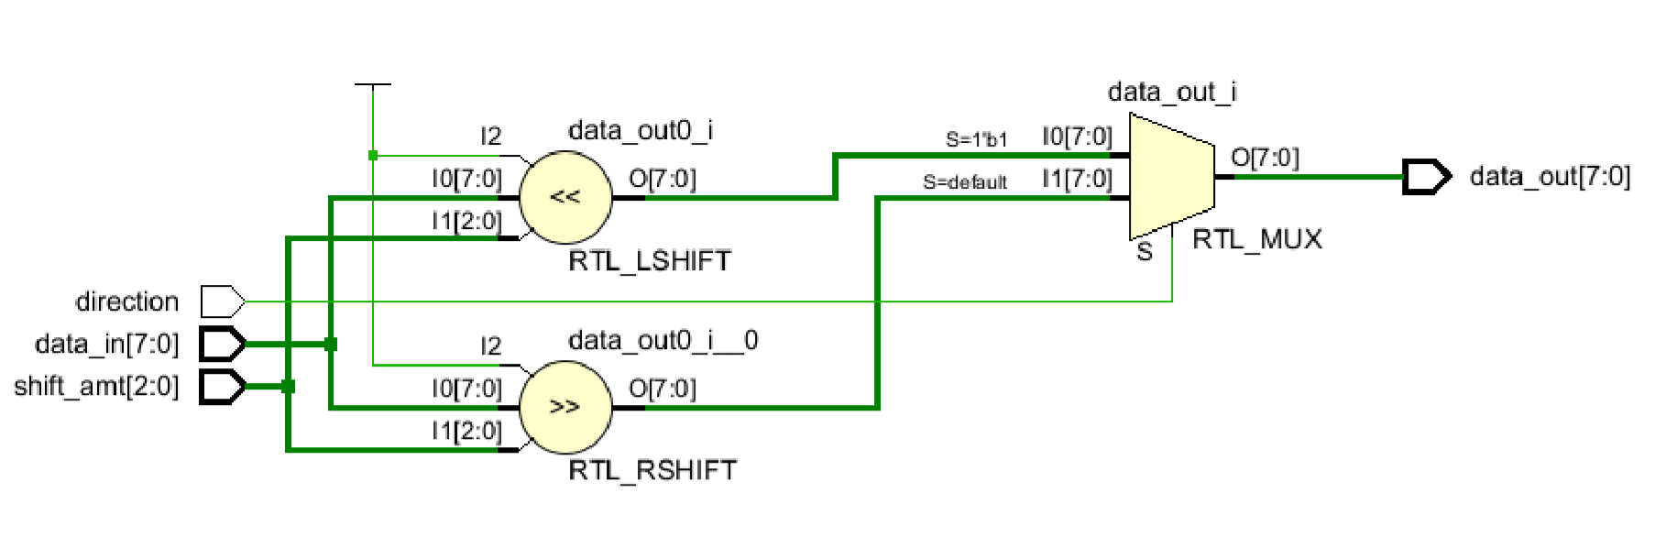

**power**

**report:**

**-**

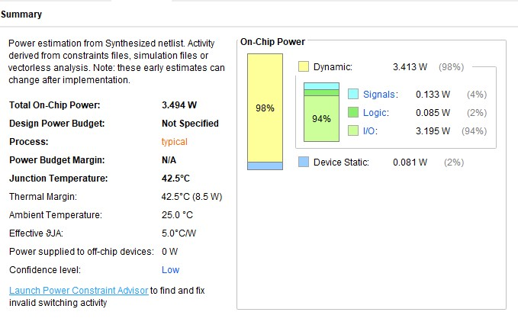

**Synthesis report:-**

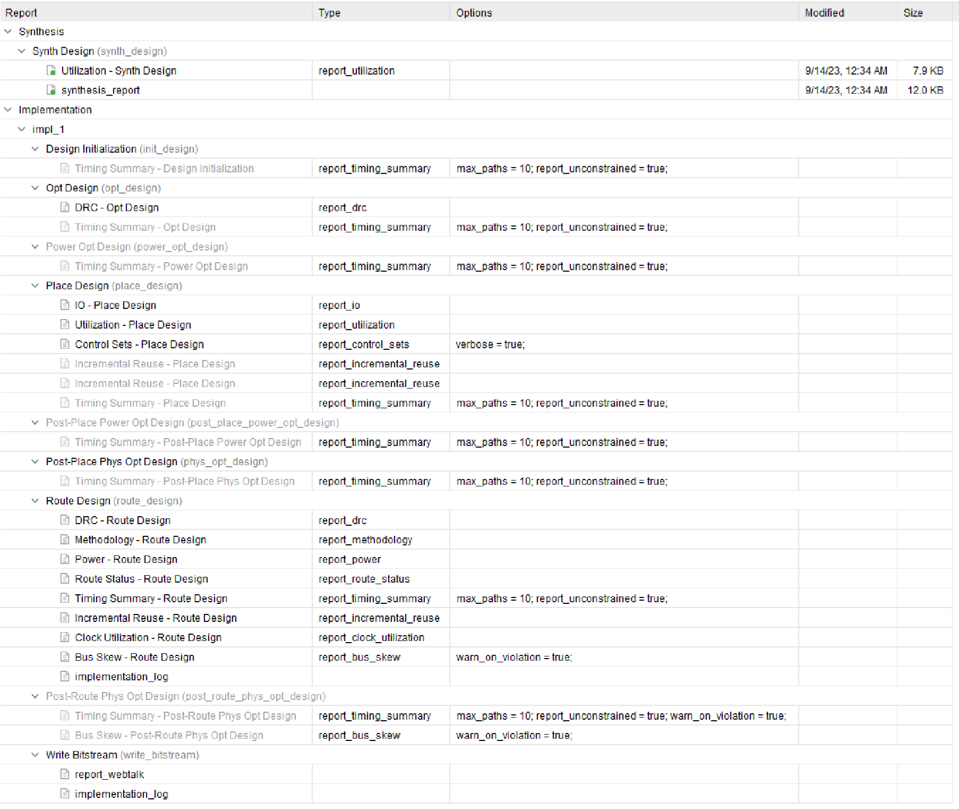

**Output:-**

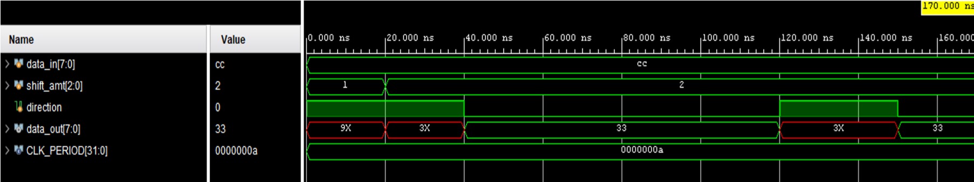

**20)ALU**

**Verilog code:-** module alu_4bit ( input [3:0] operand_A, input [3:0] operand_B, input [2:0] alu_control, output reg [3:0] result, output reg zero_flag, output reg carry_flag, output reg overflow_flag

);

always @* begin

case (alu_control)

3'b000: result = operand_A + operand_B;

3'b001: result = operand_A - operand_B;

3'b010: result = operand_A & operand_B;

3'b011: result = operand_A | operand_B;

3'b100: result = operand_A ^ operand_B;

3'b101: result = operand_A << 1;

3'b110: result = operand_A >> 1; 3'b111: result = ~operand_A;

default: result = 4'b0;

endcase zero_flag = (result == 4'b0); carry_flag = (result[4] == 1);

overflow_flag = (operand_A[3] & operand_B[3] & ~result[3]) | (~operand_A[3] &

~operand_B[3] & result[3]); end

endmodule **Testbench:-**

module tb_alu_4bit;

parameter CLK_PERIOD = 10;

reg [3:0] operand_A, operand_B; reg [2:0] alu_control; wire [3:0] result; wire zero_flag, carry_flag, overflow_flag;

alu_4bit uut (

.operand_A(operand_A), .operand_B(operand_B),

.alu_control(alu_control),

.result(result),

.zero_flag(zero_flag),

.carry_flag(carry_flag),

.overflow_flag(overflow_flag)

);

initial begin

operand_A = 4'b1101; operand_B = 4'b0101; alu_control = 3'b000;

#10 alu_control = 3'b000;

#10 $display("Result: %b, Zero: %b, Carry: %b, Overflow: %b", result, zero_flag, carry_flag, overflow_flag);

#10 alu_control = 3'b001;

#10 $display("Result: %b, Zero: %b, Carry: %b, Overflow: %b", result, zero_flag, carry_flag, overflow_flag);

#10 alu_control = 3'b010;

#10 $display("Result: %b, Zero: %b, Carry: %b, Overflow: %b", result, zero_flag, carry_flag, overflow_flag);

#10 alu_control = 3'b011;

#10 $display("Result: %b, Zero: %b, Carry: %b, Overflow: %b", result, zero_flag, carry_flag, overflow_flag);

#10 alu_control = 3'b100;

#10 $display("Result: %b, Zero: %b, Carry: %b, Overflow: %b", result, zero_flag, carry_flag, overflow_flag);

#10 alu_control = 3'b101;

#10 $display("Result: %b, Zero: %b, Carry: %b, Overflow: %b", result, zero_flag, carry_flag, overflow_flag);

#10 alu_control = 3'b110;

#10 $display("Result: %b, Zero: %b, Carry: %b, Overflow: %b", result, zero_flag, carry_flag, overflow_flag);

#10 alu_control = 3'b111;

#10 $display("Result: %b, Zero: %b, Carry: %b, Overflow: %b", result, zero_flag, carry_flag, overflow_flag);

#10 $finish; end

endmodule

**RTL schematic:-**

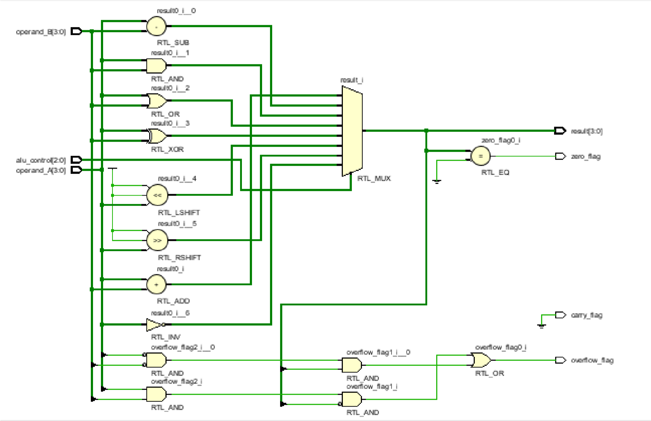

**Synthesis report:-**

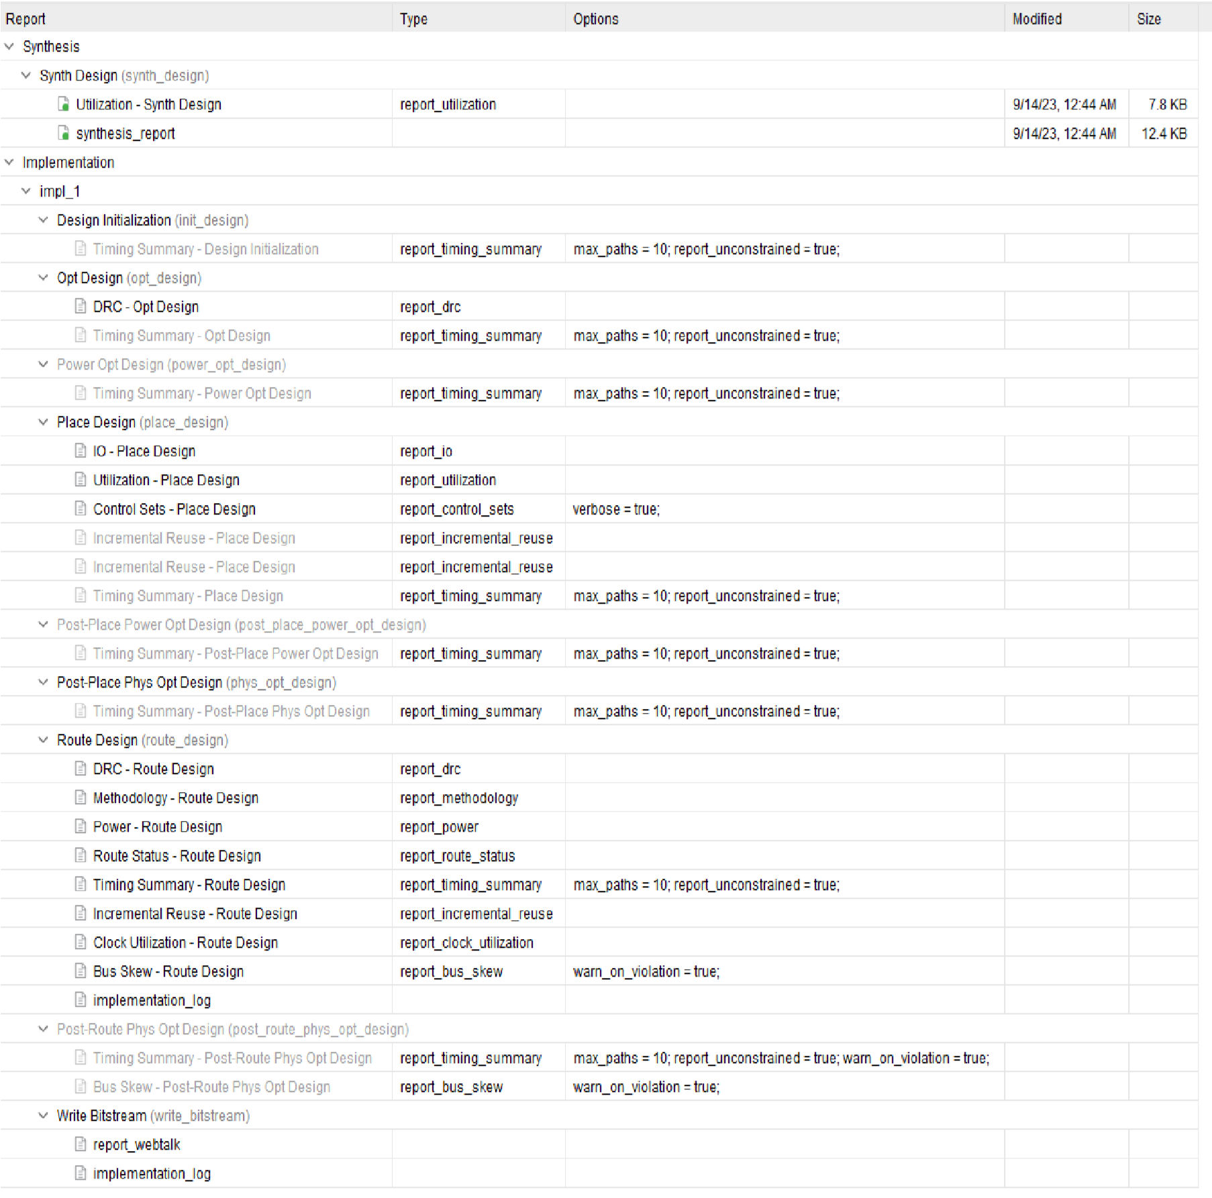

**power report:-**

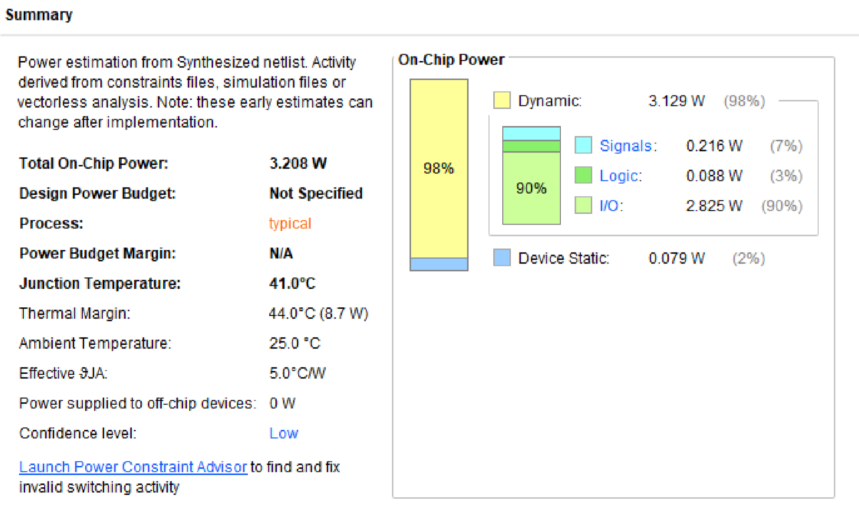

**Output:-**

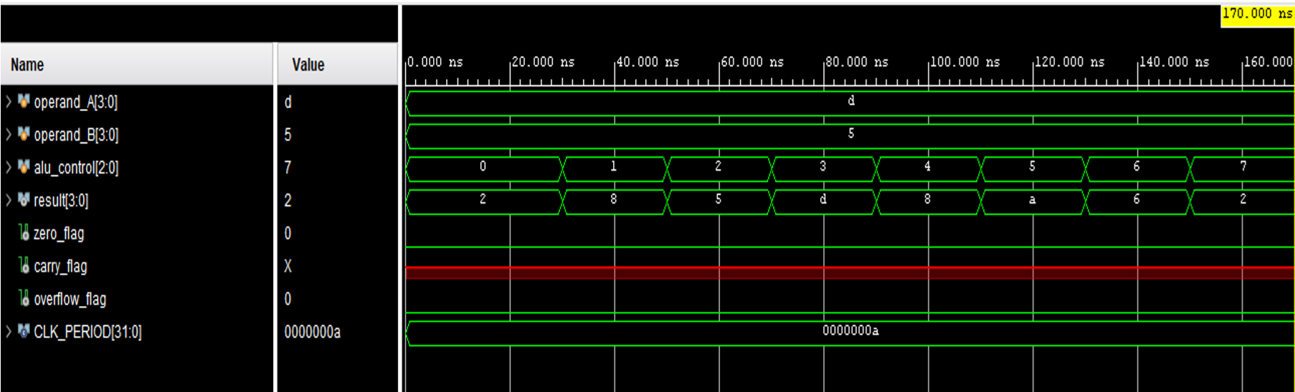

# 21) 4-Bit Asynchronous Down Counter Verilog code:- module down_counter_4bit (

input wire clk, input wire rst,

output reg [3:0] count

);

always @(posedge clk or posedge rst) begin

if (rst) begin

count <= 4'b0000; end else begin count <= count - 1; end end

endmodule **Testbench:-**

module tb_down_counter_4bit; parameter CLK_PERIOD = 10;

reg clk, rst; wire [3:0] count;

down_counter_4bit uut (

.clk(clk),

.rst(rst),

.count(count)

);

always begin

#((CLK_PERIOD / 2));

clk <= ~clk; end initial begin

clk = 0; rst = 0;

#10 rst = 0;

#10 $display("Count: %b", count);

#10 rst = 1;

#10 $display("Count: %b", count);

#10 rst = 0;

#10 $display("Count: %b", count);

#10 $display("Count: %b", count);

#10 #20;

#10 $display("Count: %b", count);

#10 $finish; end

endmodule

**RTL schematic:-**

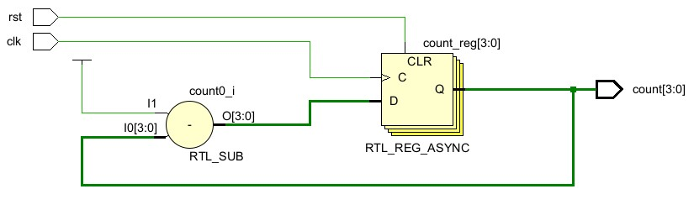

**Synthesis report:-**

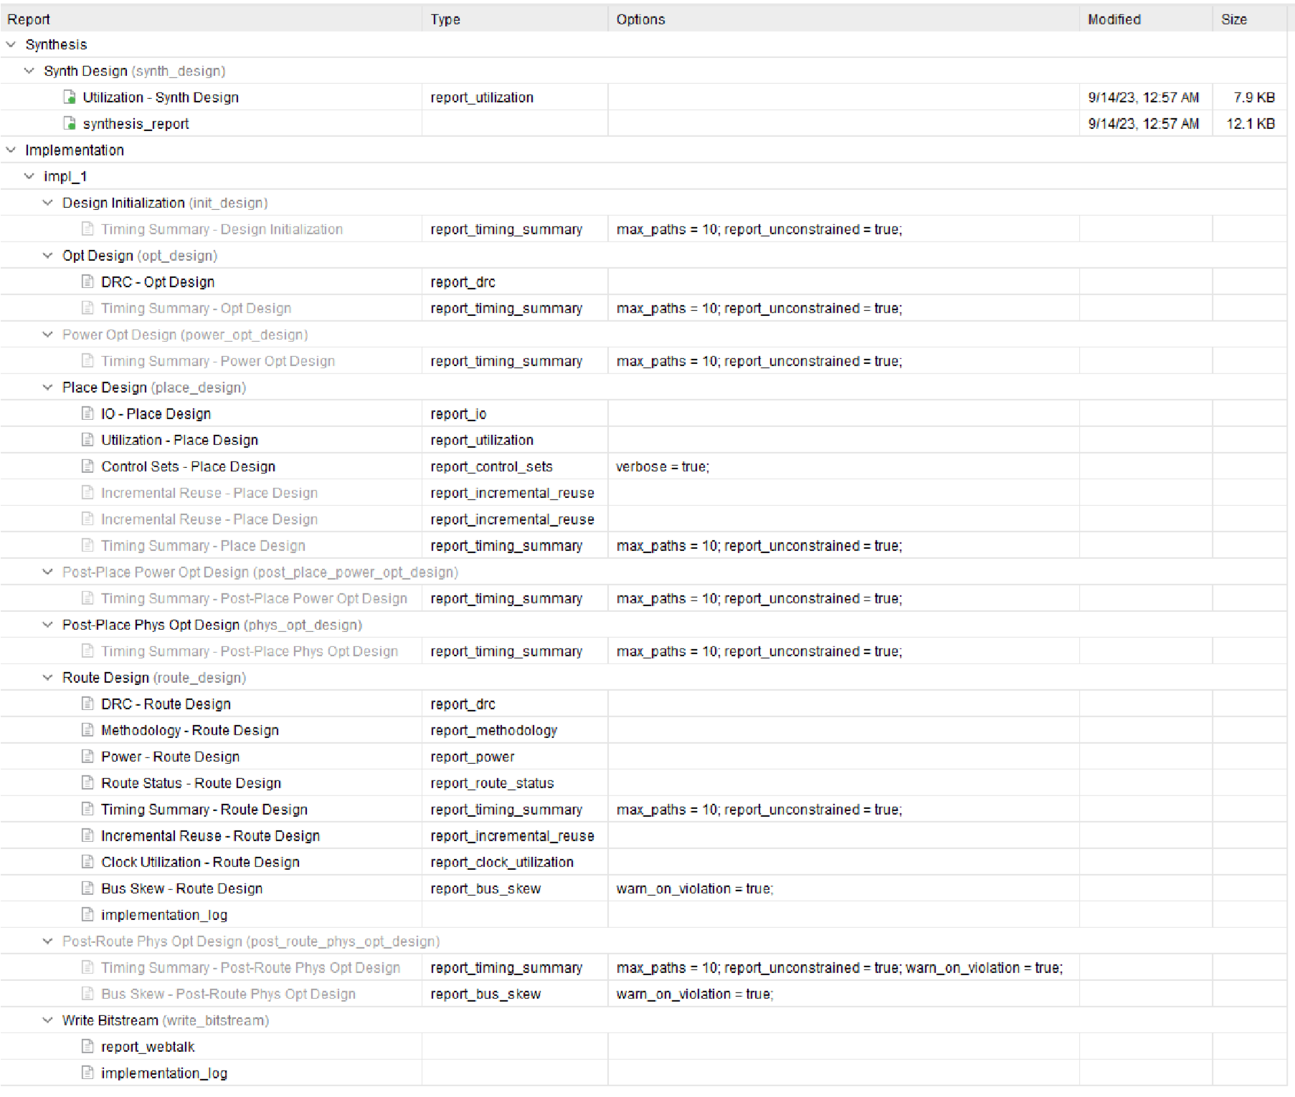

**power report:-**

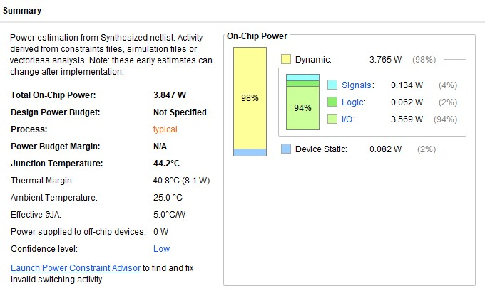

**Output:-**

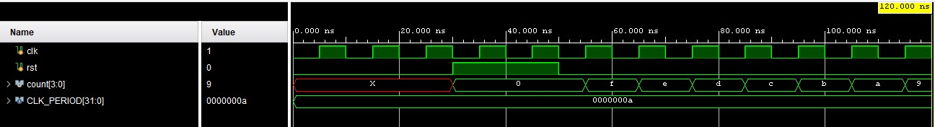

**22) Mod-N UpDown Counter**

**Verilog code:-** module mod_n_updown_counter (

input wire clk, input wire rst,

input wire up_down, output reg [3:0] count

);

always @(posedge clk or posedge rst) begin

if (rst) begin

count <= 4'b0000; end else begin if (up_down) begin if (count == 4'b1111) begin count <= 4'b0000; end else begin count <= count + 1;

end

end else begin if (count == 4'b0000) begin count <= 4'b1111; end else begin count <= count - 1;

end end end end

endmodule

**Testbench:-**

module tb_mod_n_updown_counter;

parameter CLK_PERIOD = 10;

reg clk, rst, up_down; wire [3:0] count;

mod_n_updown_counter uut (

.clk(clk),

.rst(rst),

.up_down(up_down),

.count(count)

);

always begin #((CLK_PERIOD / 2));

clk <= ~clk; end initial begin

clk = 0; rst = 0;

up_down = 1;

#10 rst = 0;

#10 $display("Count: %b", count);

#10 rst = 1;

#10 $display("Count: %b", count);

#10 rst = 0;

#10 up_down = 0;

#10 $display("Count: %b", count);

#10 $display("Count: %b", count);

#10 up_down = 1;

#10 $display("Count: %b", count); #10 #50;

#10 $display("Count: %b", count);

#10 $finish; end

endmodule

**RTL schematic:-**

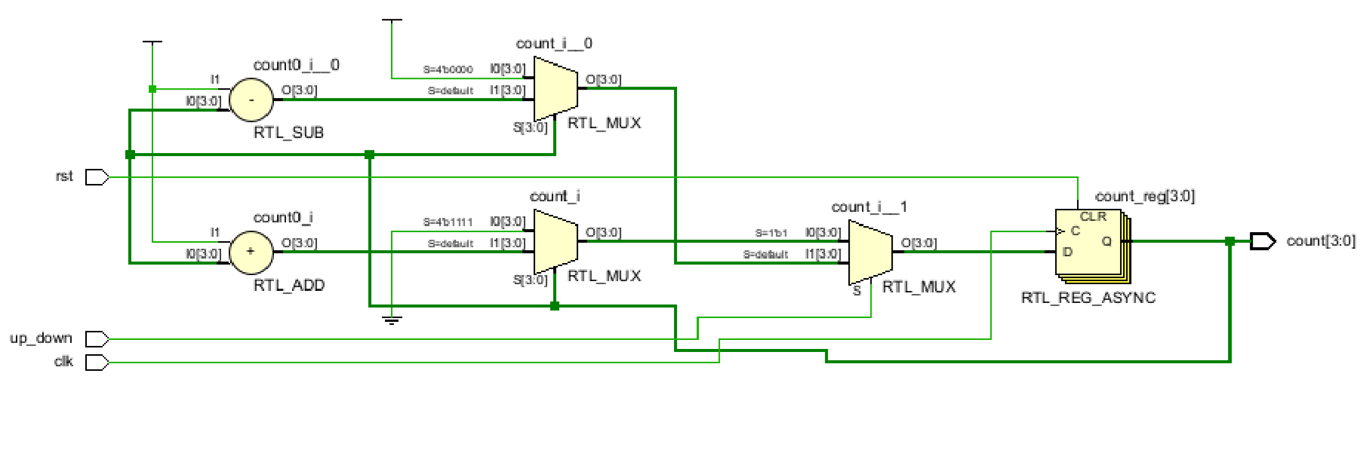

**power**

**report:**

**-**

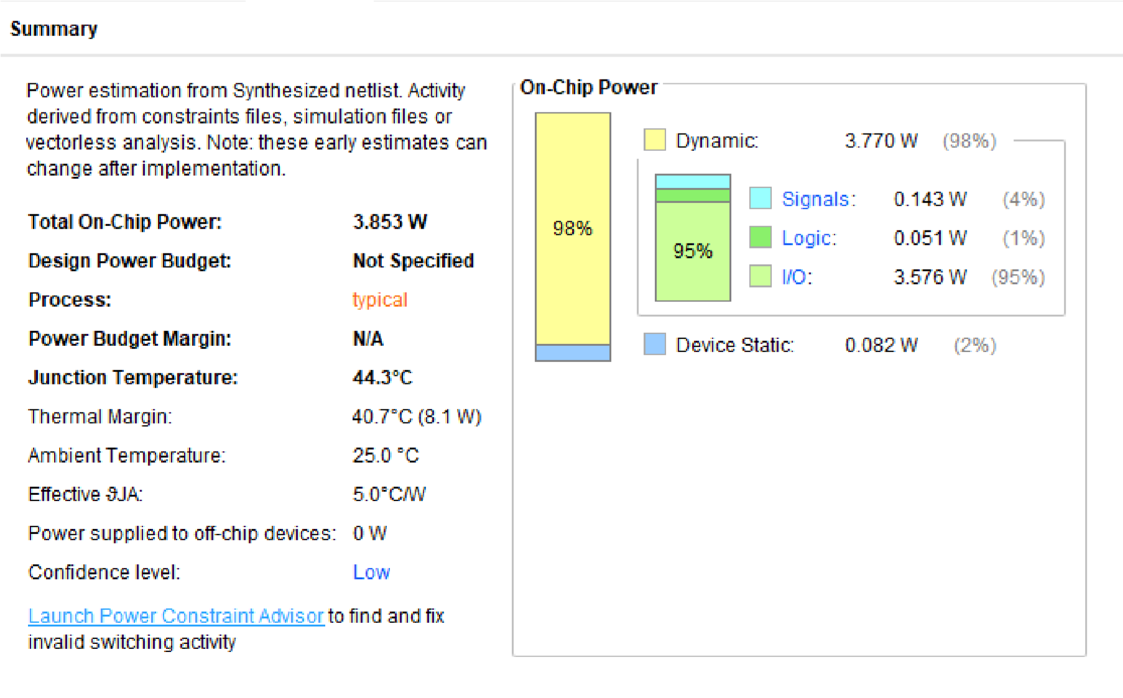

**Synthesis report:**

**-**

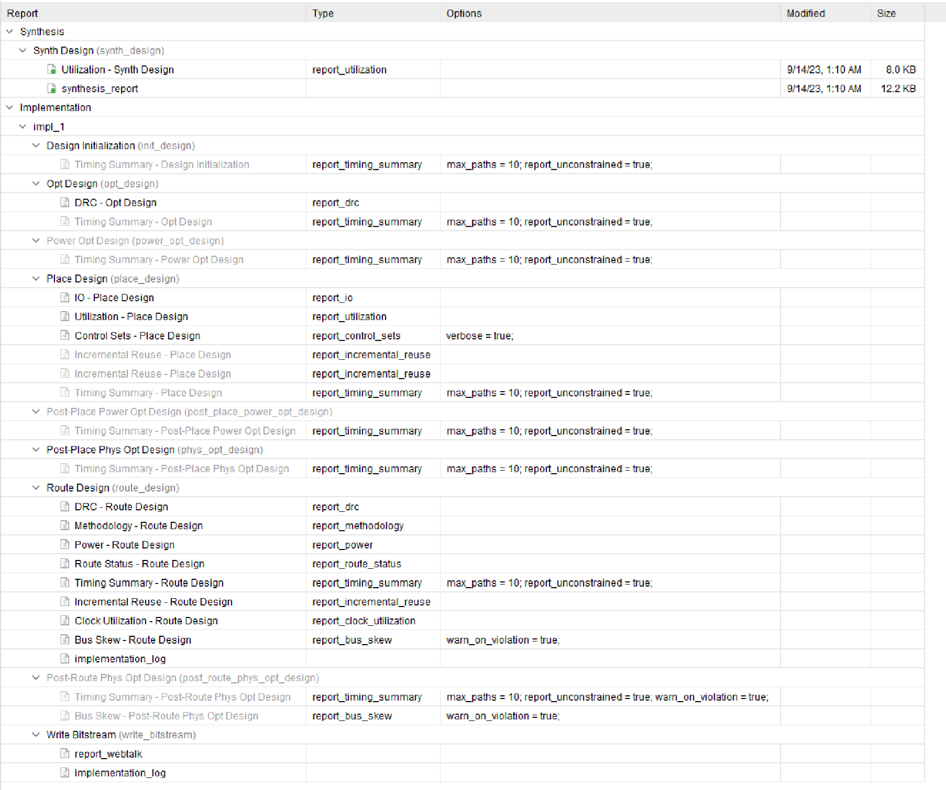

**Output:-**

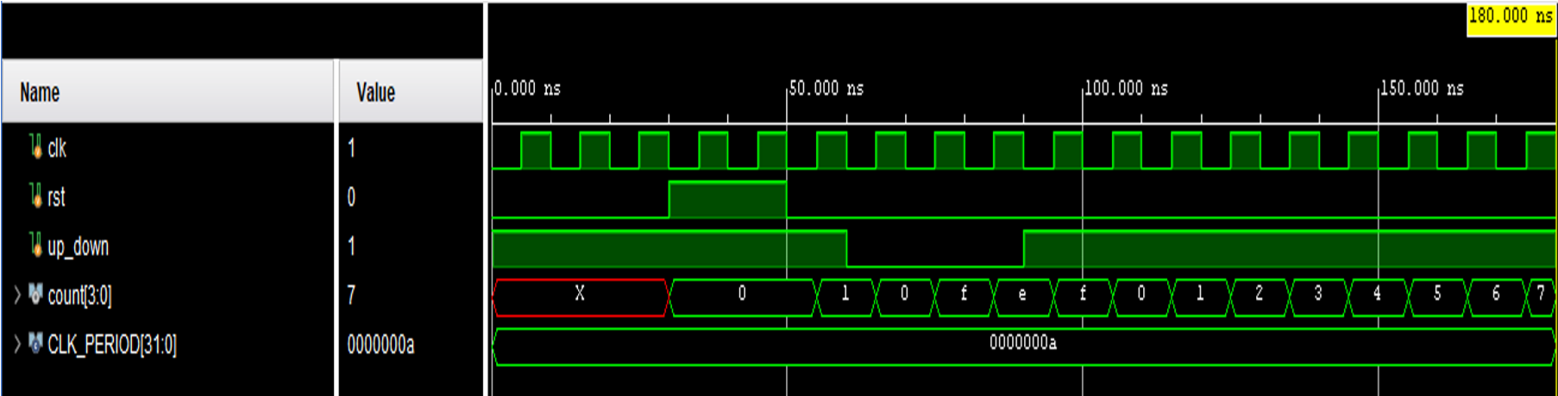

**23) Universal Shift Register**

**Verilog code:-** module universal_shift_register (

input wire clk, input wire rst,

input wire [3:0] data_in, input wire shift_en, input wire left_shift, input wire right_shift, output reg [3:0] data_out

);

always @(posedge clk or posedge rst) begin

if (rst) begin

data_out <= 4'b0000; end else if (shift_en) begin if (left_shift) begin

data_out <= {data_out[2:0], data_out[3]}; end else if (right_shift) begin data_out <= {data_out[0], data_out[3:1]};

end

end else begin data_out <= data_in; end end

endmodule

**Testbench:-**

module tb_universal_shift_register;

parameter CLK_PERIOD = 10;

reg clk, rst, shift_en, left_shift, right_shift; reg [3:0] data_in; wire [3:0] data_out;

universal_shift_register uut (

.clk(clk),

.rst(rst),

.data_in(data_in),

.shift_en(shift_en),

.left_shift(left_shift),

.right_shift(right_shift),

.data_out(data_out)

);

always begin #((CLK_PERIOD / 2));

clk <= ~clk; end

initial begin

clk = 0; rst = 0;

shift_en = 0; left_shift = 0; right_shift = 0; data_in = 4'b1010;

#10 rst = 0;

#10 shift_en = 0;

#10 $display("Data Out: %b", data_out);

#10 shift_en = 1;

#10 left_shift = 1;

#10 $display("Data Out: %b", data_out);

#10 left_shift = 0;

#10 right_shift = 1;

#10 $display("Data Out: %b", data_out);

#10 shift_en = 0;

#10 data_in = 4'b1100;

#10 $display("Data Out: %b", data_out);

#10 $finish; end

endmodule

**RTL schematic:-**

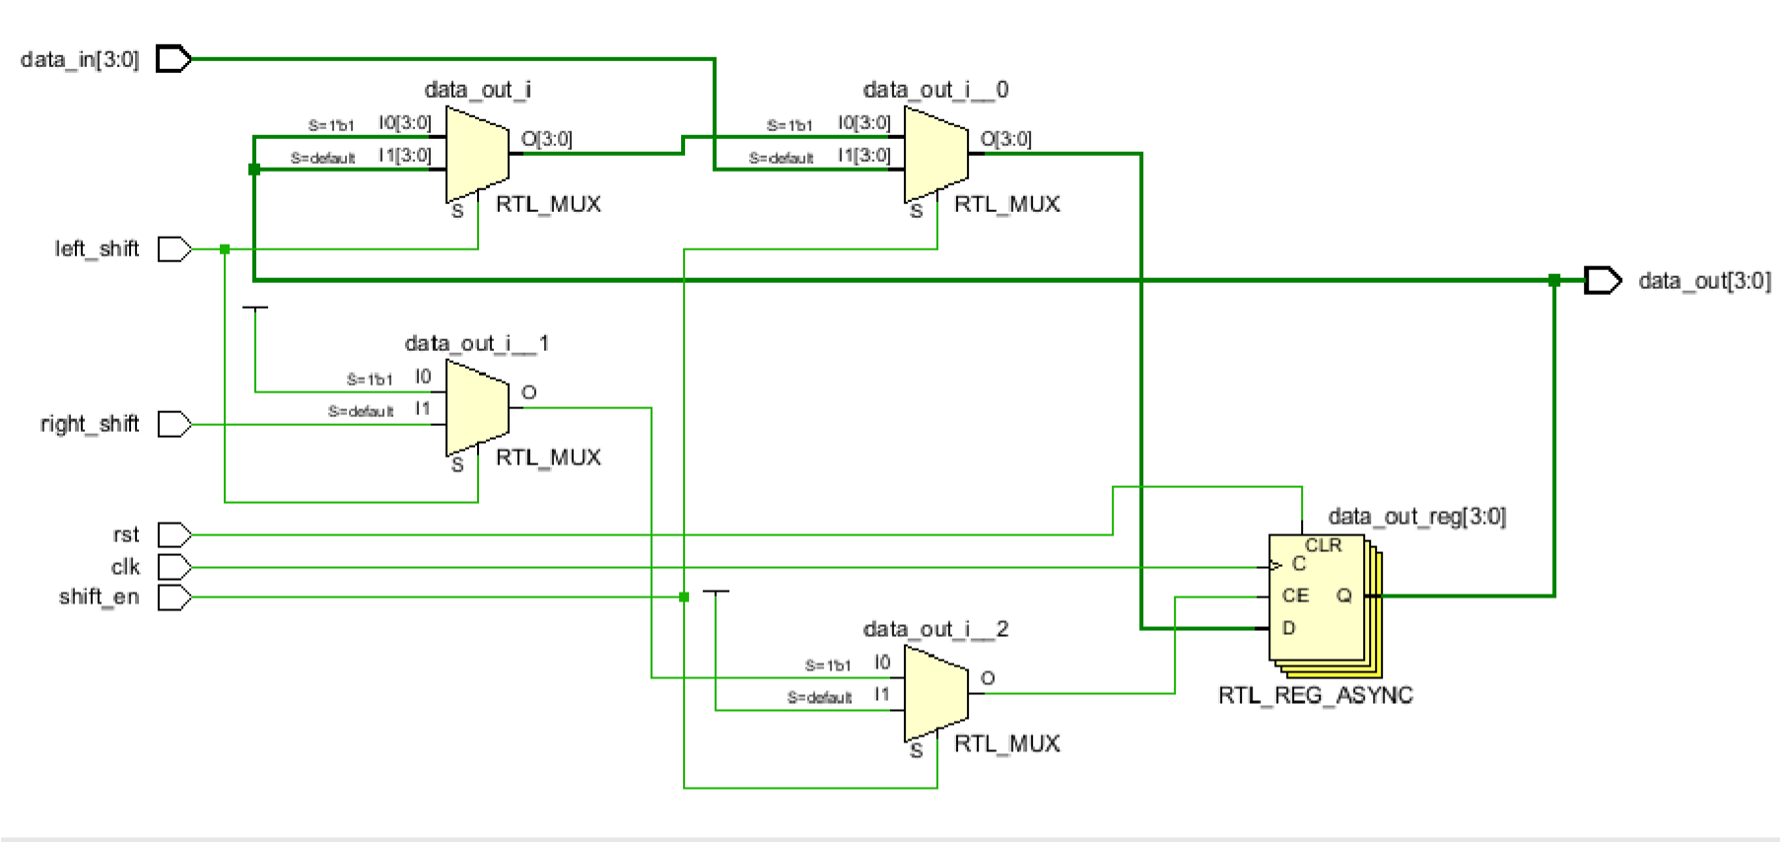

**Synthesis report:-**

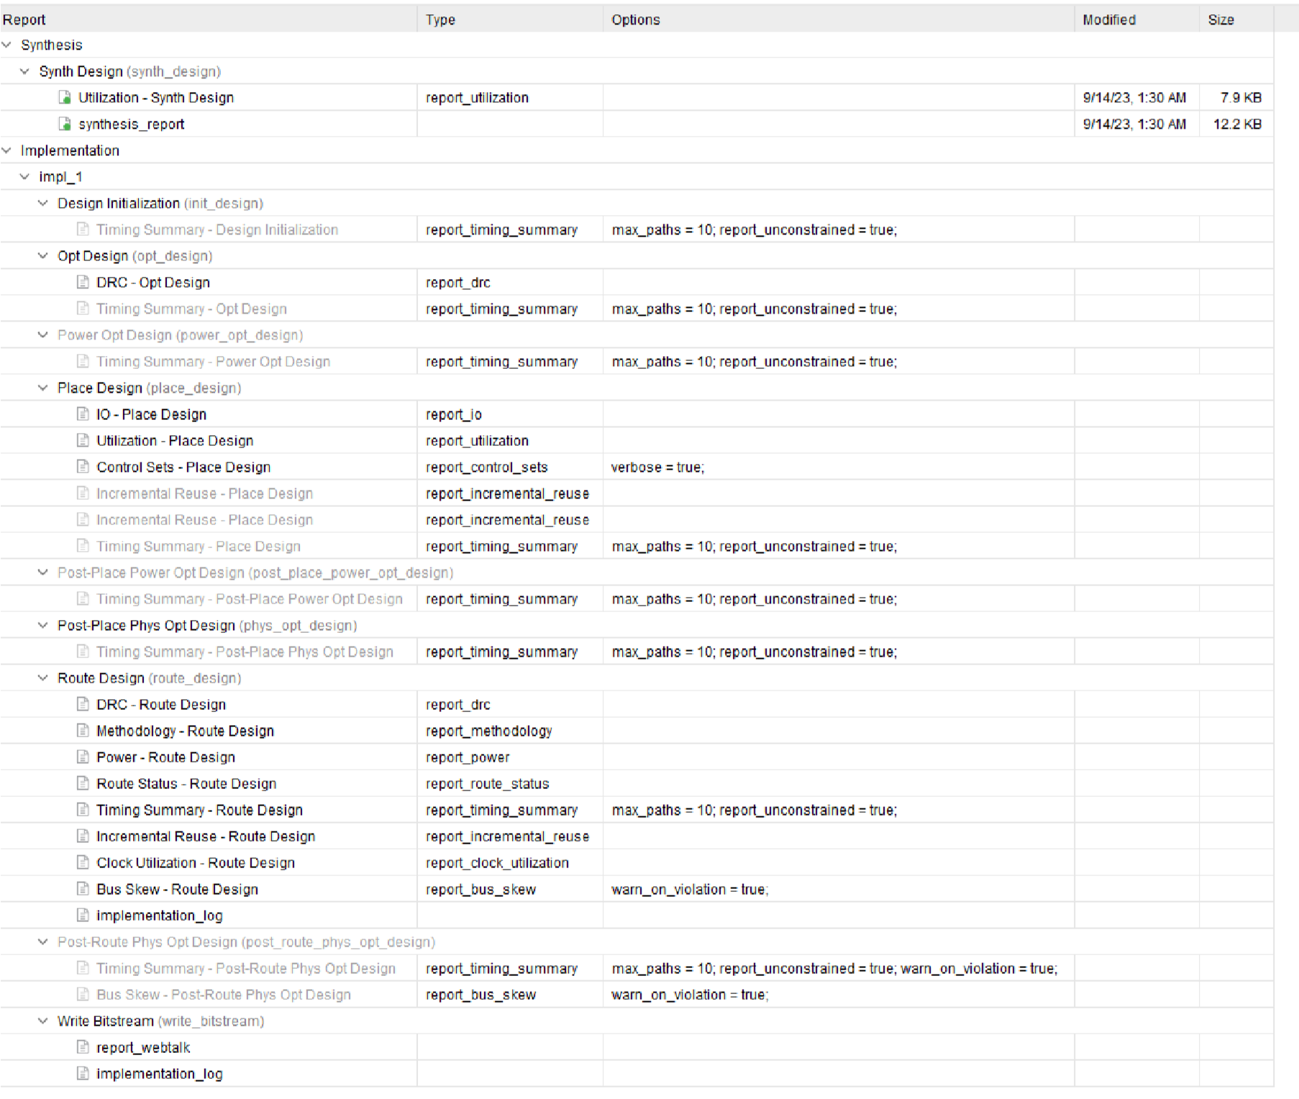

**power report:-**

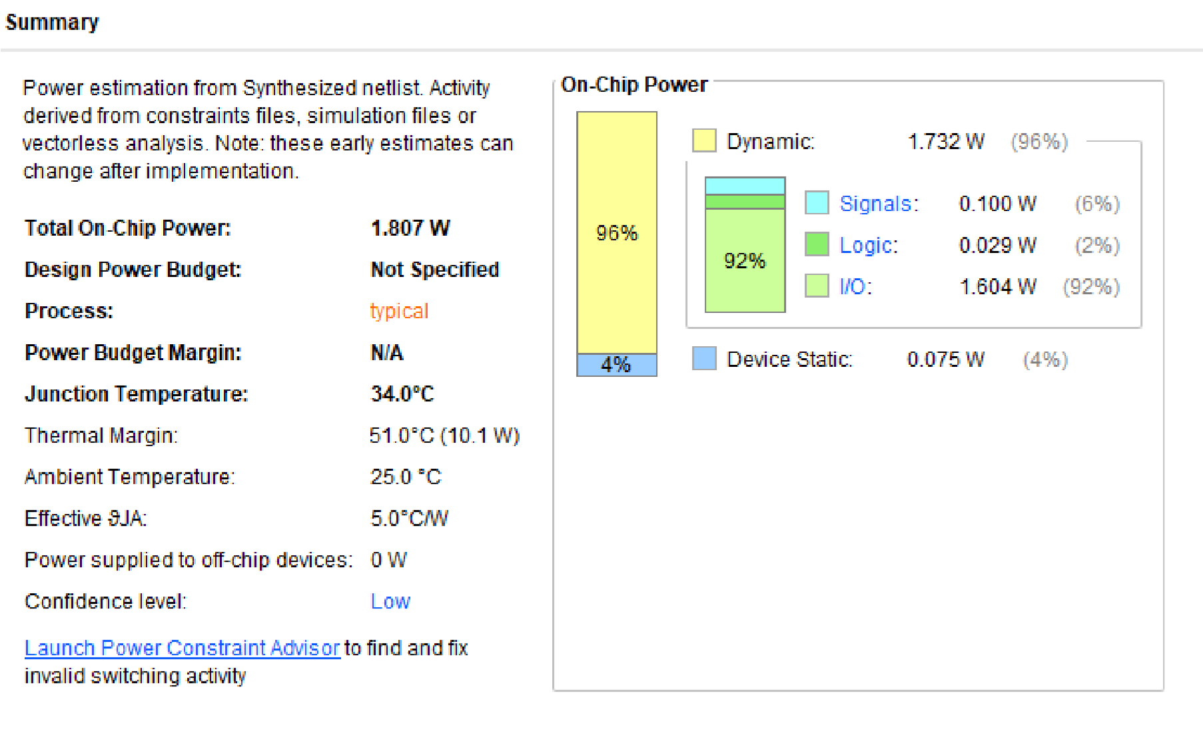

**Output:-**

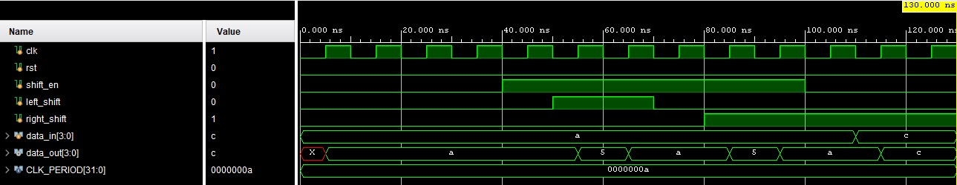

# 24) CN- Flipflop (Change -No Change Flip Flop) using DFF and 2:1 Mux Verilog code:- module cn_flipflop (

input wire clk, input wire d,

input wire change,

output reg q

);

wire q_bar;

always @(posedge clk) begin

if (change) begin

q <= d; end end

assign q_bar = ~q;

always @* begin

if (change) begin

q = d;

end else begin

q = q; end end

endmodule

**Testbench:-**

module tb_cn_flipflop; parameter CLK_PERIOD = 10;

reg clk, d, change; wire q; cn_flipflop uut (

.clk(clk),

.d(d),

.change(change),

.q(q)

);

always begin #((CLK_PERIOD / 2));

clk <= ~clk; end initial begin

clk = 0; d = 0;

change = 0; #10 d = 1;

#10 $display("q: %b", q);

#10 change = 1;

#10 $display("q: %b", q);

#10 change = 0;

#10 $display("q: %b", q); #10 $finish; end

endmodule

**RTL schematic:-**

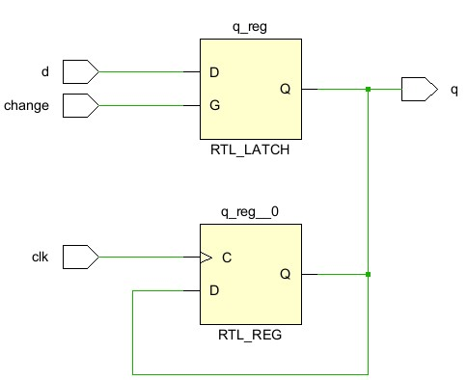

**Synthesis report:-**

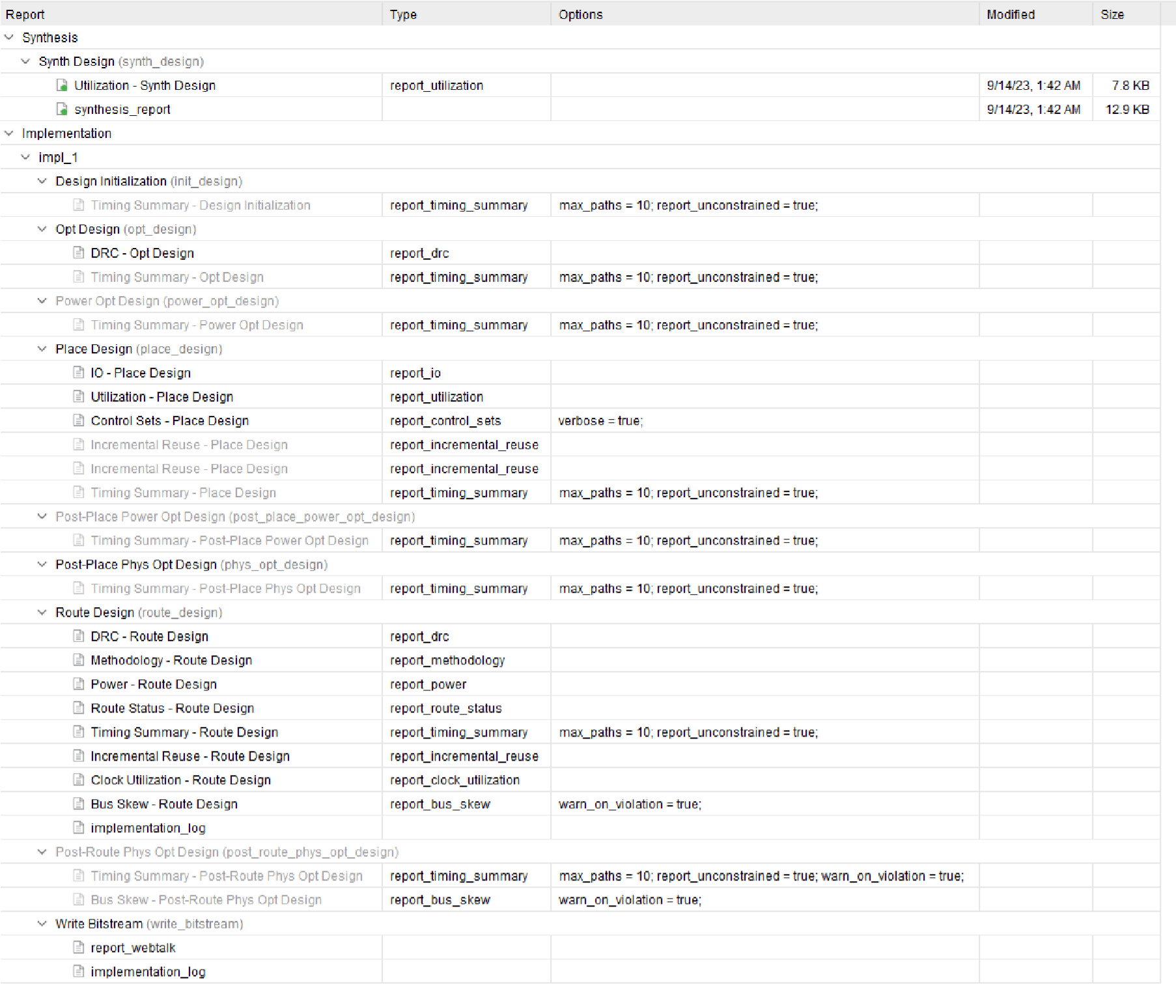

**power report:-**

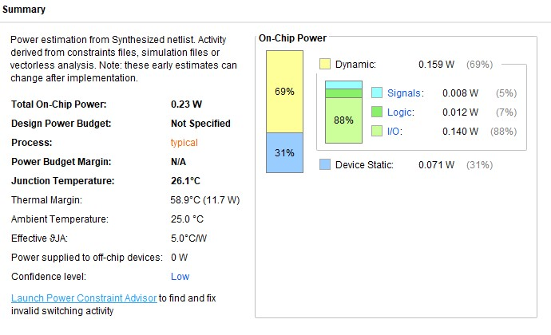

**Output:-**

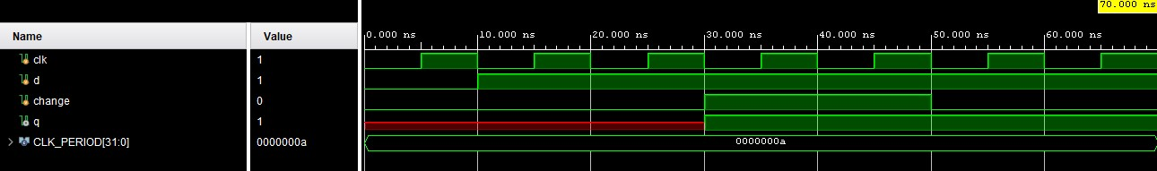

# 25) Frequency Divider by any Odd Number (Here I Used N=5) Verilog code:- module frequency_divider_by_5 (

input wire clk, input wire rst, output reg out

);

reg [2:0] counter;

always @(posedge clk or posedge rst) begin

if (rst) begin counter <= 3'b0; out <= 0; end else begin if (counter == 3'b100) begin counter <= 3'b0; out <= ~out; end else begin counter <= counter + 1;

end end end

endmodule

**Testbench:-**

module tb_frequency_divider_by_5;

parameter CLK_PERIOD = 10;

reg clk, rst; wire out;

frequency_divider_by_5 uut (

.clk(clk),

.rst(rst),

.out(out)

);

always begin #((CLK_PERIOD / 2));

clk <= ~clk; end initial begin

clk = 0; rst = 0;

#10 $display("Output: %b", out);

#10 rst = 1;

#10 $display("Output: %b", out);

#10 rst = 0;

#10 $display("Output: %b", out); #10 $finish; end

endmodule

**RTL schematic:-**

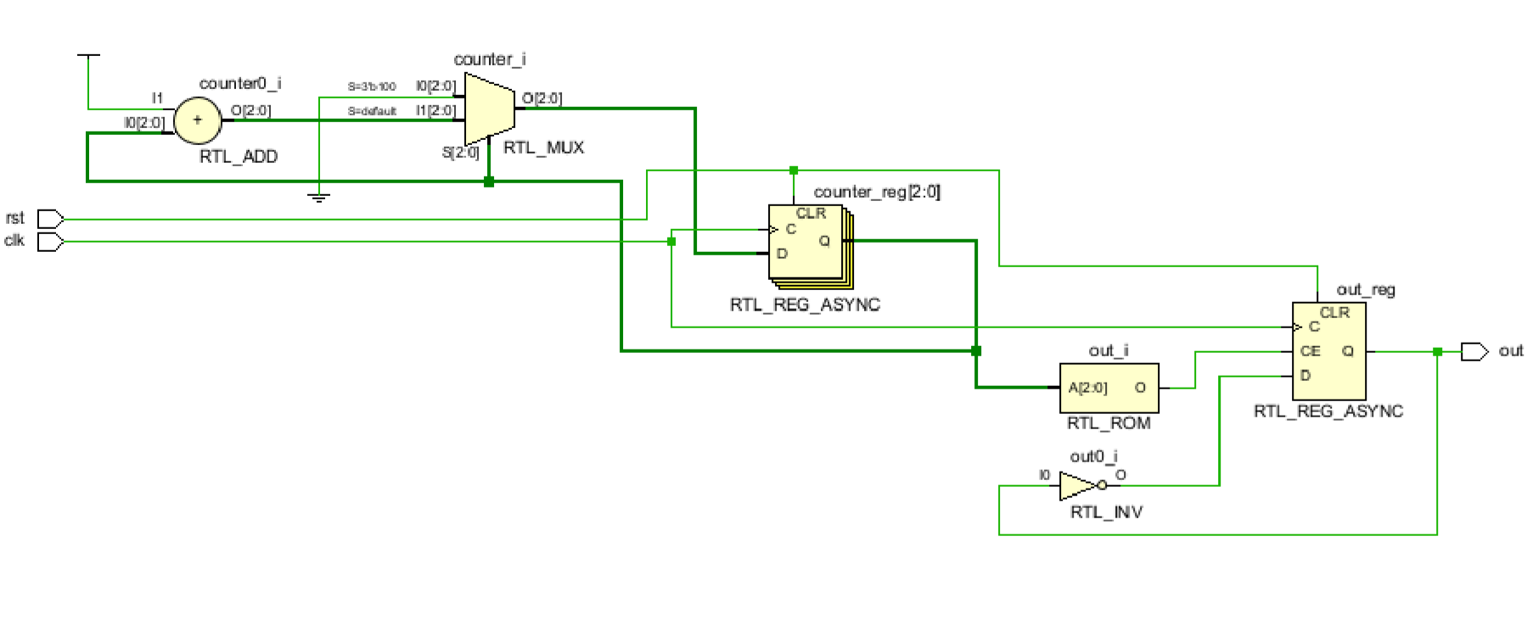

**Synthesis report:-**

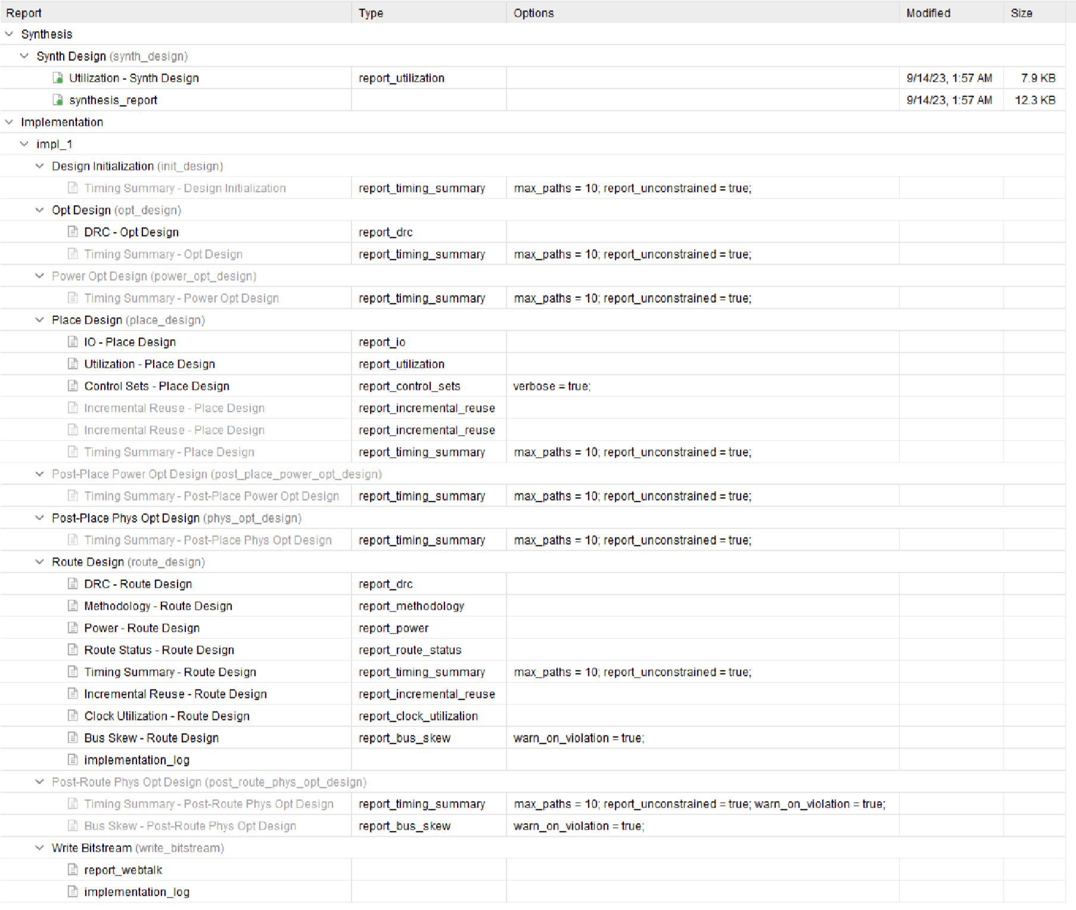

**power report:-**

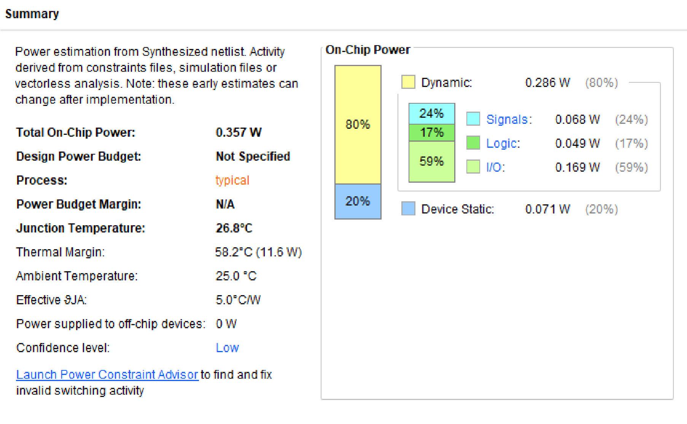

**Output:-**

